8.2 Small Group · Group 2 — Homework
Lesson 8-2-group2 • Standard 6.AT.8
Name: ______________________ Period: ______ Date: ____________

Today's Goals
Content: I can solve one-step addition and subtraction equations using inverse operations, explain why the method works, and use it on a problem I have not seen before.
Language: I can justify my answer to a skeptic and connect it to a second strategy or representation.

Key Words
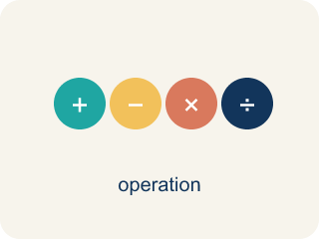
Solve One-Step Addition and Subtraction Equations (Resolver ecuaciones de suma y resta de un paso) — Use one inverse addition or subtraction operation to isolate the variable.
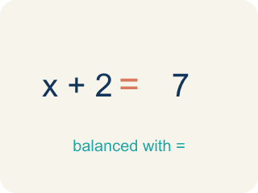
Equation (Ecuación) — A math sentence with an equal sign showing both sides are the same.

Inverse operation (Operación inversa) — Two math actions that undo each other, like × and ÷.

Isolate (Despejar) — To get the letter by itself on one side.

Solution (Solución) — A number that makes the equation or inequality true.

One-step equation (Ecuación de un paso) — An equation you can solve in a single step using one inverse operation.

Balance (Equilibrio) — Keeping both sides of an equation equal by doing the same thing to each side.

Practice
Show your work. Use the blank space under each problem.
1. A shirt costs $d. After a $15 discount, it costs $38. What is d?
A. $53
B. $23
C. $38
D. $45
______________________________________________________________________
2. Spot the Common Mistake
Step 1 (Equation): y − 13 = 28
Step 2 (Choose inverse): The inverse of − 13 is + 13, so add 13 to both sides.
Step 3 (Apply to both sides): y = 28 + 13
Step 4 (Simplify): y = 31
Which step has the mistake? Explain and fix it:
______________________________________________________________________
______________________________________________________________________
______________________________________________________________________
3. Find the Equation Error
Step 1 (Equation): x − 18 = 45
Step 2 (Identify inverse): Inverse of subtraction is subtraction
Step 3 (Apply to both sides): x − 18 − 18 = 45 − 18
Step 4 (Simplify): x = 27
Which step has the mistake? Explain and fix it:
______________________________________________________________________
______________________________________________________________________
______________________________________________________________________
4. A detective solved x + 25 = 60 and got x = 35. Another detective solved y − 25 = 60 and got y = 35. Are both correct? Explain using inverse operations and check each answer.
Sentence starter: For x + 25 = 60, the inverse operation is ___, so x = ___. Check: ___. For y − 25 = 60, the inverse operation is ___, so y = ___. Check: ___. Therefore, ___.
______________________________________________________________________
______________________________________________________________________
______________________________________________________________________
______________________________________________________________________

Answer Key (Teacher)
1. A. $53
d − 15 = 38 → d = 38 + 15 = 53.
Watch for: A common mistake is applying the same operation instead of the inverse — for example, solving x − 7 = 15 by subtracting 7 from both sides (getting the wrong x = 8) instead of adding 7 to both sides (the correct x = 22). Another common mistake is doing the inverse operation to only one side, like solving x + 6 = 14 by subtracting 6 from the left but forgetting the right side. Before you submit, name the operation shown in the equation, choose its inverse, apply it to BOTH sides, and check by substituting your answer back into the original equation.
2. Spot the Common Mistake
The mistake is in Step 4.
Correct work: The inverse operation was correct, but the addition was done wrong: 28 + 13 = 41, not 31. So y = 41. Check: 41 − 13 = 28 ✓
Watch for: The plan was correct — adding 13 to both sides is the right inverse for y − 13 = 28 — but the "Simplify" step adds wrong. 28 + 13 = 41, not 31, so y = 41. Substituting back confirms it: 41 − 13 = 28, while 31 − 13 would give 18.
3. Find the Equation Error
The mistake is in Step 2.
Correct work: Inverse of subtraction is ADDITION. Add 18 to both sides: x = 45 + 18 = 63.
Watch for: The "Identify inverse" step claims subtraction undoes subtraction, which pushes the equation further from the answer instead of isolating x. Addition undoes subtraction, so add 18 to both sides of x − 18 = 45: x = 45 + 18 = 63. Checking, 63 − 18 = 45, while the answer 27 would give 9.
4. Open response — answers will vary.
Look for key words: inverse, subtract, add, both sides, check, 35, 85.

