8.1–8.3 Catch-Up — Homework
Lesson 8-3-catchup • Standard 6.AT.8
Name: ______________________ Period: ______ Date: ____________

Today's Goals
Content: I can show I am caught up on Lessons 8.1–8.3 by using each lesson's big idea in mixed practice.
Language: I can explain which lesson's big idea I used and how, using key vocabulary from Lessons 8.1–8.3.

Key Words
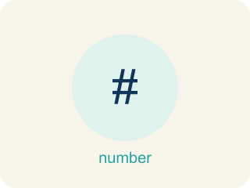
Write Equations (Escribir ecuaciones) — Represent a relationship with expressions joined by an equal sign.
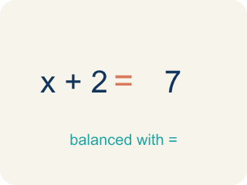
Equation (Ecuación) — A math sentence with an equal sign showing both sides are the same.
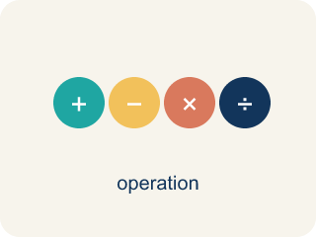
Solve One-Step Addition and Subtraction Equations (Resolver ecuaciones de suma y resta de un paso) — Use one inverse addition or subtraction operation to isolate the variable.

Solve Multiplication and Division Equations (Resolver ecuaciones de multiplicación y división) — Use inverse multiplication or division to isolate the variable.

Inverse operation (Operación inversa) — Two math actions that undo each other, like × and ÷.
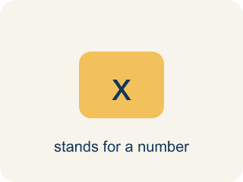
Variable (Variable) — A letter that stands for a number that is unknown or can change.
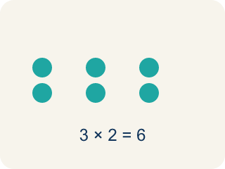
Multiply (Multiplicar) — To add equal groups again and again.

Practice
Show your work. Use the blank space under each problem.
1. (Lesson 8.1) Which equation represents: 'A number plus 12 equals 30'?
A. n + 12 = 30
B. n − 12 = 30
C. 12n = 30
D. n / 12 = 30
______________________________________________________________________
2. (Lesson 8.1) Which equation represents: 'Seven less than a number is 18'?
A. n − 7 = 18
B. 7 − n = 18
C. n + 7 = 18
D. n / 7 = 18
______________________________________________________________________
3. (Lesson 8.1) A detective found some fingerprints on Monday and 14 more on Tuesday, for a total of 30. Which equation represents this?
A. f + 14 = 30
B. f − 14 = 30
C. 14f = 30
D. f / 14 = 30
______________________________________________________________________
4. (Lesson 8.1) Crack the Equation Error
Step 1 (Clue): A number of case files divided by 3 equals 6.
Step 2 (Choose a variable): Let n be the number of case files.
Step 3 (Write the equation): 3n = 6
Which step has the mistake? Explain and fix it:
______________________________________________________________________
______________________________________________________________________
______________________________________________________________________
5. (Lesson 8.2) A shirt costs $d. After a $15 discount, it costs $38. What is d?
A. $53
B. $23
C. $38
D. $45
______________________________________________________________________
6. (Lesson 8.2) Spot the Common Mistake
Step 1 (Equation): y − 13 = 28
Step 2 (Choose inverse): The inverse of − 13 is + 13, so add 13 to both sides.
Step 3 (Apply to both sides): y = 28 + 13
Step 4 (Simplify): y = 31
Which step has the mistake? Explain and fix it:
______________________________________________________________________
______________________________________________________________________
______________________________________________________________________
7. (Lesson 8.3) A detective splits 54 clues equally among 9 case files. The equation 9c = 54 represents this. What is c?
A. c = 6
B. c = 63
C. c = 45
D. c = 9
______________________________________________________________________
8. (Lesson 8.3) Spot the Common Mistake
Step 1 (Equation): n / 4 = 12
Step 2 (Choose operation): n is in a fraction, so I will divide both sides by 4.
Step 3 (Apply to both sides): n / 4 ÷ 4 = 12 ÷ 4
Step 4 (Simplify): n = 3
Which step has the mistake? Explain and fix it:
______________________________________________________________________
______________________________________________________________________
______________________________________________________________________
9. (Lesson 8.1) A witness statement reads: 'A number c of security cameras plus 6 more equals 19.' Which equation matches?
A. c + 6 = 19
B. 6c = 19
C. c − 6 = 19
D. c / 6 = 19
______________________________________________________________________
10. (Lesson 8.2) Unlock Card 1: Solve x + 7 = 15.
A. x = 8
B. x = 22
C. x = 7
D. x = 105
______________________________________________________________________

Answer Key (Teacher)
1. A. n + 12 = 30
'Plus' means addition, so the equation is n + 12 = 30.
Watch for: A common mistake in Solve Multiplication and Division Equations is applying the SAME operation again instead of the inverse — for example, seeing 6x = 42 and multiplying both sides by 6 to get x = 252, instead of dividing by 6 to get x = 7. Before you submit, ask: did I use the OPPOSITE operation shown in the equation, and did I apply it to both sides?
2. A. n − 7 = 18
'Seven less than a number' means start with the number and subtract 7: n − 7 = 18.
Watch for: A common mistake in Solve Multiplication and Division Equations is applying the SAME operation again instead of the inverse — for example, seeing 6x = 42 and multiplying both sides by 6 to get x = 252, instead of dividing by 6 to get x = 7. Before you submit, ask: did I use the OPPOSITE operation shown in the equation, and did I apply it to both sides?
3. A. f + 14 = 30
The detective's Monday fingerprints (f) plus 14 more equals 30: f + 14 = 30.
Watch for: A common mistake in Solve Multiplication and Division Equations is applying the SAME operation again instead of the inverse — for example, seeing 6x = 42 and multiplying both sides by 6 to get x = 252, instead of dividing by 6 to get x = 7. Before you submit, ask: did I use the OPPOSITE operation shown in the equation, and did I apply it to both sides?
4. (Lesson 8.1) Crack the Equation Error
The mistake is in Step 3.
Correct work: 'Divided by 3' means division, not multiplication. The correct equation is n / 3 = 6, not 3n = 6. Check: 18 / 3 = 6.
Watch for: The clue says the case files are divided by 3, but the equation 3n = 6 multiplies instead. Dividing means splitting n into 3 equal groups, so the equation is n / 3 = 6, and 18 / 3 = 6 confirms it.
5. A. $53
d − 15 = 38 → d = 38 + 15 = 53.
Watch for: A common mistake in Solve Multiplication and Division Equations is applying the SAME operation again instead of the inverse — for example, seeing 6x = 42 and multiplying both sides by 6 to get x = 252, instead of dividing by 6 to get x = 7. Before you submit, ask: did I use the OPPOSITE operation shown in the equation, and did I apply it to both sides?
6. (Lesson 8.2) Spot the Common Mistake
The mistake is in Step 4.
Correct work: The inverse operation was correct, but the addition was done wrong: 28 + 13 = 41, not 31. So y = 41. Check: 41 − 13 = 28 ✓
Watch for: The plan was correct — adding 13 to both sides is the right inverse for y − 13 = 28 — but the "Simplify" step adds wrong. 28 + 13 = 41, not 31, so y = 41. Substituting back confirms it: 41 − 13 = 28, while 31 − 13 would give 18.
7. A. c = 6
Divide both sides by 9: c = 54 ÷ 9 = 6 clues per file.
Watch for: A common mistake in Solve Multiplication and Division Equations is applying the SAME operation again instead of the inverse — for example, seeing 6x = 42 and multiplying both sides by 6 to get x = 252, instead of dividing by 6 to get x = 7. Before you submit, ask: did I use the OPPOSITE operation shown in the equation, and did I apply it to both sides?
8. (Lesson 8.3) Spot the Common Mistake
The mistake is in Step 2.
Correct work: n is divided by 4, so the inverse is MULTIPLICATION. Multiply both sides by 4: n = 12 × 4 = 48. Check: 48 ÷ 4 = 12 ✓
Watch for: Dividing again does not undo division. Since n is divided by 4, multiply both sides by 4: n = 12 × 4 = 48, and 48 ÷ 4 = 12 confirms it. The answer 3 is a clue on its own — n has to be bigger than 12, not smaller, because it was cut into fourths.
9. A. c + 6 = 19
'Plus 6 more' means + 6 and 'equals 19' means = 19, so c + 6 = 19. Check: 13 + 6 = 19.
Watch for: A common mistake in Solve Multiplication and Division Equations is applying the SAME operation again instead of the inverse — for example, seeing 6x = 42 and multiplying both sides by 6 to get x = 252, instead of dividing by 6 to get x = 7. Before you submit, ask: did I use the OPPOSITE operation shown in the equation, and did I apply it to both sides?
10. A. x = 8
Subtract 7 from both sides: x = 15 − 7 = 8. Check: 8 + 7 = 15 ✓
Watch for: A common mistake in Solve Multiplication and Division Equations is applying the SAME operation again instead of the inverse — for example, seeing 6x = 42 and multiplying both sides by 6 to get x = 252, instead of dividing by 6 to get x = 7. Before you submit, ask: did I use the OPPOSITE operation shown in the equation, and did I apply it to both sides?

