8.3 Small Group · Group 1 — Homework
Lesson 8-3-group1 • Standard 6.AT.8
Name: ______________________ Period: ______ Date: ____________

Today's Goals
Content: With my small group, I can solve one-step multiplication and division equations using inverse operations — one step at a time, with support.
Language: I can talk through each step out loud using a sentence frame and the lesson's key words.

Key Words

Solve Multiplication and Division Equations (Resolver ecuaciones de multiplicación y división) — Use inverse multiplication or division to isolate the variable.
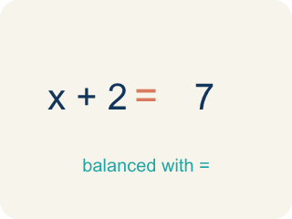
Inverse operation (Operación inversa) — Two math actions that undo each other, like × and ÷.
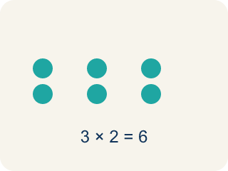
Multiply (Multiplicar) — To add equal groups again and again.
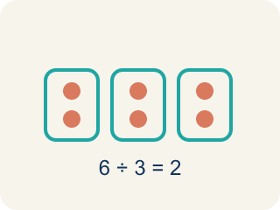
Divide (Dividir) — To split into equal groups.

Isolate (Despejar) — To get the letter by itself on one side.
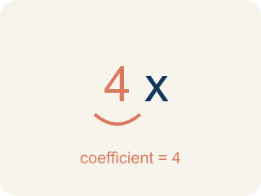
Coefficient (Coeficiente) — The number in front of a letter, like the 3 in 3x.

Solution (Solución) — A number that makes the equation or inequality true.

Practice
Show your work. Use the blank space under each problem.
1. Solve: 6x = 42
A. x = 7
B. x = 48
C. x = 36
D. x = 252
______________________________________________________________________
2. Solve: n / 3 = 8
A. n = 24
B. n = 11
C. n = 5
D. n = 3
______________________________________________________________________
3. Vault A is sealed with 4x = 32. Crack the lock: what is x?
A. x = 8
B. x = 128
C. x = 28
D. x = 36
______________________________________________________________________
4. Vault B is sealed with x / 3 = 6. Crack the lock: what is x?
A. x = 18
B. x = 2
C. x = 9
D. x = 3
______________________________________________________________________
5. Vault C is sealed with 5n = 45. Crack the lock: what is n?
A. n = 9
B. n = 225
C. n = 40
D. n = 50
______________________________________________________________________
6. Level 2 Extension - The Vault That Won't Open
Step 1 (Equation): 4x = 32
Step 2 (Identify inverse): Inverse of multiplication is multiplication
Step 3 (Apply to both sides): 4x x 4 = 32 x 4
Step 4 (Simplify): x = 128
Which step has the mistake? Explain and fix it:
______________________________________________________________________
______________________________________________________________________
______________________________________________________________________
7. Find the Equation Error
Step 1 (Equation): x / 5 = 12
Step 2 (Identify inverse): Inverse of division is division
Step 3 (Apply to both sides): x / 5 / 5 = 12 / 5
Step 4 (Simplify): x = 2.4
Which step has the mistake? Explain and fix it:
______________________________________________________________________
______________________________________________________________________
______________________________________________________________________
8. A bakery packed muffins into boxes of 8. They made 96 muffins total. Write an equation, solve it, and explain why your answer is reasonable. Then write a different situation that uses division and has the same answer.
Sentence starter: Equation: ___. Solving: ___. The answer ___ is reasonable because ___. A division situation with the same answer: ___.
______________________________________________________________________
______________________________________________________________________
______________________________________________________________________
______________________________________________________________________

Answer Key (Teacher)
1. A. x = 7
Divide both sides by 6: x = 42 ÷ 6 = 7. Check: 6 × 7 = 42 ✓
Watch for: A common mistake in Solve Multiplication and Division Equations is applying the SAME operation again instead of the inverse — for example, seeing 6x = 42 and multiplying both sides by 6 to get x = 252, instead of dividing by 6 to get x = 7. Before you submit, ask: did I use the OPPOSITE operation shown in the equation, and did I apply it to both sides?
2. A. n = 24
Multiply both sides by 3: n = 8 × 3 = 24. Check: 24 / 3 = 8 ✓
Watch for: A common mistake in Solve Multiplication and Division Equations is applying the SAME operation again instead of the inverse — for example, seeing 6x = 42 and multiplying both sides by 6 to get x = 252, instead of dividing by 6 to get x = 7. Before you submit, ask: did I use the OPPOSITE operation shown in the equation, and did I apply it to both sides?
3. A. x = 8
The 4 is multiplying x, so divide both sides by 4: x = 32 / 4 = 8. Check: 4 x 8 = 32.
Watch for: A common mistake in Solve Multiplication and Division Equations is applying the SAME operation again instead of the inverse — for example, seeing 6x = 42 and multiplying both sides by 6 to get x = 252, instead of dividing by 6 to get x = 7. Before you submit, ask: did I use the OPPOSITE operation shown in the equation, and did I apply it to both sides?
4. A. x = 18
x is divided by 3, so multiply both sides by 3: x = 6 x 3 = 18. Check: 18 / 3 = 6.
Watch for: A common mistake in Solve Multiplication and Division Equations is applying the SAME operation again instead of the inverse — for example, seeing 6x = 42 and multiplying both sides by 6 to get x = 252, instead of dividing by 6 to get x = 7. Before you submit, ask: did I use the OPPOSITE operation shown in the equation, and did I apply it to both sides?
5. A. n = 9
The 5 is multiplying n, so divide both sides by 5: n = 45 / 5 = 9. Check: 5 x 9 = 45.
Watch for: A common mistake in Solve Multiplication and Division Equations is applying the SAME operation again instead of the inverse — for example, seeing 6x = 42 and multiplying both sides by 6 to get x = 252, instead of dividing by 6 to get x = 7. Before you submit, ask: did I use the OPPOSITE operation shown in the equation, and did I apply it to both sides?
6. Level 2 Extension - The Vault That Won't Open
The mistake is in Step 2.
Correct work: The inverse of multiplication is DIVISION. Divide both sides by 4: x = 32 / 4 = 8. Check: 4 x 8 = 32.
Watch for: The inverse of multiplication is division, not more multiplication. Dividing both sides of 4x = 32 by 4 gives x = 8, and the check 4 × 8 = 32 works. Multiplying both sides by 4 instead pushed the answer up to 128, which is 16 times too big.
7. Find the Equation Error
The mistake is in Step 2.
Correct work: Inverse of division is MULTIPLICATION. Multiply both sides by 5: x = 12 × 5 = 60. Check: 60 / 5 = 12 ✓
Watch for: The inverse named in that step is wrong: division is undone by multiplication, not by more division. Multiply both sides by 5 to get x = 12 × 5 = 60, and 60 / 5 = 12 checks. Dividing again shrank x to 2.4, far below the 12 it was supposed to produce.
8. Open response — answers will vary.
Look for key words: 8x = 96, divide, 12, reasonable, inverse, boxes.

