8.3 Small Group · Group 2 — Homework
Lesson 8-3-group2 • Standard 6.AT.8
Name: ______________________ Period: ______ Date: ____________

Today's Goals
Content: I can solve one-step multiplication and division equations using inverse operations, explain why the method works, and use it on a problem I have not seen before.
Language: I can justify my answer to a skeptic and connect it to a second strategy or representation.

Key Words

Solve Multiplication and Division Equations (Resolver ecuaciones de multiplicación y división) — Use inverse multiplication or division to isolate the variable.
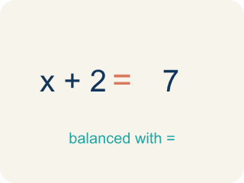
Inverse operation (Operación inversa) — Two math actions that undo each other, like × and ÷.
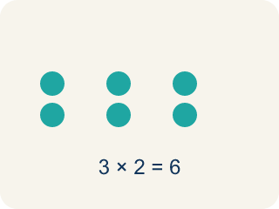
Multiply (Multiplicar) — To add equal groups again and again.
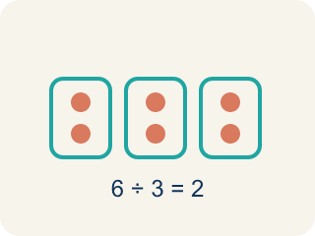
Divide (Dividir) — To split into equal groups.

Isolate (Despejar) — To get the letter by itself on one side.
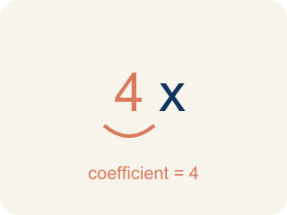
Coefficient (Coeficiente) — The number in front of a letter, like the 3 in 3x.

Solution (Solución) — A number that makes the equation or inequality true.

Practice
Show your work. Use the blank space under each problem.
1. A detective splits 54 clues equally among 9 case files. The equation 9c = 54 represents this. What is c?
A. c = 6
B. c = 63
C. c = 45
D. c = 9
______________________________________________________________________
2. Spot the Common Mistake
Step 1 (Equation): n / 4 = 12
Step 2 (Choose operation): n is in a fraction, so I will divide both sides by 4.
Step 3 (Apply to both sides): n / 4 ÷ 4 = 12 ÷ 4
Step 4 (Simplify): n = 3
Which step has the mistake? Explain and fix it:
______________________________________________________________________
______________________________________________________________________
______________________________________________________________________
3. Find the Equation Error
Step 1 (Equation): x / 5 = 12
Step 2 (Identify inverse): Inverse of division is division
Step 3 (Apply to both sides): x / 5 / 5 = 12 / 5
Step 4 (Simplify): x = 2.4
Which step has the mistake? Explain and fix it:
______________________________________________________________________
______________________________________________________________________
______________________________________________________________________
4. A bakery packed muffins into boxes of 8. They made 96 muffins total. Write an equation, solve it, and explain why your answer is reasonable. Then write a different situation that uses division and has the same answer.
Sentence starter: Equation: ___. Solving: ___. The answer ___ is reasonable because ___. A division situation with the same answer: ___.
______________________________________________________________________
______________________________________________________________________
______________________________________________________________________
______________________________________________________________________

Answer Key (Teacher)
1. A. c = 6
Divide both sides by 9: c = 54 ÷ 9 = 6 clues per file.
Watch for: A common mistake in Solve Multiplication and Division Equations is applying the SAME operation again instead of the inverse — for example, seeing 6x = 42 and multiplying both sides by 6 to get x = 252, instead of dividing by 6 to get x = 7. Before you submit, ask: did I use the OPPOSITE operation shown in the equation, and did I apply it to both sides?
2. Spot the Common Mistake
The mistake is in Step 2.
Correct work: n is divided by 4, so the inverse is MULTIPLICATION. Multiply both sides by 4: n = 12 × 4 = 48. Check: 48 ÷ 4 = 12 ✓
Watch for: Dividing again does not undo division. Since n is divided by 4, multiply both sides by 4: n = 12 × 4 = 48, and 48 ÷ 4 = 12 confirms it. The answer 3 is a clue on its own — n has to be bigger than 12, not smaller, because it was cut into fourths.
3. Find the Equation Error
The mistake is in Step 2.
Correct work: Inverse of division is MULTIPLICATION. Multiply both sides by 5: x = 12 × 5 = 60. Check: 60 / 5 = 12 ✓
Watch for: The inverse named in that step is wrong: division is undone by multiplication, not by more division. Multiply both sides by 5 to get x = 12 × 5 = 60, and 60 / 5 = 12 checks. Dividing again shrank x to 2.4, far below the 12 it was supposed to produce.
4. Open response — answers will vary.
Look for key words: 8x = 96, divide, 12, reasonable, inverse, boxes.

