8.4 Small Group · Group 2 — Homework
Lesson 8-4-group2 • Standard 6.AT.9
Name: ______________________ Period: ______ Date: ____________

Today's Goals
Content: I can write inequalities to represent real-world situations, explain what each part stands for, and build one for a situation I have not seen before.
Language: I can justify my answer to a skeptic and connect it to a second strategy or representation.

Key Words
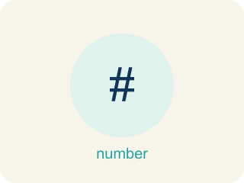
Write Inequalities (Escribir desigualdades) — Represent a range of possible values with <, >, ≤, or ≥.
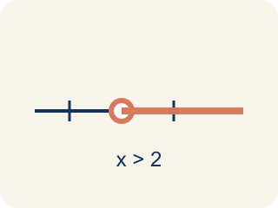
Inequality (Desigualdad) — A math sentence that compares two sides with <, >, ≤, or ≥.
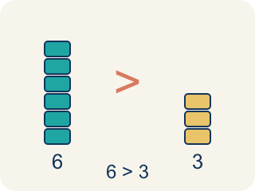
Greater than (Mayor que) — The > sign, showing one number is bigger.
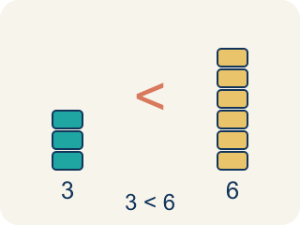
Less than (Menor que) — The < sign, showing one number is smaller.

At least / At most (Al menos / A lo más) — 'At least' means ≥. 'At most' means ≤.
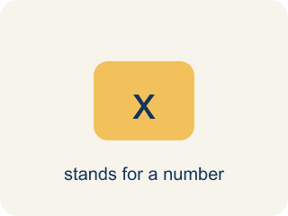
Variable (Variable) — A letter that stands for a number that is unknown or can change.

No more than (No más de) — A phrase meaning less than or equal to (≤).

Practice
Show your work. Use the blank space under each problem.
1. A parking garage charges if your stay is more than 2 hours. Which inequality represents times t that are charged?
A. t > 2
B. t ≥ 2
C. t < 2
D. t ≤ 2
______________________________________________________________________
2. Crack the Inequality Error
Step 1 (Clue): The report says no fewer than 9 witnesses saw the suspect.
Step 2 (Choose a variable): Let w stand for the number of witnesses.
Step 3 (Write the inequality): w < 9
Which step has the mistake? Explain and fix it:
______________________________________________________________________
______________________________________________________________________
______________________________________________________________________
3. Find the Inequality Error
Step 1 (Situation): No more than 25 students can join the field trip
Step 2 (Identify key phrase): 'No more than' means greater than
Step 3 (Write inequality): s > 25
Which step has the mistake? Explain and fix it:
______________________________________________________________________
______________________________________________________________________
______________________________________________________________________
4. Write two different real-world situations: one that uses > and one that uses ≥. Explain why the situations need different symbols even though both mean 'bigger.'
Sentence starter: Situation 1 (>): ___. This uses > because ___. Situation 2 (≥): ___. This uses ≥ because ___. The difference is that ≥ includes ___ while > does not.
______________________________________________________________________
______________________________________________________________________
______________________________________________________________________
______________________________________________________________________

Answer Key (Teacher)
1. A. t > 2
'More than 2 hours' means strictly greater than: t > 2. Exactly 2 hours is not charged.
Watch for: A common mistake in Write Inequalities is using a strict symbol (> or <) for a phrase that actually includes the boundary value. For 'the suspect is at least 18 years old,' students often write a > 18 instead of the correct a ≥ 18 — this wrongly excludes 18 itself, even though 'at least 18' means 18 counts as a match. The same error happens in reverse with 'at most': for 'the getaway bag holds at most 12 items,' students write n < 12 instead of n ≤ 12. Always ask: does the key phrase include the number ('at least,' 'at most,' 'no more than,' 'no fewer than' → use ≥ or ≤) or exclude it ('more than,' 'fewer than' → use > or <)?
2. Crack the Inequality Error
The mistake is in Step 3.
Correct work: 'No fewer than 9' means the count cannot drop below 9 — 9 or more witnesses is required. That is w ≥ 9, not w < 9, which would only allow numbers below 9, the opposite of what the clue says.
Watch for: The inequality step pointed the symbol the wrong way. "No fewer than 9" means the count can never drop below 9, so 9 and every larger number works: w ≥ 9. The w < 9 that was written allows only counts under 9, which is the opposite of the clue.
3. Find the Inequality Error
The mistake is in Step 2.
Correct work: 'No more than' means less than or equal to (≤), not greater than. The correct inequality is s ≤ 25.
Watch for: The key-phrase step read "no more than" as greater than, but that phrase puts a cap on the group — the number of students can never go above 25. It means "at most," so the model is s ≤ 25, which allows 25 and every smaller count.
4. Open response — answers will vary.
Look for key words: greater than, at least, equal to, included, not included, boundary.

