8.5 Small Group · Group 1 — Homework
Lesson 8-5-group1 • Standard 6.AT.9
Name: ______________________ Period: ______ Date: ____________

Today's Goals
Content: With my small group, I can graph the solutions of an inequality on a number line — one step at a time, with support.
Language: I can talk through each step out loud using a sentence frame and the lesson's key words.

Key Words
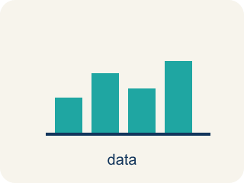
Graph Inequalities (Representar desigualdades en una recta numérica) — Show every solution to an inequality on a number line with a boundary point and an arrow.
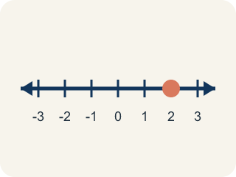
Number line (Recta numérica) — A straight line where numbers are placed in order; numbers get smaller to the left and larger to the right.
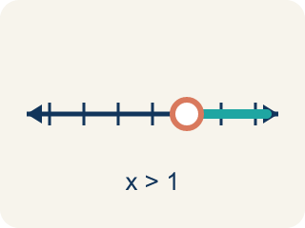
Open circle (Círculo abierto) — An empty circle showing a number is NOT included.
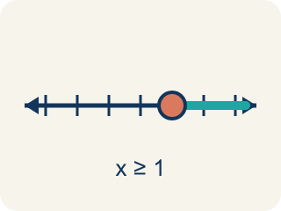
Closed circle (Círculo cerrado) — A filled-in circle showing a number IS included.
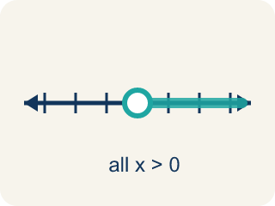
Solution set (Conjunto solución) — All the numbers that make the inequality true.
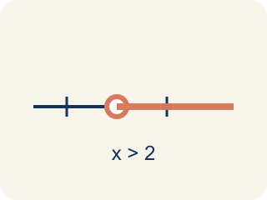
Inequality (Desigualdad) — A math sentence that compares two sides with <, >, ≤, or ≥.
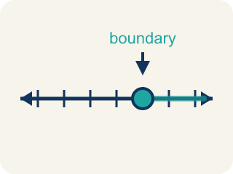
Boundary point (Punto límite) — The number on the number line where the solution set starts.

Practice
Show your work. Use the blank space under each problem.
1. Which graph represents x < 5?
A. Open circle at 5, shaded left
B. Closed circle at 5, shaded left
C. Open circle at 5, shaded right
D. Closed circle at 5, shaded right
______________________________________________________________________
2. Which graph represents x ≥ 3?
A. Closed circle at 3, shaded right
B. Open circle at 3, shaded right
C. Closed circle at 3, shaded left
D. Open circle at 3, shaded left
______________________________________________________________________
3. Clue: the witness ran more than 15 feet, so d > 15. On the number line, what do you draw?
A. Open circle at 15, shade right
B. Closed circle at 15, shade right
C. Open circle at 15, shade left
D. Closed circle at 15, shade left
______________________________________________________________________
4. Clue: the getaway car held at most 4 suspects, so s ≤ 4. How is this graphed?
A. Closed circle at 4, shade left
B. Open circle at 4, shade left
C. Closed circle at 4, shade right
D. Open circle at 4, shade right
______________________________________________________________________
5. Level 2 Extension — Crack the Graphing Mistake
Step 1 (Clue inequality): k > 19 (the loot weighed more than 19 pounds)
Step 2 (Circle type): Closed circle at 19
Step 3 (Shade direction): Shade right
Step 4 (Final graph): Closed circle at 19, shaded right
Which step has the mistake? Explain and fix it:
______________________________________________________________________
______________________________________________________________________
______________________________________________________________________
6. Find the Graphing Error
Step 1 (Inequality): x > 6
Step 2 (Circle type): Closed circle at 6
Step 3 (Shade direction): Shade right
Step 4 (Graph): Closed circle at 6, shaded right
Which step has the mistake? Explain and fix it:
______________________________________________________________________
______________________________________________________________________
______________________________________________________________________
7. A theme park has two rides. Ride A requires height h > 48 inches. Ride B requires height h ≥ 48 inches. A child is exactly 48 inches tall. Which ride can they go on? Explain using number line graphs for both inequalities.
Sentence starter: For Ride A (h > 48), the graph has a ___ circle at 48. Since 48 > 48 is ___, the child ___ ride A. For Ride B (h ≥ 48), the graph has a ___ circle at 48. Since 48 ≥ 48 is ___, the child ___ ride B.
______________________________________________________________________
______________________________________________________________________
______________________________________________________________________
______________________________________________________________________
8. Sort each inequality by the type of circle it uses on a number line.
Groups: Open circle (not included) | Closed circle (included)
______________________________________________________________________

Answer Key (Teacher)
1. A. Open circle at 5, shaded left
x < 5 means 5 is NOT included (open circle) and values less than 5 are shaded (left).
Watch for: A common mistake in Graph Inequalities is treating ≥ and ≤ the same as > and < and drawing the wrong circle. For example, students often graph x ≥ 6 with an OPEN circle (as if it were x > 6), which wrongly excludes 6 even though 6 itself makes x ≥ 6 true. A second common mistake is choosing the right circle but shading the wrong direction — for x < 9 students sometimes shade right instead of left. Always check the symbol twice: once for the circle (does it have an 'or equal to' line?) and once for the shading direction (does the symbol point toward larger or smaller numbers?).
2. A. Closed circle at 3, shaded right
x ≥ 3 means 3 IS included (closed circle) and values greater than or equal to 3 are shaded (right).
Watch for: A common mistake in Graph Inequalities is treating ≥ and ≤ the same as > and < and drawing the wrong circle. For example, students often graph x ≥ 6 with an OPEN circle (as if it were x > 6), which wrongly excludes 6 even though 6 itself makes x ≥ 6 true. A second common mistake is choosing the right circle but shading the wrong direction — for x < 9 students sometimes shade right instead of left. Always check the symbol twice: once for the circle (does it have an 'or equal to' line?) and once for the shading direction (does the symbol point toward larger or smaller numbers?).
3. A. Open circle at 15, shade right
'Greater than' (>) is a strict symbol, so 15 is NOT included — open circle. Larger values work, so shade right.
Watch for: A common mistake in Graph Inequalities is treating ≥ and ≤ the same as > and < and drawing the wrong circle. For example, students often graph x ≥ 6 with an OPEN circle (as if it were x > 6), which wrongly excludes 6 even though 6 itself makes x ≥ 6 true. A second common mistake is choosing the right circle but shading the wrong direction — for x < 9 students sometimes shade right instead of left. Always check the symbol twice: once for the circle (does it have an 'or equal to' line?) and once for the shading direction (does the symbol point toward larger or smaller numbers?).
4. A. Closed circle at 4, shade left
'Less than or equal to' (≤) includes 4 — closed circle. Smaller values work, so shade left.
Watch for: A common mistake in Graph Inequalities is treating ≥ and ≤ the same as > and < and drawing the wrong circle. For example, students often graph x ≥ 6 with an OPEN circle (as if it were x > 6), which wrongly excludes 6 even though 6 itself makes x ≥ 6 true. A second common mistake is choosing the right circle but shading the wrong direction — for x < 9 students sometimes shade right instead of left. Always check the symbol twice: once for the circle (does it have an 'or equal to' line?) and once for the shading direction (does the symbol point toward larger or smaller numbers?).
5. Level 2 Extension — Crack the Graphing Mistake
The mistake is in Step 2.
Correct work: k > 19 uses the strict symbol >, so 19 is NOT a solution. The circle must be OPEN, not closed. The shading right is correct. Final graph: open circle at 19, shaded right.
Watch for: The loot weighed MORE than 19 pounds, so 19 itself is ruled out and k > 19 needs an open circle — but the circle type step filled it in. Shading right is correct, so the finished graph is an open circle at 19 shaded right.
6. Find the Graphing Error
The mistake is in Step 2.
Correct work: x > 6 uses a strict inequality (no 'equal to'), so the circle should be OPEN, not closed. Open circle at 6, shaded right.
Watch for: The shading right matches x > 6, but the circle type step used a closed circle. Since > is strict, 6 > 6 is false and 6 is not a solution, so the graph needs an open circle at 6 shaded right.
7. Open response — answers will vary.
Look for key words: open, closed, true, false, included, not included, boundary.
8. Correct groups:

