8.5 Small Group · Group 2 — Homework
Lesson 8-5-group2 • Standard 6.AT.9
Name: ______________________ Period: ______ Date: ____________

Today's Goals
Content: I can graph the solutions of an inequality on a number line, explain what each part stands for, and build one for a situation I have not seen before.
Language: I can justify my answer to a skeptic and connect it to a second strategy or representation.

Key Words
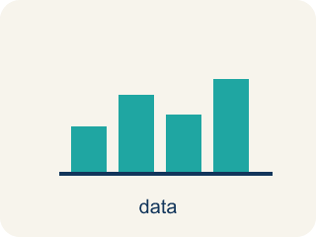
Graph Inequalities (Representar desigualdades en una recta numérica) — Show every solution to an inequality on a number line with a boundary point and an arrow.
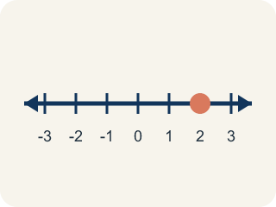
Number line (Recta numérica) — A straight line where numbers are placed in order; numbers get smaller to the left and larger to the right.
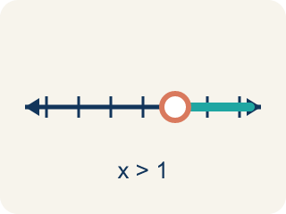
Open circle (Círculo abierto) — An empty circle showing a number is NOT included.
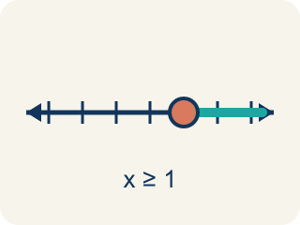
Closed circle (Círculo cerrado) — A filled-in circle showing a number IS included.
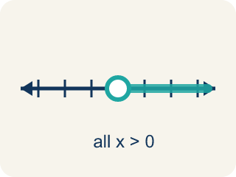
Solution set (Conjunto solución) — All the numbers that make the inequality true.
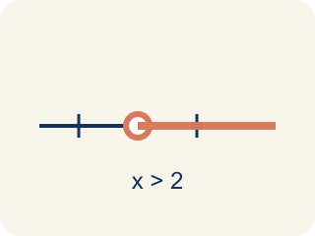
Inequality (Desigualdad) — A math sentence that compares two sides with <, >, ≤, or ≥.
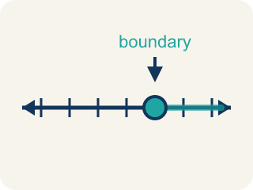
Boundary point (Punto límite) — The number on the number line where the solution set starts.

Practice
Show your work. Use the blank space under each problem.
1. A number line shows a closed circle at 8 and is shaded to the left. Which inequality does this represent?
A. x ≤ 8
B. x < 8
C. x ≥ 8
D. x > 8
______________________________________________________________________
2. Spot the Common Mistake
Step 1 (Read): The case file needs fewer than 9 clues, so c < 9. Graph it.
Step 2 (Circle choice): Open circle at 9
Step 3 (Shade direction): Shade right
Step 4 (Final graph): Open circle at 9, shaded right
Which step has the mistake? Explain and fix it:
______________________________________________________________________
______________________________________________________________________
______________________________________________________________________
3. Find the Graphing Error
Step 1 (Inequality): x > 6
Step 2 (Circle type): Closed circle at 6
Step 3 (Shade direction): Shade right
Step 4 (Graph): Closed circle at 6, shaded right
Which step has the mistake? Explain and fix it:
______________________________________________________________________
______________________________________________________________________
______________________________________________________________________
4. A theme park has two rides. Ride A requires height h > 48 inches. Ride B requires height h ≥ 48 inches. A child is exactly 48 inches tall. Which ride can they go on? Explain using number line graphs for both inequalities.
Sentence starter: For Ride A (h > 48), the graph has a ___ circle at 48. Since 48 > 48 is ___, the child ___ ride A. For Ride B (h ≥ 48), the graph has a ___ circle at 48. Since 48 ≥ 48 is ___, the child ___ ride B.
______________________________________________________________________
______________________________________________________________________
______________________________________________________________________
______________________________________________________________________

Answer Key (Teacher)
1. A. x ≤ 8
Closed circle means the value is included (≤ or ≥). Shaded left means less than or equal to: x ≤ 8.
Watch for: A common mistake in Graph Inequalities is treating ≥ and ≤ the same as > and < and drawing the wrong circle. For example, students often graph x ≥ 6 with an OPEN circle (as if it were x > 6), which wrongly excludes 6 even though 6 itself makes x ≥ 6 true. A second common mistake is choosing the right circle but shading the wrong direction — for x < 9 students sometimes shade right instead of left. Always check the symbol twice: once for the circle (does it have an 'or equal to' line?) and once for the shading direction (does the symbol point toward larger or smaller numbers?).
2. Spot the Common Mistake
The mistake is in Step 3.
Correct work: The circle choice was correct — c < 9 does not include 9, so it needs an open circle. But 'less than' means smaller values, so the shading should go LEFT toward smaller numbers, not right. Final graph: open circle at 9, shaded left.
Watch for: The open circle at 9 is correct because c < 9 leaves 9 out, but the shade direction step goes the wrong way. 'Fewer than 9 clues' means values smaller than 9, so the shading runs left, giving an open circle at 9 shaded left.
3. Find the Graphing Error
The mistake is in Step 2.
Correct work: x > 6 uses a strict inequality (no 'equal to'), so the circle should be OPEN, not closed. Open circle at 6, shaded right.
Watch for: The shading right matches x > 6, but the circle type step used a closed circle. Since > is strict, 6 > 6 is false and 6 is not a solution, so the graph needs an open circle at 6 shaded right.
4. Open response — answers will vary.
Look for key words: open, closed, true, false, included, not included, boundary.

