8.6 Small Group · Group 1 — Homework
Lesson 8-6-group1 • Standard 6.AT.8
Name: ______________________ Period: ______ Date: ____________

Today's Goals
Content: With my small group, I can solve an inequality and graph its solution set on a number line — one step at a time, with support.
Language: I can talk through each step out loud using a sentence frame and the lesson's key words.

Key Words
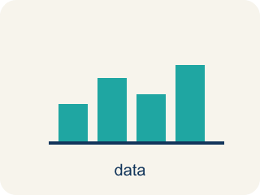
Solve and Graph Inequalities (Resolver y representar desigualdades) — Isolate the variable, then show the complete solution set on a number line.
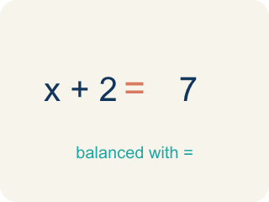
Solve (Resolver) — To find the number that makes it true.
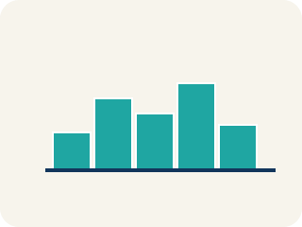
Graph (Graficar) — To show answers on a number line with circles and shading.

Solution (Solución) — A number that makes the equation or inequality true.
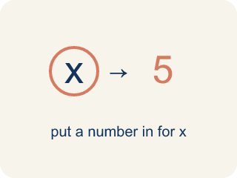
Substitute (Sustituir) — To put a number in place of a letter.
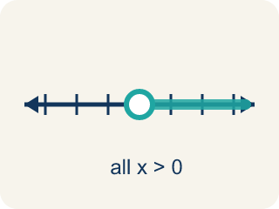
Solution set (Conjunto solución) — All the numbers that make the inequality true.

Inverse operation (Operación inversa) — Two math actions that undo each other, like × and ÷.

Practice
Show your work. Use the blank space under each problem.
1. Solve: x + 6 > 14
A. x > 8
B. x > 20
C. x < 8
D. x = 8
______________________________________________________________________
2. Solve: x − 9 ≤ 3
A. x ≤ 12
B. x ≤ 6
C. x ≥ 12
D. x = 12
______________________________________________________________________
3. Catch the Open vs. Closed Circle Mistake
Step 1 (Inequality): x − 4 ≥ 9
Step 2 (Inverse operation): Add 4 to both sides
Step 3 (Simplify): x ≥ 13
Step 4 (Graph): Open circle at 13, shade right
Which step has the mistake? Explain and fix it:
______________________________________________________________________
______________________________________________________________________
______________________________________________________________________
4. Clue 1: Which value is a solution of x > 7?
A. 9
B. 7
C. 5
D. 3
______________________________________________________________________
5. Clue 2: Is 5 a solution of x ≤ 5?
A. Yes, because 5 ≤ 5 is true
B. No, because 5 is not less than 5
C. No, because ≤ means only smaller numbers
D. Yes, but only because 5 is odd
______________________________________________________________________
6. Final gate — describe the solution set. The vault rule is x > 7. What does the solution set mean?
A. All numbers greater than 7, like 8, 9, 10, … (but NOT 7 itself)
B. Only the number 7
C. All numbers less than 7
D. Every number, including 7
______________________________________________________________________
7. Level 2 Extension — Catch the Boundary Mistake
Step 1 (Vault rule): x > 7
Step 2 (Test the boundary value): Substitute x = 7: 7 > 7
Step 3 (Rookie's conclusion): 7 > 7 is true, so 7 IS a solution and opens the gate.
Step 4 (Mark the solution set): The detective adds 7 to the list of solutions.
Which step has the mistake? Explain and fix it:
______________________________________________________________________
______________________________________________________________________
______________________________________________________________________
8. Find the Solving Error
Step 1 (Inequality): x − 8 ≥ 15
Step 2 (Inverse operation): Subtract 8 from both sides
Step 3 (Simplify): x ≥ 7
Step 4 (Graph): Closed circle at 7, shade right
Which step has the mistake? Explain and fix it:
______________________________________________________________________
______________________________________________________________________
______________________________________________________________________

Answer Key (Teacher)
1. A. x > 8
Subtract 6 from both sides: x > 14 − 6 = 8. Graph: open circle at 8, shade right.
Watch for: A common mistake in Solve and Graph Inequalities is shading the number line in the wrong direction after solving. For example, a student solves x + 4 > 10 correctly to get x > 6, but then shades LEFT toward smaller numbers instead of RIGHT toward greater numbers. The shading direction always matches the solved symbol, not the original problem: '>' and '≥' shade right (greater numbers), '<' and '≤' shade left (smaller numbers) — check this AFTER you solve, not before. To catch this mistake, substitute one shaded value and one unshaded value back into the original inequality: the shaded value should make it true, and the unshaded value should make it false.
2. A. x ≤ 12
Add 9 to both sides: x ≤ 3 + 9 = 12. Graph: closed circle at 12, shade left.
Watch for: A common mistake in Solve and Graph Inequalities is shading the number line in the wrong direction after solving. For example, a student solves x + 4 > 10 correctly to get x > 6, but then shades LEFT toward smaller numbers instead of RIGHT toward greater numbers. The shading direction always matches the solved symbol, not the original problem: '>' and '≥' shade right (greater numbers), '<' and '≤' shade left (smaller numbers) — check this AFTER you solve, not before. To catch this mistake, substitute one shaded value and one unshaded value back into the original inequality: the shaded value should make it true, and the unshaded value should make it false.
3. Catch the Open vs. Closed Circle Mistake
The mistake is in Step 4.
Correct work: The solving is correct: x ≥ 13. But the symbol ≥ means 'greater than OR equal to,' so 13 IS a solution and must be included. Use a CLOSED circle at 13 (not open), then shade right.
Watch for: The solving is correct — adding 4 to both sides gives x ≥ 13 — but the graph left the boundary out. The symbol ≥ means "greater than or equal to," so 13 is itself a solution and must be filled in: a closed circle at 13, shaded to the right.
4. A. 9
A solution makes x > 7 true. Substitute each: 9 > 7 is true, but 7 > 7, 5 > 7, and 3 > 7 are all false. So 9 is the solution that opens the gate.
Watch for: A common mistake in Solve and Graph Inequalities is shading the number line in the wrong direction after solving. For example, a student solves x + 4 > 10 correctly to get x > 6, but then shades LEFT toward smaller numbers instead of RIGHT toward greater numbers. The shading direction always matches the solved symbol, not the original problem: '>' and '≥' shade right (greater numbers), '<' and '≤' shade left (smaller numbers) — check this AFTER you solve, not before. To catch this mistake, substitute one shaded value and one unshaded value back into the original inequality: the shaded value should make it true, and the unshaded value should make it false.
5. A. Yes, because 5 ≤ 5 is true
Substitute x = 5 into x ≤ 5: 5 ≤ 5 is true because ≤ means 'less than OR equal to.' The boundary value 5 IS a solution, so the gate opens.
Watch for: A common mistake in Solve and Graph Inequalities is shading the number line in the wrong direction after solving. For example, a student solves x + 4 > 10 correctly to get x > 6, but then shades LEFT toward smaller numbers instead of RIGHT toward greater numbers. The shading direction always matches the solved symbol, not the original problem: '>' and '≥' shade right (greater numbers), '<' and '≤' shade left (smaller numbers) — check this AFTER you solve, not before. To catch this mistake, substitute one shaded value and one unshaded value back into the original inequality: the shaded value should make it true, and the unshaded value should make it false.
6. A. All numbers greater than 7, like 8, 9, 10, … (but NOT 7 itself)
The solution set is every value that makes x > 7 true. That means all numbers greater than 7, such as 8, 9, 10, and beyond. Because > does not include the boundary, 7 itself is NOT in the solution set.
Watch for: A common mistake in Solve and Graph Inequalities is shading the number line in the wrong direction after solving. For example, a student solves x + 4 > 10 correctly to get x > 6, but then shades LEFT toward smaller numbers instead of RIGHT toward greater numbers. The shading direction always matches the solved symbol, not the original problem: '>' and '≥' shade right (greater numbers), '<' and '≤' shade left (smaller numbers) — check this AFTER you solve, not before. To catch this mistake, substitute one shaded value and one unshaded value back into the original inequality: the shaded value should make it true, and the unshaded value should make it false.
7. Level 2 Extension — Catch the Boundary Mistake
The mistake is in Step 3.
Correct work: Substitute x = 7 into x > 7: this asks if 7 is greater than 7. It is NOT — 7 equals 7, it is not greater. So 7 > 7 is false, which means 7 is NOT a solution. Because the symbol is > (not ≥), the boundary value 7 is left out of the solution set. The solution set is all numbers strictly greater than 7, such as 8 and up.
Watch for: Substituting x = 7 into x > 7 asks whether 7 is greater than itself, and it is not — 7 equals 7. So 7 > 7 is false and 7 is not a solution. With the strict symbol >, the boundary is left out, and the solution set is every number above 7, starting at 8 and up.
8. Find the Solving Error
The mistake is in Step 2.
Correct work: The inverse of subtracting 8 is ADDING 8, not subtracting. Add 8 to both sides: x ≥ 15 + 8 = 23. Graph: closed circle at 23, shade right.
Watch for: The inequality shows − 8, and the inverse of subtracting is adding. Adding 8 to both sides gives x ≥ 15 + 8 = 23, not 7. The graph is a closed circle at 23 shaded to the right, since ≥ includes the boundary value.

