8.6 Small Group · Group 2 — Homework
Lesson 8-6-group2 • Standard 6.AT.8
Name: ______________________ Period: ______ Date: ____________

Today's Goals
Content: I can solve an inequality and graph its solution set on a number line, explain what each part stands for, and build one for a situation I have not seen before.
Language: I can justify my answer to a skeptic and connect it to a second strategy or representation.

Key Words
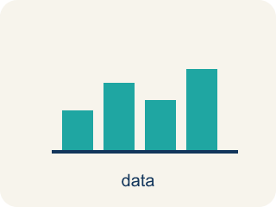
Solve and Graph Inequalities (Resolver y representar desigualdades) — Isolate the variable, then show the complete solution set on a number line.
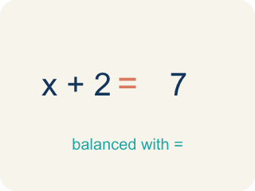
Solve (Resolver) — To find the number that makes it true.

Graph (Graficar) — To show answers on a number line with circles and shading.

Solution (Solución) — A number that makes the equation or inequality true.
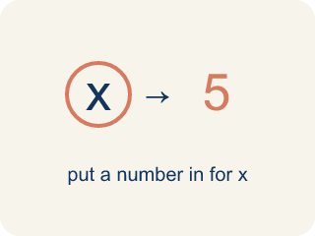
Substitute (Sustituir) — To put a number in place of a letter.
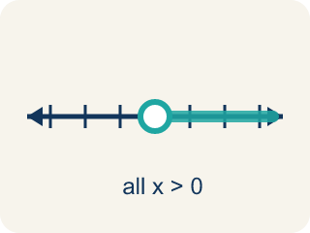
Solution set (Conjunto solución) — All the numbers that make the inequality true.

Inverse operation (Operación inversa) — Two math actions that undo each other, like × and ÷.

Practice
Show your work. Use the blank space under each problem.
1. Is x = 5 a solution to x + 4 > 12?
A. No, because 5 + 4 = 9, and 9 is not greater than 12
B. Yes, because 5 + 4 = 9
C. Yes, because 5 > 4
D. No, because 5 < 12
______________________________________________________________________
2. Catch the Open vs. Closed Circle Mistake
Step 1 (Inequality): x − 4 ≥ 9
Step 2 (Inverse operation): Add 4 to both sides
Step 3 (Simplify): x ≥ 13
Step 4 (Graph): Open circle at 13, shade right
Which step has the mistake? Explain and fix it:
______________________________________________________________________
______________________________________________________________________
______________________________________________________________________
3. Find the Solving Error
Step 1 (Inequality): x − 8 ≥ 15
Step 2 (Inverse operation): Subtract 8 from both sides
Step 3 (Simplify): x ≥ 7
Step 4 (Graph): Closed circle at 7, shade right
Which step has the mistake? Explain and fix it:
______________________________________________________________________
______________________________________________________________________
______________________________________________________________________
4. A detective has a budget of at most $100 for supplies. She already spent $37 on gloves. Write an inequality for the remaining amount r she can spend, solve it, graph it, and name three possible values for r.
Sentence starter: Inequality: 37 + r ≤ ___. Solving: r ≤ ___ − 37 = ___. Graph: ___ circle at ___, shade ___. Three possible values: ___.
______________________________________________________________________
______________________________________________________________________
______________________________________________________________________
______________________________________________________________________

Answer Key (Teacher)
1. A. No, because 5 + 4 = 9, and 9 is not greater than 12
Substitute: 5 + 4 = 9. Since 9 > 12 is false, x = 5 is NOT a solution.
Watch for: A common mistake in Solve and Graph Inequalities is shading the number line in the wrong direction after solving. For example, a student solves x + 4 > 10 correctly to get x > 6, but then shades LEFT toward smaller numbers instead of RIGHT toward greater numbers. The shading direction always matches the solved symbol, not the original problem: '>' and '≥' shade right (greater numbers), '<' and '≤' shade left (smaller numbers) — check this AFTER you solve, not before. To catch this mistake, substitute one shaded value and one unshaded value back into the original inequality: the shaded value should make it true, and the unshaded value should make it false.
2. Catch the Open vs. Closed Circle Mistake
The mistake is in Step 4.
Correct work: The solving is correct: x ≥ 13. But the symbol ≥ means 'greater than OR equal to,' so 13 IS a solution and must be included. Use a CLOSED circle at 13 (not open), then shade right.
Watch for: The solving is correct — adding 4 to both sides gives x ≥ 13 — but the graph left the boundary out. The symbol ≥ means "greater than or equal to," so 13 is itself a solution and must be filled in: a closed circle at 13, shaded to the right.
3. Find the Solving Error
The mistake is in Step 2.
Correct work: The inverse of subtracting 8 is ADDING 8, not subtracting. Add 8 to both sides: x ≥ 15 + 8 = 23. Graph: closed circle at 23, shade right.
Watch for: The inequality shows − 8, and the inverse of subtracting is adding. Adding 8 to both sides gives x ≥ 15 + 8 = 23, not 7. The graph is a closed circle at 23 shaded to the right, since ≥ includes the boundary value.
4. Open response — answers will vary.
Look for key words: 100, 63, at most, closed, left, less than or equal to, solution set.

