8.4–8.7 Catch-Up — Homework
Lesson 8-7-catchup • Standard 6.AT.8
Name: ______________________ Period: ______ Date: ____________

Today's Goals
Content: I can show I am caught up on Lessons 8.4–8.7 by using each lesson's big idea in mixed practice.
Language: I can explain which lesson's big idea I used and how, using key vocabulary from Lessons 8.4–8.7.

Key Words
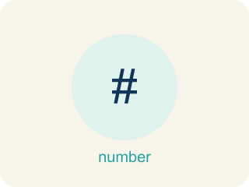
Write Inequalities (Escribir desigualdades) — Represent a range of possible values with <, >, ≤, or ≥.
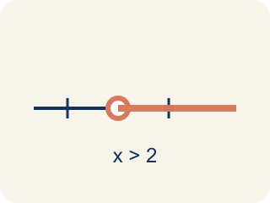
Inequality (Desigualdad) — A math sentence that compares two sides with <, >, ≤, or ≥.
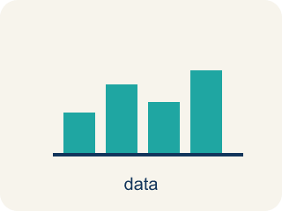
Graph Inequalities (Representar desigualdades en una recta numérica) — Show every solution to an inequality on a number line with a boundary point and an arrow.
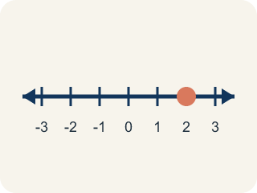
Number line (Recta numérica) — A straight line where numbers are placed in order; numbers get smaller to the left and larger to the right.

Solve and Graph Inequalities (Resolver y representar desigualdades) — Isolate the variable, then show the complete solution set on a number line.
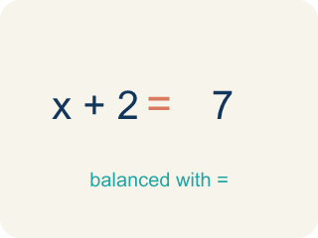
Solve (Resolver) — To find the number that makes it true.

Equations and Inequalities Problem Solving (Resolución de problemas con ecuaciones y desigualdades) — Use an equation for one exact value or an inequality for a range of values in a real situation.
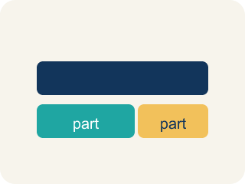
Model (Modelar) — To show a real-life situation with an equation or inequality.
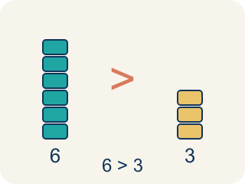
Greater than (Mayor que) — The > sign, showing one number is bigger.
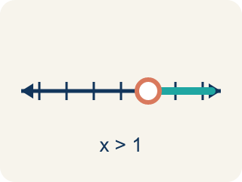
Open circle (Círculo abierto) — An empty circle showing a number is NOT included.
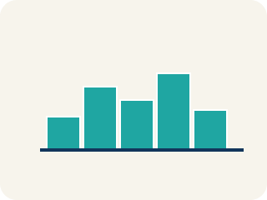
Graph (Graficar) — To show answers on a number line with circles and shading.

Equation (Ecuación) — A math sentence with an equal sign showing both sides are the same.

Practice
Show your work. Use the blank space under each problem.
1. (Lesson 8.4) Which inequality represents: 'The temperature is less than 40 degrees'?
A. t < 40
B. t > 40
C. t ≤ 40
D. t = 40
______________________________________________________________________
2. (Lesson 8.4) Which inequality represents: 'You must be at least 48 inches tall to ride'?
A. h ≥ 48
B. h > 48
C. h < 48
D. h ≤ 48
______________________________________________________________________
3. (Lesson 8.4) A parking garage charges if your stay is more than 2 hours. Which inequality represents times t that are charged?
A. t > 2
B. t ≥ 2
C. t < 2
D. t ≤ 2
______________________________________________________________________
4. (Lesson 8.4) Crack the Inequality Error
Step 1 (Clue): The report says no fewer than 9 witnesses saw the suspect.
Step 2 (Choose a variable): Let w stand for the number of witnesses.
Step 3 (Write the inequality): w < 9
Which step has the mistake? Explain and fix it:
______________________________________________________________________
______________________________________________________________________
______________________________________________________________________
5. (Lesson 8.5) A number line shows a closed circle at 8 and is shaded to the left. Which inequality does this represent?
A. x ≤ 8
B. x < 8
C. x ≥ 8
D. x > 8
______________________________________________________________________
6. (Lesson 8.5) Spot the Common Mistake
Step 1 (Read): The case file needs fewer than 9 clues, so c < 9. Graph it.
Step 2 (Circle choice): Open circle at 9
Step 3 (Shade direction): Shade right
Step 4 (Final graph): Open circle at 9, shaded right
Which step has the mistake? Explain and fix it:
______________________________________________________________________
______________________________________________________________________
______________________________________________________________________
7. (Lesson 8.6) Is x = 5 a solution to x + 4 > 12?
A. No, because 5 + 4 = 9, and 9 is not greater than 12
B. Yes, because 5 + 4 = 9
C. Yes, because 5 > 4
D. No, because 5 < 12
______________________________________________________________________
8. (Lesson 8.6) Catch the Open vs. Closed Circle Mistake
Step 1 (Inequality): x − 4 ≥ 9
Step 2 (Inverse operation): Add 4 to both sides
Step 3 (Simplify): x ≥ 13
Step 4 (Graph): Open circle at 13, shade right
Which step has the mistake? Explain and fix it:
______________________________________________________________________
______________________________________________________________________
______________________________________________________________________
9. (Lesson 8.7) A student solved 4n = 52 and got n = 13. Is the answer reasonable if n represents the number of notebooks in a box?
A. Yes — 13 notebooks per box is reasonable
B. No — 13 is too many notebooks
C. No — the answer should be 48
D. Yes — but only if n is a fraction
______________________________________________________________________
10. (Lesson 8.7) Spot the Common Mistake
Step 1 (Problem): Seven evidence lockers hold 84 case files in all, split equally. How many files per locker?
Step 2 (Model): 7f = 84
Step 3 (Solve): f = 84 − 7 = 77
Step 4 (Answer): 77 files per locker.
Which step has the mistake? Explain and fix it:
______________________________________________________________________
______________________________________________________________________
______________________________________________________________________

Answer Key (Teacher)
1. A. t < 40
'Less than' means <, so the inequality is t < 40.
Watch for: A common mistake in Equations and Inequalities Problem Solving is matching the wrong model to a key phrase. For 'the getaway car held no more than 6 bags,' students often write the equation b = 6 instead of the inequality b ≤ 6, because they see one number and assume it must be exact. The same mistake happens in reverse: for 'the reward split equally among 5 people gave each $40,' students sometimes write the inequality 5p ≥ 40 instead of the equation 5p = 40, because 'split equally' sounds like it could mean a range. Before you submit, ask: does this phrase give one exact value (equation, =) or a limit/range (inequality, <, >, ≤, ≥)?
2. A. h ≥ 48
'At least' means greater than or equal to, so h ≥ 48.
Watch for: A common mistake in Equations and Inequalities Problem Solving is matching the wrong model to a key phrase. For 'the getaway car held no more than 6 bags,' students often write the equation b = 6 instead of the inequality b ≤ 6, because they see one number and assume it must be exact. The same mistake happens in reverse: for 'the reward split equally among 5 people gave each $40,' students sometimes write the inequality 5p ≥ 40 instead of the equation 5p = 40, because 'split equally' sounds like it could mean a range. Before you submit, ask: does this phrase give one exact value (equation, =) or a limit/range (inequality, <, >, ≤, ≥)?
3. A. t > 2
'More than 2 hours' means strictly greater than: t > 2. Exactly 2 hours is not charged.
Watch for: A common mistake in Equations and Inequalities Problem Solving is matching the wrong model to a key phrase. For 'the getaway car held no more than 6 bags,' students often write the equation b = 6 instead of the inequality b ≤ 6, because they see one number and assume it must be exact. The same mistake happens in reverse: for 'the reward split equally among 5 people gave each $40,' students sometimes write the inequality 5p ≥ 40 instead of the equation 5p = 40, because 'split equally' sounds like it could mean a range. Before you submit, ask: does this phrase give one exact value (equation, =) or a limit/range (inequality, <, >, ≤, ≥)?
4. (Lesson 8.4) Crack the Inequality Error
The mistake is in Step 3.
Correct work: 'No fewer than 9' means the count cannot drop below 9 — 9 or more witnesses is required. That is w ≥ 9, not w < 9, which would only allow numbers below 9, the opposite of what the clue says.
Watch for: The inequality step pointed the symbol the wrong way. "No fewer than 9" means the count can never drop below 9, so 9 and every larger number works: w ≥ 9. The w < 9 that was written allows only counts under 9, which is the opposite of the clue.
5. A. x ≤ 8
Closed circle means the value is included (≤ or ≥). Shaded left means less than or equal to: x ≤ 8.
Watch for: A common mistake in Equations and Inequalities Problem Solving is matching the wrong model to a key phrase. For 'the getaway car held no more than 6 bags,' students often write the equation b = 6 instead of the inequality b ≤ 6, because they see one number and assume it must be exact. The same mistake happens in reverse: for 'the reward split equally among 5 people gave each $40,' students sometimes write the inequality 5p ≥ 40 instead of the equation 5p = 40, because 'split equally' sounds like it could mean a range. Before you submit, ask: does this phrase give one exact value (equation, =) or a limit/range (inequality, <, >, ≤, ≥)?
6. (Lesson 8.5) Spot the Common Mistake
The mistake is in Step 3.
Correct work: The circle choice was correct — c < 9 does not include 9, so it needs an open circle. But 'less than' means smaller values, so the shading should go LEFT toward smaller numbers, not right. Final graph: open circle at 9, shaded left.
Watch for: The open circle at 9 is correct because c < 9 leaves 9 out, but the shade direction step goes the wrong way. 'Fewer than 9 clues' means values smaller than 9, so the shading runs left, giving an open circle at 9 shaded left.
7. A. No, because 5 + 4 = 9, and 9 is not greater than 12
Substitute: 5 + 4 = 9. Since 9 > 12 is false, x = 5 is NOT a solution.
Watch for: A common mistake in Equations and Inequalities Problem Solving is matching the wrong model to a key phrase. For 'the getaway car held no more than 6 bags,' students often write the equation b = 6 instead of the inequality b ≤ 6, because they see one number and assume it must be exact. The same mistake happens in reverse: for 'the reward split equally among 5 people gave each $40,' students sometimes write the inequality 5p ≥ 40 instead of the equation 5p = 40, because 'split equally' sounds like it could mean a range. Before you submit, ask: does this phrase give one exact value (equation, =) or a limit/range (inequality, <, >, ≤, ≥)?
8. (Lesson 8.6) Catch the Open vs. Closed Circle Mistake
The mistake is in Step 4.
Correct work: The solving is correct: x ≥ 13. But the symbol ≥ means 'greater than OR equal to,' so 13 IS a solution and must be included. Use a CLOSED circle at 13 (not open), then shade right.
Watch for: The solving is correct — adding 4 to both sides gives x ≥ 13 — but the graph left the boundary out. The symbol ≥ means "greater than or equal to," so 13 is itself a solution and must be filled in: a closed circle at 13, shaded to the right.
9. A. Yes — 13 notebooks per box is reasonable
4 × 13 = 52 ✓. 13 notebooks per box is a reasonable whole number answer.
Watch for: A common mistake in Equations and Inequalities Problem Solving is matching the wrong model to a key phrase. For 'the getaway car held no more than 6 bags,' students often write the equation b = 6 instead of the inequality b ≤ 6, because they see one number and assume it must be exact. The same mistake happens in reverse: for 'the reward split equally among 5 people gave each $40,' students sometimes write the inequality 5p ≥ 40 instead of the equation 5p = 40, because 'split equally' sounds like it could mean a range. Before you submit, ask: does this phrase give one exact value (equation, =) or a limit/range (inequality, <, >, ≤, ≥)?
10. (Lesson 8.7) Spot the Common Mistake
The mistake is in Step 3.
Correct work: The variable f is multiplied by 7, so you undo it by dividing both sides by 7 (the inverse operation), not by subtracting 7. 7f = 84 becomes f = 84 ÷ 7 = 12. So there are 12 files per locker. Check: 7 × 12 = 84 ✓
Watch for: The model 7f = 84 is correct, but f is MULTIPLIED by 7, and subtracting 7 does not undo a multiplication. Divide both sides by 7 instead: f = 84 ÷ 7 = 12 files per locker. Check: 7 × 12 = 84 ✓

