8.7 Small Group · Group 1 — Homework
Lesson 8-7-group1 • Standard 6.AT.8
Name: ______________________ Period: ______ Date: ____________

Today's Goals
Content: With my small group, I can model and solve real-world problems using equations and inequalities — one step at a time, with support.
Language: I can talk through each step out loud using a sentence frame and the lesson's key words.

Key Words
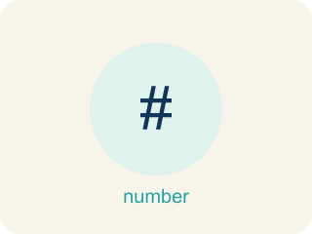
Equations and Inequalities Problem Solving (Resolución de problemas con ecuaciones y desigualdades) — Use an equation for one exact value or an inequality for a range of values in a real situation.
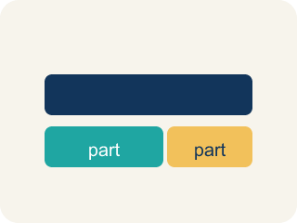
Model (Modelar) — To show a real-life situation with an equation or inequality.
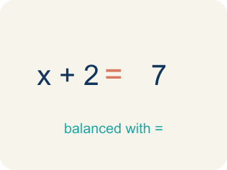
Equation (Ecuación) — A math sentence with an equal sign showing both sides are the same.
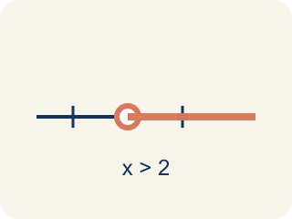
Inequality (Desigualdad) — A math sentence that compares two sides with <, >, ≤, or ≥.
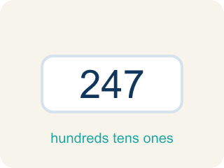
Reasonableness (Razonabilidad) — Checking if your answer makes sense.
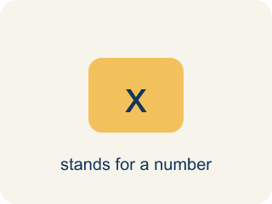
Variable (Variable) — A letter that stands for a number that is unknown or can change.

Constraint (Restricción) — A limit in a problem that tells what values are allowed.

Practice
Show your work. Use the blank space under each problem.
1. A museum has some paintings. After adding 12, they have 45. Which equation models this?
A. p + 12 = 45
B. p − 12 = 45
C. 12p = 45
D. p / 12 = 45
______________________________________________________________________
2. A detective needs more than 8 hours to finish the investigation. She has already worked 3 hours. Which inequality represents the additional hours h she needs?
A. 3 + h > 8
B. 3 + h = 8
C. h > 3
D. 8 + h > 3
______________________________________________________________________
3. Room 2: The vault keypad clue reads, 'A number of stolen coins plus 6 equals 14.' Solve x + 6 = 14 to find the code x.
A. x = 8
B. x = 20
C. x = 6
D. x = 2
______________________________________________________________________
4. Room 3: A sign warns, 'The safe holds at most 20 gold bars.' Which inequality models the number of bars x?
A. x ≤ 20
B. x ≥ 20
C. x > 20
D. x = 20
______________________________________________________________________
5. Room 4: A locked drawer clue reads, 'Five identical evidence boxes weigh 60 pounds in all.' Solve 5w = 60 for each box's weight w.
A. w = 12
B. w = 55
C. w = 300
D. w = 65
______________________________________________________________________
6. Level 2 Extension — The Final Door: Catch the Detective's Mistake
Step 1 (Clue): Solve the keypad inequality 3x ≤ 18 to find how many bars x fit.
Step 2 (Step 1): 3x ≤ 18
Step 3 (Step 2): Divide only the left side by 3: 3x ÷ 3 ≤ 18
Step 4 (Step 3): x ≤ 18
Step 5 (Answer): At most 18 bars fit.
Which step has the mistake? Explain and fix it:
______________________________________________________________________
______________________________________________________________________
______________________________________________________________________
7. Find the Problem-Solving Error
Step 1 (Problem): A parking lot holds at most 200 cars. There are 134 already. How many more can park?
Step 2 (Model): 134 + c = 200
Step 3 (Solve): c = 66
Step 4 (Answer): Exactly 66 more cars can park.
Which step has the mistake? Explain and fix it:
______________________________________________________________________
______________________________________________________________________
______________________________________________________________________
8. Create two word problems about the same situation: one that requires an equation and one that requires an inequality. Solve both and explain why the models are different.
Sentence starter: Equation problem: ___. Model: ___. Solution: ___. Inequality problem: ___. Model: ___. Solution: ___. The models are different because ___.
______________________________________________________________________
______________________________________________________________________
______________________________________________________________________
______________________________________________________________________

Answer Key (Teacher)
1. A. p + 12 = 45
'Adding 12' to the original number gives 45: p + 12 = 45. Solve: p = 33.
Watch for: A common mistake in Equations and Inequalities Problem Solving is matching the wrong model to a key phrase. For 'the getaway car held no more than 6 bags,' students often write the equation b = 6 instead of the inequality b ≤ 6, because they see one number and assume it must be exact. The same mistake happens in reverse: for 'the reward split equally among 5 people gave each $40,' students sometimes write the inequality 5p ≥ 40 instead of the equation 5p = 40, because 'split equally' sounds like it could mean a range. Before you submit, ask: does this phrase give one exact value (equation, =) or a limit/range (inequality, <, >, ≤, ≥)?
2. A. 3 + h > 8
3 hours plus additional hours h must be more than 8: 3 + h > 8. Solve: h > 5.
Watch for: A common mistake in Equations and Inequalities Problem Solving is matching the wrong model to a key phrase. For 'the getaway car held no more than 6 bags,' students often write the equation b = 6 instead of the inequality b ≤ 6, because they see one number and assume it must be exact. The same mistake happens in reverse: for 'the reward split equally among 5 people gave each $40,' students sometimes write the inequality 5p ≥ 40 instead of the equation 5p = 40, because 'split equally' sounds like it could mean a range. Before you submit, ask: does this phrase give one exact value (equation, =) or a limit/range (inequality, <, >, ≤, ≥)?
3. A. x = 8
Subtract 6 from both sides: x = 14 − 6 = 8. Check: 8 + 6 = 14 ✓
Watch for: A common mistake in Equations and Inequalities Problem Solving is matching the wrong model to a key phrase. For 'the getaway car held no more than 6 bags,' students often write the equation b = 6 instead of the inequality b ≤ 6, because they see one number and assume it must be exact. The same mistake happens in reverse: for 'the reward split equally among 5 people gave each $40,' students sometimes write the inequality 5p ≥ 40 instead of the equation 5p = 40, because 'split equally' sounds like it could mean a range. Before you submit, ask: does this phrase give one exact value (equation, =) or a limit/range (inequality, <, >, ≤, ≥)?
4. A. x ≤ 20
'At most 20' means 20 or fewer, so x ≤ 20.
Watch for: A common mistake in Equations and Inequalities Problem Solving is matching the wrong model to a key phrase. For 'the getaway car held no more than 6 bags,' students often write the equation b = 6 instead of the inequality b ≤ 6, because they see one number and assume it must be exact. The same mistake happens in reverse: for 'the reward split equally among 5 people gave each $40,' students sometimes write the inequality 5p ≥ 40 instead of the equation 5p = 40, because 'split equally' sounds like it could mean a range. Before you submit, ask: does this phrase give one exact value (equation, =) or a limit/range (inequality, <, >, ≤, ≥)?
5. A. w = 12
Divide both sides by 5: w = 60 ÷ 5 = 12 pounds. Check: 5 × 12 = 60 ✓
Watch for: A common mistake in Equations and Inequalities Problem Solving is matching the wrong model to a key phrase. For 'the getaway car held no more than 6 bags,' students often write the equation b = 6 instead of the inequality b ≤ 6, because they see one number and assume it must be exact. The same mistake happens in reverse: for 'the reward split equally among 5 people gave each $40,' students sometimes write the inequality 5p ≥ 40 instead of the equation 5p = 40, because 'split equally' sounds like it could mean a range. Before you submit, ask: does this phrase give one exact value (equation, =) or a limit/range (inequality, <, >, ≤, ≥)?
6. Level 2 Extension — The Final Door: Catch the Detective's Mistake
The mistake is in Step 3.
Correct work: Whatever you do to one side of an inequality, you must do to the OTHER side too. Dividing only the left side by 3 breaks the balance. 3x ≤ 18 becomes 3x ÷ 3 ≤ 18 ÷ 3, which gives x ≤ 6. So at most 6 bars fit, not 18.
Watch for: An inequality stays true only if both sides get exactly the same treatment. Dividing just the left side by 3 breaks that balance, which is how the impossible x ≤ 18 appeared. Dividing both sides gives 3x ÷ 3 ≤ 18 ÷ 3, so x ≤ 6 — at most 6 bars fit.
7. Find the Problem-Solving Error
The mistake is in Step 2.
Correct work: 'At most' means less than or equal to, so the model should be an inequality: 134 + c ≤ 200. Solving: c ≤ 66. Up to 66 more cars can park, not exactly 66.
Watch for: The arithmetic is fine, but the model is too strict. 'At most 200 cars' means the lot can hold 200 or fewer, which is ≤, not =. The model should be 134 + c ≤ 200, giving c ≤ 66 — up to 66 more cars can park, not exactly 66.
8. Open response — answers will vary.
Look for key words: equation, inequality, exactly, at least, at most, more than, reasonable.

