8.7 Small Group · Group 2 — Homework
Lesson 8-7-group2 • Standard 6.AT.8
Name: ______________________ Period: ______ Date: ____________

Today's Goals
Content: I can model and solve real-world problems using equations and inequalities, explain what each part stands for, and build one for a situation I have not seen before.
Language: I can justify my answer to a skeptic and connect it to a second strategy or representation.

Key Words
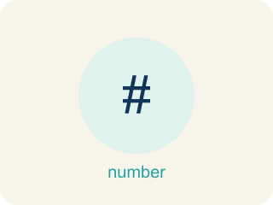
Equations and Inequalities Problem Solving (Resolución de problemas con ecuaciones y desigualdades) — Use an equation for one exact value or an inequality for a range of values in a real situation.
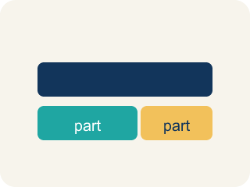
Model (Modelar) — To show a real-life situation with an equation or inequality.
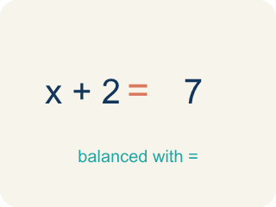
Equation (Ecuación) — A math sentence with an equal sign showing both sides are the same.
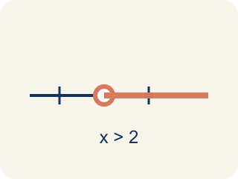
Inequality (Desigualdad) — A math sentence that compares two sides with <, >, ≤, or ≥.
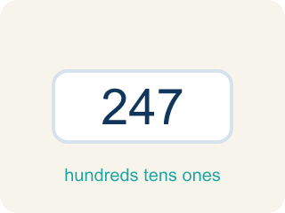
Reasonableness (Razonabilidad) — Checking if your answer makes sense.
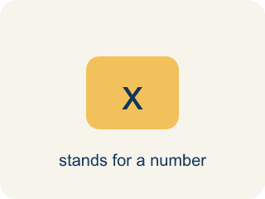
Variable (Variable) — A letter that stands for a number that is unknown or can change.

Constraint (Restricción) — A limit in a problem that tells what values are allowed.

Practice
Show your work. Use the blank space under each problem.
1. A student solved 4n = 52 and got n = 13. Is the answer reasonable if n represents the number of notebooks in a box?
A. Yes — 13 notebooks per box is reasonable
B. No — 13 is too many notebooks
C. No — the answer should be 48
D. Yes — but only if n is a fraction
______________________________________________________________________
2. Spot the Common Mistake
Step 1 (Problem): Seven evidence lockers hold 84 case files in all, split equally. How many files per locker?
Step 2 (Model): 7f = 84
Step 3 (Solve): f = 84 − 7 = 77
Step 4 (Answer): 77 files per locker.
Which step has the mistake? Explain and fix it:
______________________________________________________________________
______________________________________________________________________
______________________________________________________________________
3. Find the Problem-Solving Error
Step 1 (Problem): A parking lot holds at most 200 cars. There are 134 already. How many more can park?
Step 2 (Model): 134 + c = 200
Step 3 (Solve): c = 66
Step 4 (Answer): Exactly 66 more cars can park.
Which step has the mistake? Explain and fix it:
______________________________________________________________________
______________________________________________________________________
______________________________________________________________________
4. Create two word problems about the same situation: one that requires an equation and one that requires an inequality. Solve both and explain why the models are different.
Sentence starter: Equation problem: ___. Model: ___. Solution: ___. Inequality problem: ___. Model: ___. Solution: ___. The models are different because ___.
______________________________________________________________________
______________________________________________________________________
______________________________________________________________________
______________________________________________________________________

Answer Key (Teacher)
1. A. Yes — 13 notebooks per box is reasonable
4 × 13 = 52 ✓. 13 notebooks per box is a reasonable whole number answer.
Watch for: A common mistake in Equations and Inequalities Problem Solving is matching the wrong model to a key phrase. For 'the getaway car held no more than 6 bags,' students often write the equation b = 6 instead of the inequality b ≤ 6, because they see one number and assume it must be exact. The same mistake happens in reverse: for 'the reward split equally among 5 people gave each $40,' students sometimes write the inequality 5p ≥ 40 instead of the equation 5p = 40, because 'split equally' sounds like it could mean a range. Before you submit, ask: does this phrase give one exact value (equation, =) or a limit/range (inequality, <, >, ≤, ≥)?
2. Spot the Common Mistake
The mistake is in Step 3.
Correct work: The variable f is multiplied by 7, so you undo it by dividing both sides by 7 (the inverse operation), not by subtracting 7. 7f = 84 becomes f = 84 ÷ 7 = 12. So there are 12 files per locker. Check: 7 × 12 = 84 ✓
Watch for: The model 7f = 84 is correct, but f is MULTIPLIED by 7, and subtracting 7 does not undo a multiplication. Divide both sides by 7 instead: f = 84 ÷ 7 = 12 files per locker. Check: 7 × 12 = 84 ✓
3. Find the Problem-Solving Error
The mistake is in Step 2.
Correct work: 'At most' means less than or equal to, so the model should be an inequality: 134 + c ≤ 200. Solving: c ≤ 66. Up to 66 more cars can park, not exactly 66.
Watch for: The arithmetic is fine, but the model is too strict. 'At most 200 cars' means the lot can hold 200 or fewer, which is ≤, not =. The model should be 134 + c ≤ 200, giving c ≤ 66 — up to 66 more cars can park, not exactly 66.
4. Open response — answers will vary.
Look for key words: equation, inequality, exactly, at least, at most, more than, reasonable.

