9.1 Small Group · Group 2 — Homework
Lesson 9-1-group2 • Standard 6.AT.11
Name: ______________________ Period: ______ Date: ____________

Today's Goals
Content: I can recognize when two quantities change together, and identify which one is the independent variable and which is the dependent variable, explain how I can tell, and judge a case I have not seen before.
Language: I can justify my answer to a skeptic and connect it to a second strategy or representation.

Key Words
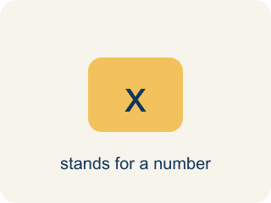
independent variable (variable independiente) — The quantity that is subject to choice. It does not depend on the other quantity.

dependent variable (variable dependiente) — The quantity that changes in response to the independent variable.

depends on (depende de) — One quantity depends on another when changing the first causes the second to change.

quantity (cantidad) — Something that can be counted or measured.
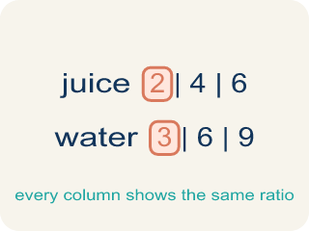
relationship (relación) — How two quantities change together.

Practice
Show your work. Use the blank space under each problem.
1. A gym charges $24.95 per month. Which pair correctly names the variables?
A. Independent: months; Dependent: total cost
B. Independent: total cost; Dependent: months
C. Independent: $24.95; Dependent: months
D. Independent: months; Dependent: $24.95
______________________________________________________________________
2. Claire jogs 30 minutes and burns 123 Calories. At the same rate, how many Calories would a 90-minute jog burn?
A. 369
B. 246
C. 410
D. 300
______________________________________________________________________
3. Which of these pairs is NOT a dependent relationship?
A. Number of pizzas sold and number of employees the shop has
B. Number of pizzas sold and weekly cost of cheese
C. Hours jogged and Calories burned
D. Tickets bought and total cost
______________________________________________________________________
4. A plant grows 2 cm for every hour of daily sunlight. Which table row is correct?
A. 4 hours to 8 cm
B. 4 hours to 6 cm
C. 4 hours to 2 cm
D. 4 hours to 4 cm
______________________________________________________________________

Answer Key (Teacher)
1. A. Independent: months; Dependent: total cost
You choose how many months to stay a member. The total cost responds to that.
Watch for: Naming the variables backward — calling the responding quantity 'independent' because it is the one the question asks about.
2. A. 369
30 minutes burned 123 Calories, and 90 is 3 times 30, so the Calories are 3 times 123, which is 369.
Watch for: Naming the variables backward — calling the responding quantity 'independent' because it is the one the question asks about.
3. A. Number of pizzas sold and number of employees the shop has
The shop has 6 employees whether it sells 5 pizzas or 500. That count does not respond to pizza sales.
Watch for: Naming the variables backward — calling the responding quantity 'independent' because it is the one the question asks about.
4. A. 4 hours to 8 cm
At 2 cm per hour, 4 hours of sunlight gives 4 times 2, which is 8 cm.
Watch for: Naming the variables backward — calling the responding quantity 'independent' because it is the one the question asks about.

