9.2 Small Group · Group 1 — Homework
Lesson 9-2-group1 • Standard 6.AT.11
Name: ______________________ Period: ______ Date: ____________

Today's Goals
Content: With my small group, I can use a table and a graph to determine and analyze the relationship between two variable quantities — one step at a time, with support.
Language: I can talk through each step out loud using a sentence frame and the lesson's key words.

Key Words
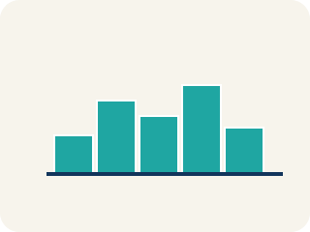
graph (gráfica) — A picture on a coordinate plane that shows how two quantities are related.
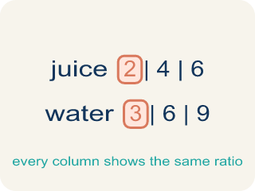
table of values (tabla de valores) — A list of matched pairs of values that shows a relationship using numbers.
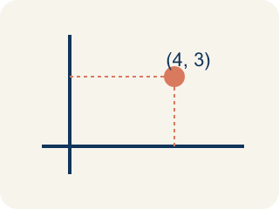
ordered pair (par ordenado) — Two numbers written as (x, y) that name one point on a graph. The independent variable comes first.
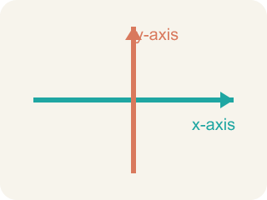
axis (eje) — One of the two number lines that frame a graph. Each axis is labeled with a quantity from the problem.

coordinates (coordenadas) — The numbers in an ordered pair that tell how far to move along each axis to reach a point.

Practice
Show your work. Use the blank space under each problem.
1. Football tickets cost $45 each. What is the total cost of 3 tickets?
A. $135
B. $48
C. $90
D. $45
______________________________________________________________________
2. Which ordered pair belongs on the ticket graph for 2 tickets?
A. (2, 90)
B. (90, 2)
C. (2, 45)
D. (2, 47)
______________________________________________________________________
3. The Sandia Peak tram travels 1,200 feet each minute and the ascent takes 15 minutes. How long is the whole ascent in feet?
A. 18,000 feet
B. 1,215 feet
C. 12,000 feet
D. 16,800 feet
______________________________________________________________________
4. On the tram graph with minutes on the horizontal axis and feet on the vertical axis, which ordered pair lies on the graph?
A. (5, 6000)
B. (6000, 5)
C. (5, 1200)
D. (5, 5000)
______________________________________________________________________
5. A table pairs hours with kilometers: (1, 48), (2, 96), (5, 240). How many kilometers are traveled each hour?
A. 48
B. 96
C. 240
D. 24
______________________________________________________________________
6. Why is the line on the football ticket graph dashed instead of solid?
A. You can only buy whole numbers of tickets, so the points between whole numbers do not make sense
B. The graph is unfinished
C. Dashed lines always mean the cost is decreasing
D. The ticket price changes between points
______________________________________________________________________
7. The ticket table and ticket graph are two representations. Which statement about them is true?
A. Both show the same relationship — the table with numerical values, the graph in a more visual way
B. The graph shows a different relationship than the table
C. Only the table can show that cost increases with tickets
D. Only the graph is a real mathematical representation
______________________________________________________________________
8. Using the ticket table, what are the coordinates of the point for 4 tickets?
A. (4, 180)
B. (4, 160)
C. (180, 4)
D. (4, 49)
______________________________________________________________________

Answer Key (Teacher)
1. A. $135
The total cost is 45 times the number of tickets, and 3 × 45 = 135.
Watch for: Reversing the coordinates of a point — writing (cost, tickets) instead of (tickets, cost). The independent variable always comes first in the ordered pair.
2. A. (2, 90)
The number of tickets goes first, and 2 tickets cost 2 × 45 = 90 dollars, so the point is (2, 90).
Watch for: Reversing the coordinates of a point — writing (cost, tickets) instead of (tickets, cost). The independent variable always comes first in the ordered pair.
3. A. 18,000 feet
The total distance is 15 × 1,200 = 18,000 feet.
Watch for: Reversing the coordinates of a point — writing (cost, tickets) instead of (tickets, cost). The independent variable always comes first in the ordered pair.
4. A. (5, 6000)
After 5 minutes the tram has traveled 5 × 1,200 = 6,000 feet, so the point is (5, 6000).
Watch for: Reversing the coordinates of a point — writing (cost, tickets) instead of (tickets, cost). The independent variable always comes first in the ordered pair.
5. A. 48
Each row is 48 times the number of hours: 2 × 48 = 96 and 5 × 48 = 240, so the rate is 48 kilometers per hour.
Watch for: Reversing the coordinates of a point — writing (cost, tickets) instead of (tickets, cost). The independent variable always comes first in the ordered pair.
6. A. You can only buy whole numbers of tickets, so the points between whole numbers do not make sense
You cannot buy 2.5 tickets, so only the whole-number points represent real purchases — the dashes show the trend without claiming the in-between points are possible.
Watch for: Reversing the coordinates of a point — writing (cost, tickets) instead of (tickets, cost). The independent variable always comes first in the ordered pair.
7. A. Both show the same relationship — the table with numerical values, the graph in a more visual way
Every row of the table is plotted as a point, so both show cost = 45 × tickets — the table numerically, the graph visually.
Watch for: Reversing the coordinates of a point — writing (cost, tickets) instead of (tickets, cost). The independent variable always comes first in the ordered pair.
8. A. (4, 180)
4 tickets cost 4 × 45 = 180 dollars, and tickets come first, so the point is (4, 180).
Watch for: Reversing the coordinates of a point — writing (cost, tickets) instead of (tickets, cost). The independent variable always comes first in the ordered pair.

