9.2 Small Group · Group 2 — Homework
Lesson 9-2-group2 • Standard 6.AT.11
Name: ______________________ Period: ______ Date: ____________

Today's Goals
Content: I can use a table and a graph to determine and analyze the relationship between two variable quantities, explain what each part stands for, and build one for a situation I have not seen before.
Language: I can justify my answer to a skeptic and connect it to a second strategy or representation.

Key Words

graph (gráfica) — A picture on a coordinate plane that shows how two quantities are related.
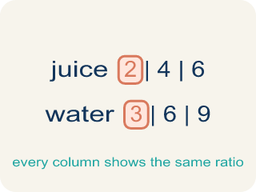
table of values (tabla de valores) — A list of matched pairs of values that shows a relationship using numbers.
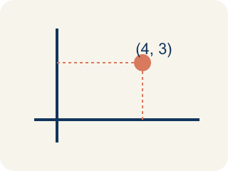
ordered pair (par ordenado) — Two numbers written as (x, y) that name one point on a graph. The independent variable comes first.
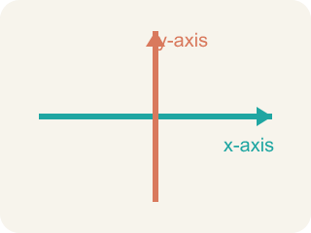
axis (eje) — One of the two number lines that frame a graph. Each axis is labeled with a quantity from the problem.

coordinates (coordenadas) — The numbers in an ordered pair that tell how far to move along each axis to reach a point.

Practice
Show your work. Use the blank space under each problem.
1. The Sandia Peak tram travels 1,200 feet each minute and the ascent takes 15 minutes. How long is the whole ascent in feet?
A. 18,000 feet
B. 1,215 feet
C. 12,000 feet
D. 16,800 feet
______________________________________________________________________
2. On the tram graph with minutes on the horizontal axis and feet on the vertical axis, which ordered pair lies on the graph?
A. (5, 6000)
B. (6000, 5)
C. (5, 1200)
D. (5, 5000)
______________________________________________________________________
3. A table pairs hours with kilometers: (1, 48), (2, 96), (5, 240). How many kilometers are traveled each hour?
A. 48
B. 96
C. 240
D. 24
______________________________________________________________________
4. Why is the line on the football ticket graph dashed instead of solid?
A. You can only buy whole numbers of tickets, so the points between whole numbers do not make sense
B. The graph is unfinished
C. Dashed lines always mean the cost is decreasing
D. The ticket price changes between points
______________________________________________________________________

Answer Key (Teacher)
1. A. 18,000 feet
The total distance is 15 × 1,200 = 18,000 feet.
Watch for: Reversing the coordinates of a point — writing (cost, tickets) instead of (tickets, cost). The independent variable always comes first in the ordered pair.
2. A. (5, 6000)
After 5 minutes the tram has traveled 5 × 1,200 = 6,000 feet, so the point is (5, 6000).
Watch for: Reversing the coordinates of a point — writing (cost, tickets) instead of (tickets, cost). The independent variable always comes first in the ordered pair.
3. A. 48
Each row is 48 times the number of hours: 2 × 48 = 96 and 5 × 48 = 240, so the rate is 48 kilometers per hour.
Watch for: Reversing the coordinates of a point — writing (cost, tickets) instead of (tickets, cost). The independent variable always comes first in the ordered pair.
4. A. You can only buy whole numbers of tickets, so the points between whole numbers do not make sense
You cannot buy 2.5 tickets, so only the whole-number points represent real purchases — the dashes show the trend without claiming the in-between points are possible.
Watch for: Reversing the coordinates of a point — writing (cost, tickets) instead of (tickets, cost). The independent variable always comes first in the ordered pair.

