9.3 Small Group · Group 1 — Homework
Lesson 9-3-group1 • Standard 6.AT.11
Name: ______________________ Period: ______ Date: ____________

Today's Goals
Content: With my small group, I can write an equation from a table or a graph to model the relationship between the dependent and independent variables — one step at a time, with support.
Language: I can talk through each step out loud using a sentence frame and the lesson's key words.

Key Words
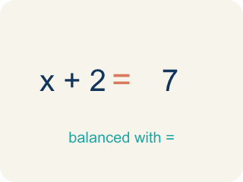
equation (ecuación) — A mathematical sentence with an equals sign that shows two amounts are the same.
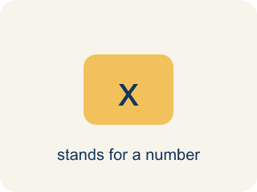
variable (variable) — A letter that represents a quantity that can change, or vary.
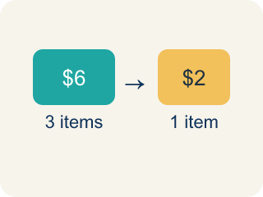
rate (tasa) — A fixed amount of one quantity for every one unit of the other quantity.
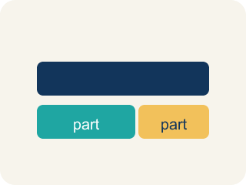
represent (representar) — To show a relationship using a tool such as a table, a graph, or an equation.

define the variables (definir las variables) — To state exactly what quantity each letter in an equation stands for.

Practice
Show your work. Use the blank space under each problem.
1. Recreation World charges $24.95 per month. What is the total cost of 2 months of membership?
A. $49.90
B. $26.95
C. $24.95
D. $74.85
______________________________________________________________________
2. In the equation c = 24.95m for the gym membership, what does m represent?
A. The number of months of membership
B. The total cost in dollars
C. The monthly fee of $24.95
D. The name of the gym
______________________________________________________________________
3. Using c = 24.95m, what is the total cost of 10 months of membership?
A. $249.50
B. $34.95
C. $224.55
D. $2,495.00
______________________________________________________________________
4. Using c = 15h, what is the total cost of a 5-hour canoe rental?
A. $75
B. $20
C. $60
D. $80
______________________________________________________________________
5. A table pairs months with total cost: (1, 24.95), (2, 49.90), (4, 99.80). Which equation matches the table, with m = months and c = cost?
A. c = 24.95m
B. c = m + 24.95
C. c = 49.90m
D. m = 24.95 + c
______________________________________________________________________
6. On the canoe graph with hours on the horizontal axis and cost on the vertical axis, which point lies on the graph?
A. (4, 60)
B. (60, 4)
C. (4, 19)
D. (4, 55)
______________________________________________________________________
7. The friends have $90 to spend. Using c = 15h, for how many hours can they rent the canoe?
A. 6 hours
B. 5 hours
C. 75 hours
D. 1,350 hours
______________________________________________________________________
8. How are the canoe graph and the equation c = 15h related?
A. Every point on the graph is a pair (h, c) that makes the equation true
B. The graph and the equation show different relationships
C. The equation only works for the points shown on the graph
D. The graph replaces the equation, so only one can be used
______________________________________________________________________

Answer Key (Teacher)
1. A. $49.90
Two months at $24.95 each is 2 × 24.95 = 49.90.
Watch for: Writing the equation with addition — c = 24.95 + m — instead of multiplication. The fee is charged EVERY month, so the total is the rate times the number of months; always test the equation against a row of the table.
2. A. The number of months of membership
m stands for the quantity Miguel chooses — the number of months. The letter c stands for the total cost that results.
Watch for: Writing the equation with addition — c = 24.95 + m — instead of multiplication. The fee is charged EVERY month, so the total is the rate times the number of months; always test the equation against a row of the table.
3. A. $249.50
Substitute m = 10: c = 24.95 × 10 = 249.50.
Watch for: Writing the equation with addition — c = 24.95 + m — instead of multiplication. The fee is charged EVERY month, so the total is the rate times the number of months; always test the equation against a row of the table.
4. A. $75
Substitute h = 5: c = 15 × 5 = 75.
Watch for: Writing the equation with addition — c = 24.95 + m — instead of multiplication. The fee is charged EVERY month, so the total is the rate times the number of months; always test the equation against a row of the table.
5. A. c = 24.95m
Test each row: 24.95 × 1 = 24.95, 24.95 × 2 = 49.90, and 24.95 × 4 = 99.80 — every row fits c = 24.95m.
Watch for: Writing the equation with addition — c = 24.95 + m — instead of multiplication. The fee is charged EVERY month, so the total is the rate times the number of months; always test the equation against a row of the table.
6. A. (4, 60)
4 hours cost 4 × 15 = 60 dollars, and hours come first, so the point is (4, 60).
Watch for: Writing the equation with addition — c = 24.95 + m — instead of multiplication. The fee is charged EVERY month, so the total is the rate times the number of months; always test the equation against a row of the table.
7. A. 6 hours
Solve 15h = 90 by dividing both sides by 15: h = 90 ÷ 15 = 6.
Watch for: Writing the equation with addition — c = 24.95 + m — instead of multiplication. The fee is charged EVERY month, so the total is the rate times the number of months; always test the equation against a row of the table.
8. A. Every point on the graph is a pair (h, c) that makes the equation true
The graph is a picture of the equation: each point (h, c) on it satisfies c = 15h, like (3, 45) and (5, 75).
Watch for: Writing the equation with addition — c = 24.95 + m — instead of multiplication. The fee is charged EVERY month, so the total is the rate times the number of months; always test the equation against a row of the table.

