9.3 Small Group · Group 2 — Homework
Lesson 9-3-group2 • Standard 6.AT.11
Name: ______________________ Period: ______ Date: ____________

Today's Goals
Content: I can write an equation from a table or a graph to model the relationship between the dependent and independent variables, explain what each part stands for, and build one for a situation I have not seen before.
Language: I can justify my answer to a skeptic and connect it to a second strategy or representation.

Key Words
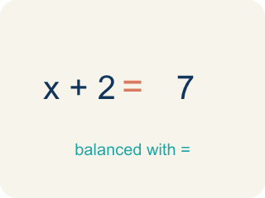
equation (ecuación) — A mathematical sentence with an equals sign that shows two amounts are the same.
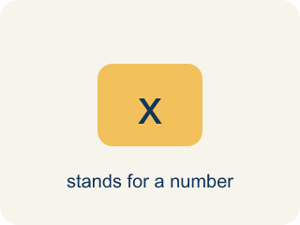
variable (variable) — A letter that represents a quantity that can change, or vary.
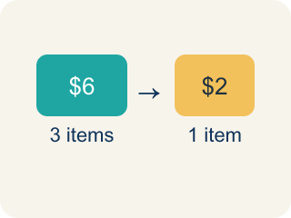
rate (tasa) — A fixed amount of one quantity for every one unit of the other quantity.
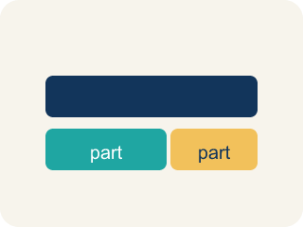
represent (representar) — To show a relationship using a tool such as a table, a graph, or an equation.

define the variables (definir las variables) — To state exactly what quantity each letter in an equation stands for.

Practice
Show your work. Use the blank space under each problem.
1. Using c = 24.95m, what is the total cost of 10 months of membership?
A. $249.50
B. $34.95
C. $224.55
D. $2,495.00
______________________________________________________________________
2. Using c = 15h, what is the total cost of a 5-hour canoe rental?
A. $75
B. $20
C. $60
D. $80
______________________________________________________________________
3. A table pairs months with total cost: (1, 24.95), (2, 49.90), (4, 99.80). Which equation matches the table, with m = months and c = cost?
A. c = 24.95m
B. c = m + 24.95
C. c = 49.90m
D. m = 24.95 + c
______________________________________________________________________
4. On the canoe graph with hours on the horizontal axis and cost on the vertical axis, which point lies on the graph?
A. (4, 60)
B. (60, 4)
C. (4, 19)
D. (4, 55)
______________________________________________________________________

Answer Key (Teacher)
1. A. $249.50
Substitute m = 10: c = 24.95 × 10 = 249.50.
Watch for: Writing the equation with addition — c = 24.95 + m — instead of multiplication. The fee is charged EVERY month, so the total is the rate times the number of months; always test the equation against a row of the table.
2. A. $75
Substitute h = 5: c = 15 × 5 = 75.
Watch for: Writing the equation with addition — c = 24.95 + m — instead of multiplication. The fee is charged EVERY month, so the total is the rate times the number of months; always test the equation against a row of the table.
3. A. c = 24.95m
Test each row: 24.95 × 1 = 24.95, 24.95 × 2 = 49.90, and 24.95 × 4 = 99.80 — every row fits c = 24.95m.
Watch for: Writing the equation with addition — c = 24.95 + m — instead of multiplication. The fee is charged EVERY month, so the total is the rate times the number of months; always test the equation against a row of the table.
4. A. (4, 60)
4 hours cost 4 × 15 = 60 dollars, and hours come first, so the point is (4, 60).
Watch for: Writing the equation with addition — c = 24.95 + m — instead of multiplication. The fee is charged EVERY month, so the total is the rate times the number of months; always test the equation against a row of the table.

