9.4 Small Group · Group 2 — Homework
Lesson 9-4-group2 • Standard 6.AT.11
Name: ______________________ Period: ______ Date: ____________

Today's Goals
Content: I can write an equation to represent the relationship between two variable quantities and use it to solve a real problem, explain what each part stands for, and build one for a situation I have not seen before.
Language: I can justify my answer to a skeptic and connect it to a second strategy or representation.

Key Words
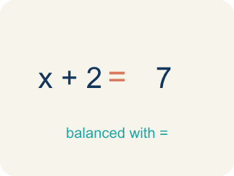
solution (solución) — A value of the variable that makes an equation true.
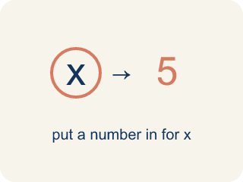
substitute (sustituir) — To replace a variable with a number so you can compute.
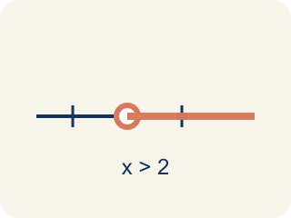
at least (al menos) — That amount or more — the smallest amount that still works.
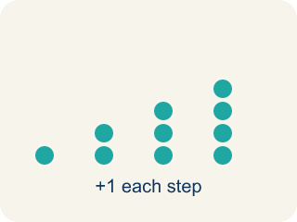
predict (predecir) — To make a reasonable guess about a future amount using information you already have.

justify (justificar) — To explain WHY an answer or recommendation makes sense, using the mathematics.

Practice
Show your work. Use the blank space under each problem.
1. The order requires 1,000 cars. Using 2.5h = 1,000, how many hours will the plant need?
A. 400 hours
B. 2,500 hours
C. 997.5 hours
D. 40 hours
______________________________________________________________________
2. The plant needs 400 hours to fill the order. Running 24 hours a day, about how many days is that?
A. About 17 days
B. 400 days
C. 50 days
D. 4 days
______________________________________________________________________
3. The goal is $500 at $12 per car. Using 12n = 500, at least how many cars must be washed?
A. 42 cars
B. 41 cars
C. 40 cars
D. 50 cars
______________________________________________________________________
4. Can the student council wash 41 cars at $12 each and meet the $500 goal?
A. No — 41 cars raise $492, which is less than $500
B. Yes — 41 cars raise $502
C. Yes — 41 rounds up to 42, so it counts
D. No — 41 cars raise $412
______________________________________________________________________

Answer Key (Teacher)
1. A. 400 hours
Divide both sides by 2.5: h = 1,000 ÷ 2.5 = 400 hours.
Watch for: Adding the rate instead of multiplying — writing 2.5 + 8 = 10.5 cars for an 8-hour shift instead of 2.5 × 8 = 20. The rate applies to EVERY hour, so the total is always rate × amount.
2. A. About 17 days
Divide the hours by the hours in a day: 400 ÷ 24 ≈ 16.7, which is about 17 days — about 2.5 weeks.
Watch for: Adding the rate instead of multiplying — writing 2.5 + 8 = 10.5 cars for an 8-hour shift instead of 2.5 × 8 = 20. The rate applies to EVERY hour, so the total is always rate × amount.
3. A. 42 cars
500 ÷ 12 is about 41.7, and you cannot wash a fraction of a car, so round UP: 42 cars raise 42 × 12 = $504, which meets the goal.
Watch for: Adding the rate instead of multiplying — writing 2.5 + 8 = 10.5 cars for an 8-hour shift instead of 2.5 × 8 = 20. The rate applies to EVERY hour, so the total is always rate × amount.
4. A. No — 41 cars raise $492, which is less than $500
41 × 12 = 492, and $492 < $500, so 41 cars fall $8 short.
Watch for: Adding the rate instead of multiplying — writing 2.5 + 8 = 10.5 cars for an 8-hour shift instead of 2.5 × 8 = 20. The rate applies to EVERY hour, so the total is always rate × amount.

