Name Date Period
Lesson 4-1 · Session 1 · Explain Your Thinking

Percent Means Per Hundred
Study the model. Then solve your own problem the same way. Use only the help you need.
WORDS percent (por ciento) · decimal grid (cuadrícula decimal) · equivalent ratio (razón equivalente)

1 · SEE A MODEL read it with a partner
SEE A MODEL a problem like yours, solved
A garden has 20 plants. 8 of them are tomato plants. What percent of the plants are tomatoes?
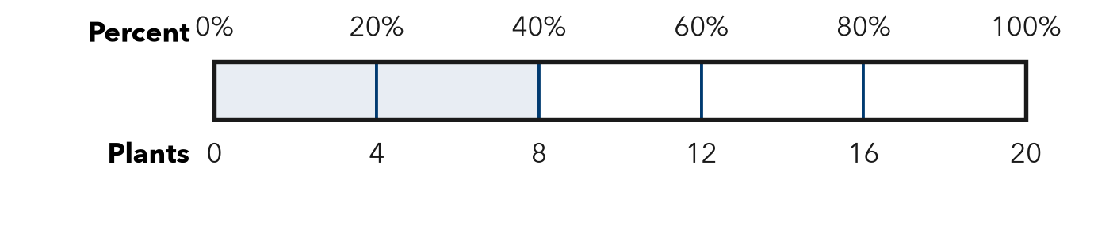
HOW I SOLVED IT  1 Name the whole. All 20 plants = 100%.  2 Find one part. 5 equal parts: 20 ÷ 5 = 4 plants, and 100% ÷ 5 = 20%.  3 Count parts. 8 plants fill 2 parts. 2 × 20% = 40%. | I SAY  “The whole is 20 plants, so each part is 20%. 8 plants fill 2 parts, so 40% are tomatoes.”  I WRITE  I know the whole is 20 plants because the garden has 20 plants in all. Each part of the bar is 20%, so 8 plants is 2 × 20% = 40%.

2 · DRAW IT your turn: label the whole, the part and the percent
A team finished 9 of 12 challenges at field day. Use the bar to show what percent of the challenges they finished.
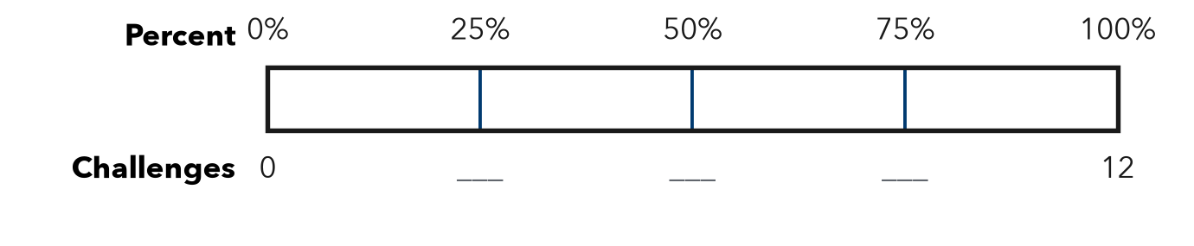
TRY THESE STEPS fill in the blanks as you work
1 Name the whole: challenges = 100%.
2 Find one part: 12 ÷ 4 = challenges = %.
3 Count the parts that 9 challenges fill.

3 · SAY IT tell a partner
Partner A: “The whole is challenges, so each part is %.” Partner B: “9 challenges fill parts, so the team finished %.”

4 · WRITE IT pick a starter · name the whole · use units
WORD BANK the whole · each part · equal parts · fill · out of · percent
Because I know the whole is because .
But Some students think 9 of 12 is 9%, but .
So Each part of the bar is %, so .
Name Date Period
Lesson 4-1 · Session 2 · Explain Your Thinking

Percents Greater Than 100%
Study the model. Then solve your own problem the same way. Use only the help you need.
WORDS the whole (el entero) · times as much (veces tanto como) · greater than 100% (mayor que 100%)

1 · SEE A MODEL read it with a partner
SEE A MODEL a problem like yours, solved
A puppy weighs 10 pounds. Its mother weighs 25 pounds. The mother’s weight is what percent of the puppy’s weight?
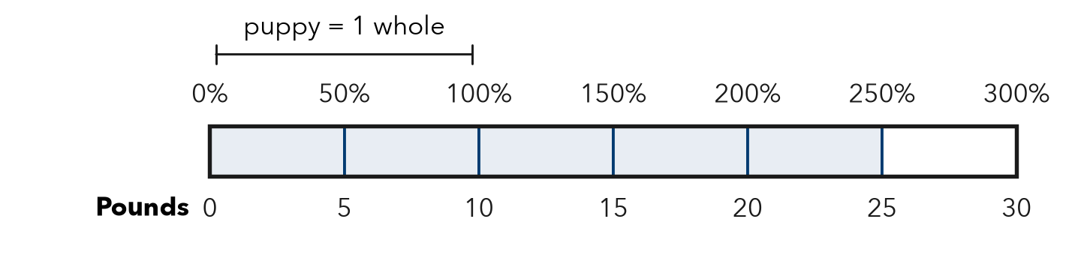
HOW I SOLVED IT  1 Name the whole. The puppy, 10 pounds = 100%.  2 Find one part. 10 pounds is 2 parts, so 1 part = 5 pounds = 50%.  3 Count parts. 25 pounds fills 5 parts: 5 × 50% = 250%. | I SAY  “The whole is 10 pounds, so each part is 50%. 25 pounds fills 5 parts, so it is 250%, more than 100%.”  I WRITE  I know the puppy is the whole because we compare the mother to the puppy. She weighs more than one whole, so her weight is 250%.

2 · DRAW IT your turn: label the whole, the part and the percent
A gray kitten weighs 8 ounces. Its brother weighs 14 ounces. Use the bar to show the brother’s weight as a percent of the gray kitten’s weight.
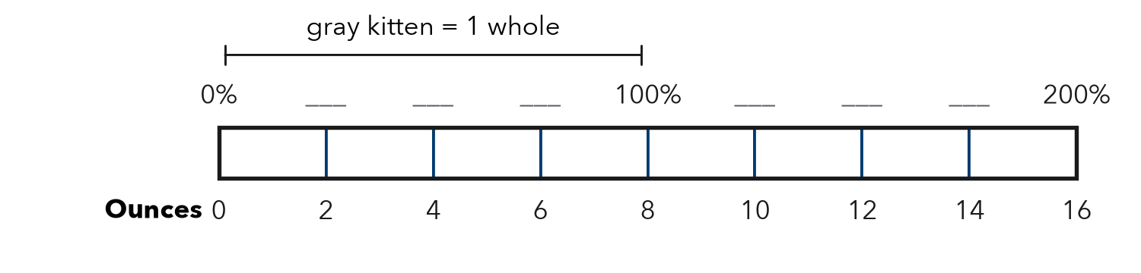
TRY THESE STEPS fill in the blanks as you work
1 Name the whole: the gray kitten, ounces = 100%.
2 Find one part: 8 ÷ 4 = ounces = %.
3 Count the parts that 14 ounces fills.

3 · SAY IT tell a partner
Partner A: “The whole is ounces, so each part is %.” Partner B: “14 ounces fills parts, so it is %, more than 100%.”

4 · WRITE IT pick a starter · name the whole · use units
WORD BANK the whole · compare to · more than 100% · one whole · times as much · each part
Because I know is the whole because .
But Some students think a percent cannot be more than 100%, but .
So The brother weighs more than one whole, so .

