Name Date Period
Lesson 4-4 · Session 1 · Explain Your Thinking

Find the Percent of a Number
Study the model. Then solve your own problem the same way. Use only the help you need.
WORDS part (parte) · whole (entero) · equation (ecuación)

1 · SEE A MODEL read it with a partner
SEE A MODEL a problem like yours, solved
A shelf has 240 books. 45% of them are mysteries. Use the percent bar and an equation to find how many books are mysteries.
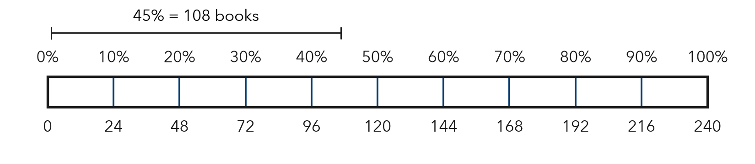
HOW I SOLVED IT  1 Find 10%. 240 ÷ 10 = 24 books.  2 Build 45%. 40% = 4 × 24 = 96. 5% = half of 24 = 12. 96 + 12 = 108 books.  3 Check with an equation. 0.45 × 240 = 108. 108 is less than half of 240 (120), so it makes sense. | I SAY  “The whole is 240. 10% of it is 24, so 45% is 108.” “Check: 0.45 × 240 = 108.”  I WRITE  I know 45% of 240 is 108 because 10% is 24, so 40% is 96, and 5% is 12; 96 + 12 = 108.

2 · DRAW IT your turn: label the whole, the part and the percent
A theater has 360 seats. 35% of the seats are in the balcony. Use the percent bar and an equation to find how many seats are in the balcony.
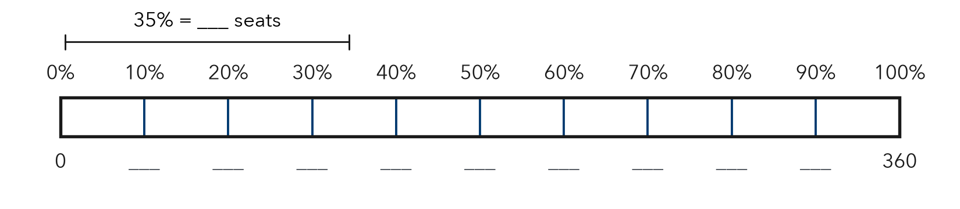
TRY THESE STEPS fill in the blanks as you work
1 Find 10% of 360: 360 ÷ 10 = .
2 Build 35%: 30% = and 5% = . Add them.
3 Check: 0.35 × 360 = .

3 · SAY IT tell a partner
Partner A: “The whole is . 10% of it is , so 35% is .” Partner B: “Check with an equation: × = . Is the part less than the whole?”

4 · WRITE IT pick a starter · name the whole · use units
WORD BANK 10% of · half of · the whole · the part · equation · less than half
Because I know 35% of 360 is because .
But Some students multiply 35 × 360, but .
So 35% is less than half of the whole, so .
Name Date Period
Lesson 4-4 · Session 2 · Explain Your Thinking

Compare Percents
Study the model. Then solve your own problem the same way. Use only the help you need.
WORDS part-to-whole ratio (razón de parte al entero) · common whole (entero común) · compare (comparar)

1 · SEE A MODEL read it with a partner
SEE A MODEL a problem like yours, solved
Ana got 21 of 30 quiz points. Ben got 18 of 20. Ana got more points. Who did better on the quiz?
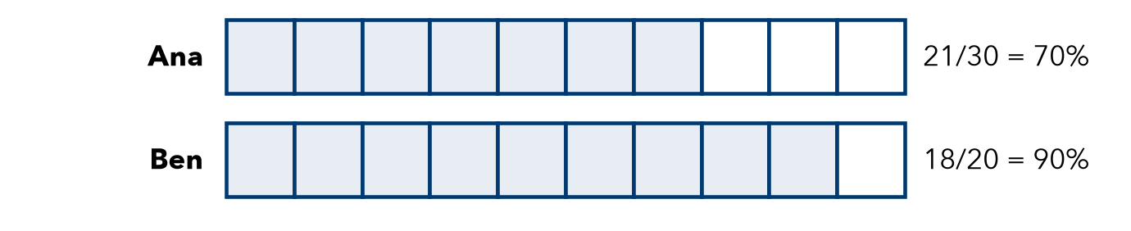
HOW I SOLVED IT  1 Ana. 21/30 = 7/10 = 70/100 = 70%. Shade 7 of 10 parts.  2 Ben. 18/20 = 9/10 = 90/100 = 90%. Shade 9 of 10 parts.  3 Compare percents. 90% > 70%, so Ben did better, even with fewer points. | I SAY  “21 out of 30 is 70%, and 18 out of 20 is 90%.” “The bigger count does not decide it, because the wholes are different.”  I WRITE  The two wholes are different, so I compare percents: 90% > 70%, so Ben did better.

2 · DRAW IT your turn: label the whole, the part and the percent
Kira made 36 of 60 free throws. Dev made 32 of 40. Kira made more. Shade each bar to show each percent. Who is the better shooter?
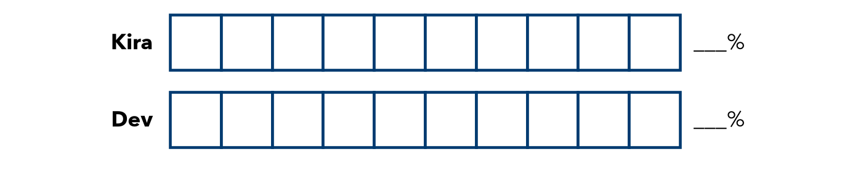
TRY THESE STEPS fill in the blanks as you work
1 Kira: 36/60 = /10 = %.
2 Dev: 32/40 = /10 = %.
3 Shade each bar, then compare the percents.

3 · SAY IT tell a partner
Partner A: “ out of is %, and out of is %.” Partner B: “So who did better? Why doesn’t the bigger count decide it?”

4 · WRITE IT pick a starter · name the whole · use units
WORD BANK out of · the whole · different wholes · compare · greater than (>) · better
Because I know is the better shooter because % > %.
But Some students think is better because , but .
So The two wholes are different, so .

