UNIT 2 · LESSON 10 STANDARD 6.DS.6D

Choose Appropriate Measures
Student Notes Packet
Name: ______________________ Date: ____________ Period: ________
Level 2 · Standard

Today's Goals
Content: I can choose the best measure of center for a data set based on its shape.
Language: I can explain my choice using the words mean, median, outlier, and skewed.

Key Vocabulary
Look at the picture, read the word, then read what it means.
 | Appropriate Measures of Center Medidas de centro apropiadas  A mean, median, or mode chosen because it describes a data set fairly.  Example: Use the median when an outlier would pull the mean too far.
 | Mean Media  The average. Add all the numbers, then divide by how many there are.  Example: Mean of 10, 20, 30 = (10+20+30) ÷ 3 = 20
 | Median Mediana  The middle number when you put them in order.  Example: Data: 5, 8, 12, 15, 20 → median is 12 (the 3rd of 5 values)
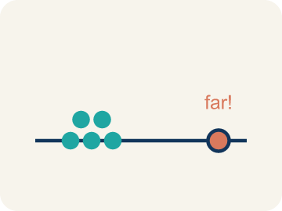 | Outlier Valor atípico  A number that is much bigger or smaller than the rest.  Example: Data: 12, 14, 13, 15, 45 → 45 is far from the cluster, so it is an outlier
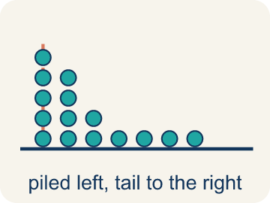 | Skewed Sesgado  When most data sits on one side with a tail on the other.  Example: Scores: 5, 6, 7, 8, 8, 35 → most scores are low, but 35 creates a tail to the right (skewed right)
 | Data distribution Distribución de datos  How the data looks: where it sits and how spread out it is.  Example: Symmetric = even on both sides. Skewed = bunched on one side with a tail
 | Variability Variabilidad  How spread out the numbers are.  Example: 88, 90, 89, 91 (low variability) vs. 50, 70, 95, 100 (high variability)
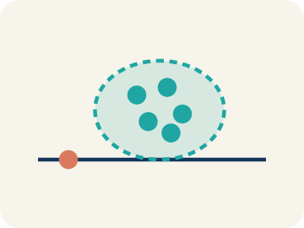 | Cluster Grupo  Values bunched close together in one part of a display.  Example: Values packed near 3 on the dot plot.
 | Gap Brecha  A space on a display where no data values fall.  Example: Nothing between 11 and 32 on the number line.

Guided Notes
Fill in each blank as we go. Use the Word Bank to help you.
WORD BANK
Appropriate Measures of Center • Mean • Median • Outlier • Skewed • Data distribution • Variability • Cluster • Gap

1. A center chosen because it describes the data fairly is an ________________ ________________ ________________ ________________.
2. The average of a data set is the ________________.
3. The middle value when data is in order, often best when there is an outlier, is the ________________.
4. A value far from the rest of the data, which can pull the mean, is an ________________.
5. Data that is bunched on one side with a tail on the other is ________________.
6. The way data values are spread out is the ________________.
7. How much the data values differ is the ________________.
8. Values bunched close together in one spot form a ________________.
9. A space where no values fall on a display is a ________________.

Write About the Math
Is $85 a fair way to describe a 'typical' ticket price? What measure should the reporter use?
¿$85 es una manera justa de describir un precio de boleto «típico»? ¿Qué medida debería usar el reportero?
Say your answer to a partner first. Then write it, using at least two of these words:
☐ Mean · Media
☐ Median · Mediana
☐ Outlier · Valor atípico
☐ Skewed · Sesgado
☐ Data distribution · Distribución de datos
Model: Data with an outlier or a skewed shape is better summarized by the median. — A strong answer says the presence of an outlier or skew signals the median, while symmetric data with no outliers fits the mean.

Start Most language support
Complete the frames. Use the word bank.
Completa las oraciones. Usa el banco de palabras.
The reporter used the ___, which is ___. A better measure would be the ___ (about ___) because ___. The courtside seat at $260 is an ___ that pulls the mean ___.
My answer is ___ because ___.
Mi respuesta es ___ porque ___.

Build Some language support
Write two connected sentences. Use because, so, or but.
Escribe dos oraciones conectadas. Usa porque, entonces o pero.
My claim is ___.
Mi afirmación es ___.
My evidence is ___, so ___.
Mi evidencia es ___, entonces ___.

Explain Light language support
Write a claim, give math evidence, and explain your reasoning.
Escribe una afirmación, da evidencia matemática y explica tu razonamiento.

Check Your Explanation three quick checks
☐ I answered the question.
☐ I used math evidence: numbers, an equation, or a model.
☐ I used at least two math words.

Worked Example

Watch & Read I Do — follow along with your teacher
Teaching Experience
The students want to describe the data they collected about the number of years of teaching experience of the teachers in their school. Which measure of center and measure of variation should they use to summarize the data set?

Think about:
• How does the 58-point game compare to the other scores?
• What is the mean? What is the median?
• Which measure is closer to what this player usually scores?
• When does an outlier make the mean misleading?
• Is there a rule for when to use mean vs. median?

Solved Example I Do — watch each step
Problem: A gymnast's scores are: 8.5, 8.8, 8.7, 8.6, 8.9. There are no outliers. Which measure best represents a typical score?
A) Median
B) Neither — the data is too small
C) Both are equally bad
D) Mean
Step 1: The data is symmetric with no outliers, so the mean (8.7) best represents the typical score.
Answer: D. Mean

Guided Practice

Solve Together We Do — work with your class
Problem: A runner's mile times are: 7:10, 7:15, 7:12, 7:20, 12:00. The 12:00 was due to a cramp. Which measure best represents a typical mile?
A) Mean — it uses all the data
B) Median — the outlier 12:00 pulls the mean too high
C) Mode — it shows the most common time
D) Neither measure works
Step 1:

Step 2:

Answer:

A sports reporter writes: 'The average ticket price for the playoffs is $85.' The actual prices are: $45, $50, $48, $52, $55, $260. The $260 ticket is a courtside seat.
Is $85 a fair way to describe a 'typical' ticket price? What measure should the reporter use?

Sentence frame: The reporter used the ___, which is ___. A better measure would be the ___ (about ___) because ___. The courtside seat at $260 is an ___ that pulls the mean ___.

Turn & Talk discuss with a partner
1. [Launch] The students collected years of teaching experience. What would make you choose the median instead of the mean to describe this data?
2. [Explore] As you sort scenarios into 'Use Mean' or 'Use Median,' what clue tells you a data set needs the median instead of the mean?
Start with: I use the median when the data has ___.
Uso la mediana cuando los datos tienen ___.
Word bank: mean, median, outlier, skewed, measure of center
3. [Connect] A reporter writes 'the average playoff ticket is $85,' but prices are $45, $50, $48, $52, $55, $260. Is $85 a fair 'typical' price? What measure should the reporter use?
Start with: $85 is / is not fair because the $260 ticket ___.
$85 es / no es justo porque el boleto de $260 ___.
Word bank: mean, median, outlier, skewed, measure of center
4. [Reflect] For the data set 15, 18, 16, 17, 15, 72, which measure of center best represents the data, and why?
Start with: The ___ best represents the data because ___.
La ___ representa mejor los datos porque ___.
Word bank: mean, median, outlier, skewed, measure of center
5. [Practice] During practice on Appropriate Measures, what strategy did you use when a problem felt tricky?
Start with: I use the median when the data has ___.
Uso la mediana cuando los datos tienen ___.
Word bank: Mean, Median, Outlier, Skewed

Independent Practice

On Your Own You Do — show your work
Solve each problem. Show your thinking in the work box.

On Level grade-level practice
1. A baseball player's batting averages over 6 seasons are: .280, .295, .290, .285, .300, .110. The .110 was an injury-shortened season. Which measure better represents the player's typical batting average?
A) Median, because the .110 outlier pulls the mean down
B) Mean, because it uses all the data
C) Mean, because .110 is a real season
D) Neither measure works

2. Match the reason with whether to use mean or median.

Exit Ticket
Answer on your own. This shows what you learned today.
★ Data set: 15, 18, 16, 17, 15, 72. Which measure of center best represents the data?
A) Median, because 72 is an outlier
B) Mean, because it uses all values
C) Mean, because it is always best
D) Neither works for this data

