UNIT 2 · LESSON 4 STANDARD 6.DS.5

Represent and Describe Data in a Box Plot
Student Notes Packet
Name: ______________________ Date: ____________ Period: ________
Level 3 · Enrichment

Today's Goals
Content: I can make and read a box plot to summarize a data set.
Language: I can explain my box plot using the words box plot, median, quartile, and interquartile range.

Key Vocabulary
Look at the picture, read the word, then read what it means.
 | Display Data with Box Plots Representar datos con diagramas de caja  Show a data set's five-number summary in a box-and-whisker display.  Example: minimum | Q1 [ median ] Q3 | maximum
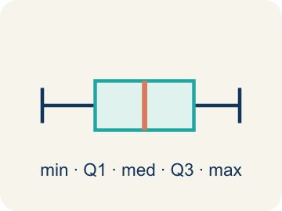 | Box Plot Diagrama de caja  A graph that shows how data is spread using five key numbers.  Example: A box from Q1 to Q3 with a line at the median, and whiskers from min to max
 | Median Mediana  The middle number when you put them in order.  Example: Data: 10, 15, 20, 25, 30 → median is 20 (the 3rd value)
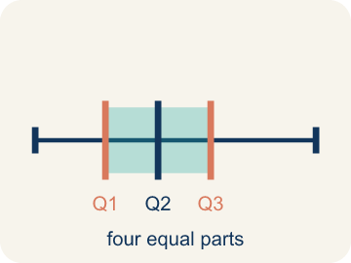 | Quartile Cuartil  Numbers that split the data into four equal parts.  Example: Data: 2, 4, 6, 8, 10, 12, 14 → Q1 = 4 (median of lower half), Q3 = 12 (median of upper half)
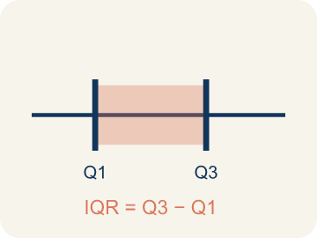 | Interquartile Range Rango intercuartílico  The spread of the middle half of the data (Q3 − Q1).  Example: If Q1 = 12 and Q3 = 20, then IQR = 20 − 12 = 8 — the middle 50% spans 8 units
 | Data distribution Distribución de datos  How the data looks: where it sits and how spread out it is.  Example: A box plot where the median is centered in the box shows symmetric distribution
 | Variability Variabilidad  How spread out the numbers are.  Example: Small IQR = low variability in the middle 50%. Large IQR = high variability
Five-number summary Resumen de cinco números
The minimum, first quartile, median, third quartile, and maximum of a data set.
Example: 6, 8, 14, 19, 22 — the five values a box plot is built from.
Whisker Bigote
A line on a box plot that reaches from the box out to the least or greatest value.
Example: The left whisker reaches the minimum; the right whisker reaches the maximum.
Middle half Mitad central
The values from the first quartile to the third quartile, which the box covers.
Example: The box holds half of the data.

Guided Notes
Fill in each blank as we go. Use the Word Bank to help you.
WORD BANK
Display Data with Box Plots • Box Plot • Median • Quartile • Interquartile Range • Data distribution • Variability • Five-number summary • Whisker • Middle half

1. A box plot shows the ________________-number summary: least, Q1, median, Q3, greatest.
2. A graph that shows data with a box and whiskers based on the five-number summary is a ________________.
3. The middle value of the data, shown as a line inside the box, is the ________________.
4. A value that divides the data into four equal parts is a ________________.
5. The distance between the first and third quartiles, showing the middle 50% of data, is the ________________.
6. The way data values are spread out is the ________________.
7. How spread out the data values are is the ________________.
8. The minimum, Q1, median, Q3, and maximum together are the ________________.
9. The line that reaches from the box to an extreme value is a ________________.
10. The box of a box plot covers the ________________ of the data.

Write About the Math
Which team is more consistently scoring high? Use the box plot values to support your answer?
¿Qué equipo anota alto de forma más consistente? Usa los valores del diagrama de caja para apoyar tu respuesta?
Say your answer to a partner first. Then write it, using at least two of these words:
☐ Box Plot · Diagrama de caja
☐ Median · Mediana
☐ Quartile · Cuartil
☐ Interquartile Range · Rango intercuartílico
☐ Data distribution · Distribución de datos
Model: A box plot is built from the minimum, Q1, median, Q3, and maximum. — Students name the five-number summary (min, Q1, median, Q3, max) and find the median (14) for the 11 ordered scores.

Start Most language support
Complete the frames. Use the word bank.
Completa las oraciones. Usa el banco de palabras.
Team A's IQR is ___ and Team B's IQR is ___. Team B's middle 50% scores between ___ and ___. The fan is wrong because ___. The box plot shows that Team B is more consistent because its Q1 and median are higher and its IQR (10) is smaller, while ___.
My answer is ___ because ___.
Mi respuesta es ___ porque ___.

Build Some language support
Write two connected sentences. Use because, so, or but.
Escribe dos oraciones conectadas. Usa porque, entonces o pero.
My claim is ___.
Mi afirmación es ___.
My evidence is ___, so ___.
Mi evidencia es ___, entonces ___.

Explain Light language support
Write a claim, give math evidence, and explain your reasoning.
Escribe una afirmación, da evidencia matemática y explica tu razonamiento.

Check Your Explanation three quick checks
☐ I answered the question.
☐ I used math evidence: numbers, an equation, or a model.
☐ I used at least two math words.

Worked Example

Watch & Read I Do — follow along with your teacher
Team Scoring Breakdown
The basketball league wants to compare scoring across teams. Here are the points scored by each player on the Wildcats in their last game: 4, 6, 8, 10, 12, 14, 15, 18, 22, 24, 28. The league needs a quick visual that shows the spread, the middle 50%, and any high or low scorers. Time to build a box plot!

Think about:
• What are the lowest and highest scores?
• What score is in the middle of the data?
• Are the scores bunched together or spread out?
• How can you show the spread of all this data in one picture?
• What does the 'middle half' of the data look like?

Solved Example I Do — watch each step
Problem: A box plot shows: Min = 10, Q1 = 15, Median = 20, Q3 = 28, Max = 35. What is the interquartile range (IQR)?
A) 10
B) 13
C) 20
D) 25
Step 1: IQR = Q3 − Q1 = 28 − 15 = 13.
Answer: B. 13

Exit Ticket
Answer on your own. This shows what you learned today.
★ A box plot has Q1 = 20 and Q3 = 36. What is the IQR and what does it represent?
A) IQR = 16; it is the spread of the middle 50% of the data
B) IQR = 28; it is the median between Q1 and Q3
C) IQR = 36; it is the value of Q3
D) IQR = 56; it is the total of Q1 and Q3

Answer Key & Teacher Guide
Teacher reference — remove or fold back before distributing to students.

Guided Notes (Fill-in)
Notes 1: Display Data with Box Plots
Notes 2: Box Plot
Notes 3: Median
Notes 4: Quartile
Notes 5: Interquartile Range
Notes 6: Data distribution
Notes 7: Variability
Notes 8: Five-number summary
Notes 9: Whisker
Notes 10: Middle half

Worked Notes (I Do / We Do)
I Do: B. 13
We Do: A. The median

Independent Practice
Watch for this mistake: A common mistake in Display Data: Box Plots is treating a quartile as just one data point instead of the median of a half — for the lower half 4, 8, 10, 14, some students pick 10 (the last value) as Q1 instead of finding the median of that half: Q1 = (8 + 10) ÷ 2 = 9. A second common slip is finding IQR by adding the quartiles instead of subtracting, writing IQR = Q3 + Q1 (like 30 + 18 = 48) instead of IQR = Q3 − Q1 (30 − 18 = 12) — always order the data first, then subtract Q1 from Q3 to find the spread of the middle 50%.

Level 1 Support
1. B) 50% — The box in a box plot contains the middle 50% of the data (from Q1 to Q3).
2. C) 23 — Range = max − min = 31 − 8 = 23.

On Level
3. A) Team A's middle 50% is more consistent; Team B's is more spread out — A smaller IQR means the middle 50% of data is more tightly clustered. Team A's scoring is more consistent in the middle range.

Exit Ticket
A) IQR = 16; it is the spread of the middle 50% of the data — IQR = Q3 − Q1 = 36 − 20 = 16. The IQR tells you the range of the middle 50% of the data.

Math Writing Criteria
The support level changes the amount of language scaffolding, not the mathematical expectation.
☐ The answer to the math question is correct.
☐ The evidence is real lesson mathematics (numbers, equation, or model), not restated claim.
☐ The support level changed the language scaffolding, never the mathematical expectation.

