UNIT 2 · LESSON 7 STANDARD 6.NOS.3

Divide Decimals Using an Algorithm
Student Notes Packet
Name: ______________________ Date: ____________ Period: ________
Level 3 · Enrichment

Today's Goals
Content: I can divide with decimals by making the divisor a whole number first.
Language: I can explain my work using the words dividend, divisor, quotient, and equivalent division.

Key Vocabulary
Look at the picture, read the word, then read what it means.
 | Divide Decimals Dividir decimales  Find a quotient with decimals by sliding both decimal points right until the divisor is a whole number.  Example: 8.4 ÷ 2.1 = 84 ÷ 21 = 4
 | Dividend Dividendo  The total number being divided into equal groups (the number inside the division bracket).  Example: In 8.4 ÷ 2.1 = 4, the dividend is 8.4 — the total amount being divided
 | Divisor Divisor  The number of equal groups you are dividing into (the number outside the division bracket).  Example: In 8.4 ÷ 2.1 = 4, the divisor is 2.1 — the number of equal groups
 | Quotient Cociente  The answer when you divide.  Example: In 8.4 ÷ 2.1 = 4, the quotient is 4 — there are 4 groups
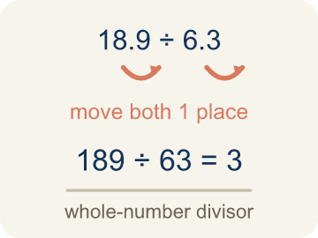 | Decimal Division Algorithm Algoritmo de división decimal  The steps for dividing decimals: slide the divisor's decimal point right until the divisor is a whole number, slide the dividend's point right the same number of places, then divide.  Example: 8.4 ÷ 2.1 → move the point in both → 84 ÷ 21 → divide, multiply, subtract, bring down → 4
 | Equivalent division División equivalente  Multiplying both numbers by 10 or 100 gives the same answer.  Example: 7.56 ÷ 0.12 = 756 ÷ 12 = 63 (both multiplied by 100)
Annex a zero Agregar un cero
Write a zero after the last decimal digit without changing the value.
Example: 7.2 → 7.20
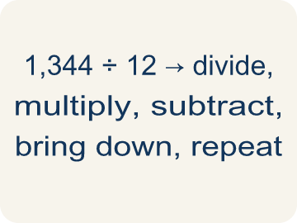 | Algorithm Algoritmo  A set of steps you follow the same way every time.  Example: Divide, multiply, subtract, bring down — then repeat.
 | Power of ten Potencia de diez  Ten, one hundred, one thousand, and so on.  Example: Multiplying by 10 slides every digit one place.

Guided Notes
Fill in each blank as we go. Use the Word Bank to help you.
WORD BANK
Divide Decimals • Dividend • Divisor • Quotient • Decimal Division Algorithm • Equivalent division • Annex a zero • Algorithm • Power of ten

1. Make the ________________ a whole number first, then slide the dividend's point right the same number of places.
2. In a division problem, the total amount being divided is the ________________.
3. In a division problem, the number of equal groups you divide into is the ________________.
4. The answer to a division problem is the ________________.
5. The steps that make the divisor whole before you divide are called the ________________.
6. Multiplying both the dividend and divisor by the same power of 10 creates an ________________ that is easier to solve.
7. Writing 7.2 as 7.20 is called ________________ a zero.
8. Steps you follow the same way every time make an ________________.
9. 10, 100, and 1,000 are each a ________________.

Write About the Math
How does decimal division help you figure out how many pieces you can cut?
¿Cómo te ayuda la división de decimales a averiguar cuántas piezas puedes cortar?
Say your answer to a partner first. Then write it, using at least two of these words:
☐ Dividend · Dividendo
☐ Divisor · Divisor
☐ Quotient · Cociente
☐ Decimal Division Algorithm · Algoritmo de división decimal
☐ Equivalent division · División equivalente
Model: Move both decimal points the same number of places so the value stays equal. — Students rewrite 18.9 ÷ 6.3 as 189 ÷ 63 = 3, explaining moving both points one place keeps the division equivalent, so 3 pods are filled.

Start Most language support
Complete the frames. Use the word bank.
Completa las oraciones. Usa el banco de palabras.
I can cut ___ pieces because 16.8 ÷ 2.4 = ___.
My answer is ___ because ___.
Mi respuesta es ___ porque ___.

Build Some language support
Write two connected sentences. Use because, so, or but.
Escribe dos oraciones conectadas. Usa porque, entonces o pero.
My claim is ___.
Mi afirmación es ___.
My evidence is ___, so ___.
Mi evidencia es ___, entonces ___.

Explain Light language support
Write a claim, give math evidence, and explain your reasoning.
Escribe una afirmación, da evidencia matemática y explica tu razonamiento.

Check Your Explanation three quick checks
☐ I answered the question.
☐ I used math evidence: numbers, an equation, or a model.
☐ I used at least two math words.

Worked Example

Watch & Read I Do — follow along with your teacher
Textbook Purchases
A school bought new math workbooks as shown in the order form. What is the cost of each workbook?

Think about:
• What total amount is being divided?
• What is the size of each pod?
• How do you divide when the divisor is a decimal?
• Can you turn this into a whole number division problem?

Solved Example I Do — watch each step
Problem: What is 14.4 ÷ 1.2?
A) 0.12
B) 1.2
C) 12
D) 120
Step 1: Multiply both by 10: 144 ÷ 12 = 12.
Answer: C. 12

Exit Ticket
Answer on your own. This shows what you learned today.
★ What is 19.2 ÷ 0.8?
A) 0.24
B) 2.4
C) 24
D) 240

