UNIT 5 · LESSON 1 STANDARD 6.GR.1

Determine the Area of Parallelograms and Rhombuses
Student Notes Packet
Name: ______________________ Date: ____________ Period: ________

Today's Goals
Content: I can find the area of a parallelogram using base × height.
Language: I can explain how I found the area using the words base, height, area, and formula.

Key Vocabulary
Look at the picture, read the word, then read what it means.
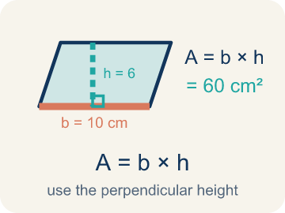 | Area of Parallelograms Área de paralelogramos  The space inside a parallelogram. Formula: A = b × h, using the perpendicular height.  Example: A = b × h; if b = 10 cm and h = 6 cm, A = 60 cm².
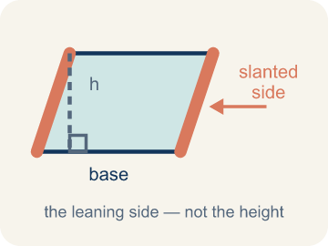 | Slanted side Lado inclinado  A side that leans instead of going straight up and down. It is not the perpendicular height.  Example: In a leaning parallelogram, use the dashed 90° height—not the slanted side—in A = b × h.
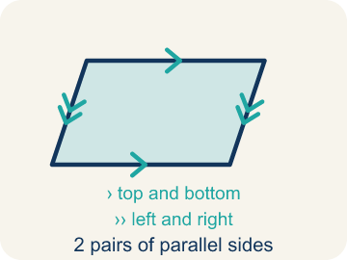 | Parallelogram Paralelogramo  A four-sided shape with two pairs of parallel sides.  Example: Think of a leaning door — the top and bottom are parallel, and the two sides are parallel, like a slanted rectangle
 | Parallel Paralelas  Two lines or sides that stay the same distance apart and never meet.  Example: The top and bottom of a parallelogram never get closer together — matching arrowheads (›) mark one parallel pair, double arrowheads (››) mark the other.
 | Base Base  Any side of a parallelogram can be the base. Once you pick a base, the height must be measured perpendicular (at a 90° angle) to it.  Example: Any side can be the base: choose the 10 cm side and b = 10 cm, then draw the height at 90° to that side in A = b × h
 | Height Altura  The straight-up distance from the base to the top.  Example: A dashed vertical line from the top side straight down to the base, forming a 90° angle — NOT the slanted side
 | Perpendicular Perpendicular  Two lines that meet to make a square corner (90 degrees).  Example: The dashed height meets the base at a square corner — the small 90° box is what makes it perpendicular, not slanted.
 | Area Área  How much space is inside a flat shape.  Example: A 3 cm × 4 cm rectangle covers 12 square centimeters — imagine 12 tiny 1×1 squares inside it
 | Composite figure Figura compuesta  A shape made by putting two or more simple shapes together.  Example: An L-shaped room = a 10×8 rectangle joined to a 4×5 rectangle; total area = 80 + 20 = 100 sq ft
 | Formula Fórmula  A math rule written with symbols.  Example: A = b × h means Area equals base times height; for a parallelogram with b = 6 and h = 4, A = 24
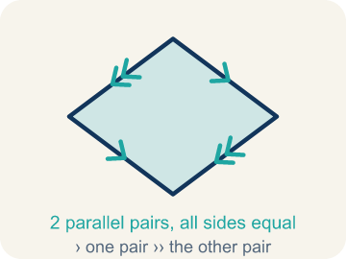 | Rhombus Rombo  A parallelogram with four sides of the same length.  Example: All 4 sides equal, with two diagonals that cross at right angles.
Diagonal Diagonal
A segment that joins two corners that are not next to each other.
Example: Corner to opposite corner.

Guided Notes
Fill in each blank as we go. Use the Word Bank to help you.
WORD BANK
Area of Parallelograms • Slanted side • Parallelogram • Parallel • Base • Height • Perpendicular • Area • Composite figure • Formula • Rhombus • Diagonal

1. The space inside a parallelogram, found with A = b × h, is the ________________.
2. The leaning side of a parallelogram, which is NOT the height, is the ________________.
3. A quadrilateral with two pairs of parallel sides is a ________________.
4. Two sides that stay the same distance apart and never meet are ________________.
5. The side of a parallelogram you measure the height from at a 90° angle is the ________________.
6. The perpendicular distance between the base and the opposite side is the ________________.
7. Two lines that meet at a 90° square corner are ________________.
8. The amount of flat space inside a two-dimensional figure is its ________________.
9. A shape made of two or more basic shapes combined is a ________________.
10. A math rule written with symbols, like A = b × h, is a ________________.
11. A parallelogram whose four sides are all the same length is a ________________.
12. A segment from one corner to the opposite corner is a ________________.

Write About the Math
How many tiles does the architect need?
¿Cuántos azulejos necesita el arquitecto?
Say your answer to a partner first. Then write it, using at least two of these words:
☐ Slanted side · Lado inclinado
☐ Parallelogram · Paralelogramo
☐ Parallel · Paralelas
☐ Base · Base
☐ Height · Altura
Model: We use the height because it is perpendicular to the base. — Students connect 'height' to the perpendicular (straight-up) distance from base to top, and recognize the slanted side is longer and would overstate the area.

Start Most language support
Complete the frames. Use the word bank.
Completa las oraciones. Usa el banco de palabras.
The courtyard's area is ___ sq ft because A = ___ x ___ . She needs ___ tiles because ___ / 2 = ___.
My answer is ___ because ___.
Mi respuesta es ___ porque ___.

Build Some language support
Write two connected sentences. Use because, so, or but.
Escribe dos oraciones conectadas. Usa porque, entonces o pero.
My claim is ___.
Mi afirmación es ___.
My evidence is ___, so ___.
Mi evidencia es ___, entonces ___.

Explain Light language support
Write a claim, give math evidence, and explain your reasoning.
Escribe una afirmación, da evidencia matemática y explica tu razonamiento.

Check Your Explanation three quick checks
☐ I answered the question.
☐ I used math evidence: numbers, an equation, or a model.
☐ I used at least two math words.

Worked Example

Watch & Read I Do — follow along with your teacher
Blueprint Review
Your architecture firm is designing a parallelogram-shaped patio for a client's backyard. The client needs to know how many square feet of pavers to order. The patio has a base of 14 feet and a height of 9 feet.

Think about:
• What shape is the patio?
• What measurements are given?
• How is a parallelogram different from a rectangle?
• Why do we use the height instead of the slanted side to find the area?
• Can you rearrange a parallelogram into a rectangle?

Solved Example I Do — watch each step
Problem: What is the area of a parallelogram with base 10 cm and height 7 cm?
A) 17 sq cm
B) 34 sq cm
C) 70 sq cm
D) 70 cm
Step 1: A = b × h = 10 × 7 = 70 square centimeters.
Answer: C. 70 sq cm

Guided Practice

Solve Together We Do — work with your class
Problem: A parallelogram has an area of 54 sq ft and a base of 9 ft. What is the height?
A) 6 ft
B) 27 ft
C) 45 ft
D) 63 ft
Step 1:

Step 2:

Answer:

A landscape architect is tiling a parallelogram-shaped courtyard. The courtyard has a base of 18 feet and a height of 10 feet. Each tile covers 2 square feet.
How many tiles does the architect need?

Sentence frame: The courtyard's area is ___ sq ft because A = ___ x ___ . She needs ___ tiles because ___ / 2 = ___.

Turn & Talk discuss with a partner
1. [Launch] Look at the patio blueprint with a base of 14 feet and a height of 9 feet. Why do we use the height (9 ft) and not the slanted side to find the area?
Start with: We use the height because it is ___ to the base.
Usamos la altura porque es ___ a la base.
Word bank: base, height, area, parallelogram, formula
2. [Explore] On the grid you cut a triangle off one end of the parallelogram and slid it to the other side. What shape did you make, and why does that prove the area is base x height?
Start with: When I move the triangle, I get a ___.
Cuando muevo el triángulo, obtengo un ___.
Word bank: rearrange, rectangle, base, height, area
3. [Connect] The landscape architect tiles an 18 ft by 10 ft parallelogram courtyard and each tile covers 2 sq ft. Talk through how you find the number of tiles.
Start with: First I find the area: 18 times 10 equals ___ square feet.
Primero hallo el área: 18 por 10 es ___ pies cuadrados.
Word bank: area, base, height, parallelogram, tiles
4. [Practice] During practice on Area of Parallelograms, what strategy did you use when a problem felt tricky?
Start with: A strategy I used was ___ because ___.
Una estrategia que usé fue ___ porque ___.
Word bank: Parallelogram, Base, Height, Area

Independent Practice

On Your Own You Do — show your work
Solve each problem. Show your thinking in the work box.

Level 1 Support extra scaffolding
1. What is the area of a parallelogram with base 9 cm and height 5 cm?
A) 14 sq cm
B) 22.5 sq cm
C) 45 sq cm
D) 90 sq cm

2. Which measurement is the height of a parallelogram?
A) The length of the slanted side
B) The perimeter divided by 4
C) The perpendicular distance between the base and the opposite side
D) The longest side

Exit Ticket
Answer on your own. This shows what you learned today.
★ A parallelogram has a base of 13 inches and a height of 5 inches. What is its area?
A) 18 sq in
B) 36 sq in
C) 65 sq in
D) 65 in

