UNIT 5 · LESSON 10 STANDARD 6.GR.2

Volume of Rectangular Prisms
Student Notes Packet
Name: ______________________ Date: ____________ Period: ________
Level 2 · Standard

Today's Goals
Content: I can find the volume of a rectangular prism, including ones with fractional edge lengths, using base area × height.
Language: I can explain my work using the words volume, rectangular prism, dimensions, and base area.

Key Vocabulary
Look at the picture, read the word, then read what it means.
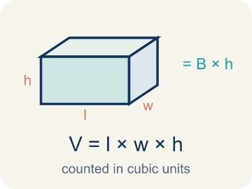 | Volume of Rectangular Prisms Volumen de prismas rectangulares  The space inside a rectangular prism. Formula: V = Bh = l × w × h.  Example: V = Bh = l × w × h
 | Volume Volumen  How much space is inside a solid shape.  Example: A box 2 × 1.5 × 1 = 3 ft³ — it holds 3 cubic feet of stuff
 | Rectangular prism Prisma rectangular  A solid box shape with six flat rectangle sides.  Example: A tissue box, a fish tank, a brick — all rectangular prisms
 | Cubic units Unidades cúbicas  The units used to measure space inside, like cubic inches.  Example: 1 ft³ = a cube that is 1 foot on every edge
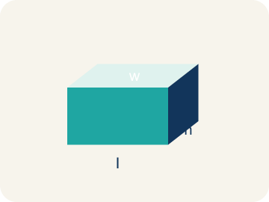 | Dimensions Dimensiones  How long, how wide, and how tall a shape is.  Example: A box with dimensions 4 × 3 × 2 means l = 4, w = 3, h = 2
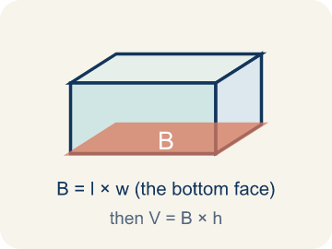 | Base area Área de la base  The area of the bottom of a solid. Volume = base area × height.  Example: If the base is 6 × 4 = 24 cm² and h = 3, then V = 24 × 3 = 72 cm³

Guided Notes
Fill in each blank as we go. Use the Word Bank to help you.
WORD BANK
Volume of Rectangular Prisms • Volume • Rectangular prism • Cubic units • Dimensions • Base area

1. The space inside a rectangular prism, found with V = l × w × h, is the ________________.
2. The amount of space inside a three-dimensional solid is its ________________.
3. A solid with six rectangular faces is a ________________.
4. The unit used to measure volume is ________________.
5. The measurements of length, width, and height of a solid are its ________________.
6. The area of the bottom face of a prism, multiplied by height to find volume, is the ________________.

Write About the Math
How many gallons of water does the small tank hold?
¿Cuántos galones de agua tiene la pecera pequeña?
Say your answer to a partner first. Then write it, using at least two of these words:
☐ Volume · Volumen
☐ Rectangular prism · Prisma rectangular
☐ Cubic units · Unidades cúbicas
☐ Dimensions · Dimensiones
☐ Base area · Área de la base
Model: You still multiply length × width × height even when an edge is a fraction or decimal. — Students explain the formula stays the same (V = l × w × h = 2 × 1.5 × 1 = 3 ft³) and that a fractional edge just means multiplying with a fraction or decimal.

Start Most language support
Complete the frames. Use the word bank.
Completa las oraciones. Usa el banco de palabras.
The tank's volume is ___ in³ because V = ___ × ___ × ___. It holds about ___ gallons because ___ ÷ 231 ≈ ___.
My answer is ___ because ___.
Mi respuesta es ___ porque ___.

Build Some language support
Write two connected sentences. Use because, so, or but.
Escribe dos oraciones conectadas. Usa porque, entonces o pero.
My claim is ___.
Mi afirmación es ___.
My evidence is ___, so ___.
Mi evidencia es ___, entonces ___.

Explain Light language support
Write a claim, give math evidence, and explain your reasoning.
Escribe una afirmación, da evidencia matemática y explica tu razonamiento.

Check Your Explanation three quick checks
☐ I answered the question.
☐ I used math evidence: numbers, an equation, or a model.
☐ I used at least two math words.

Worked Example

Watch & Read I Do — follow along with your teacher
Time Capsule Project
Your class is building a time capsule to bury on school grounds. The capsule is a rectangular prism that is 2 feet long, 1.5 feet wide, and 1 foot tall. You need to figure out how much stuff can fit inside — that means calculating the volume!

Think about:
• What are the three measurements of the time capsule?
• What does volume measure — length, area, or space inside?
• How is volume different from area?
• What if we made the capsule taller but narrower — would the volume change?
• What units do we use for volume versus area?

Solved Example I Do — watch each step
Problem: What is the volume of a rectangular prism with l = 4 in, w = 3 in, h = 5 in?
A) 12 in³
B) 24 in³
C) 60 in³
D) 60 in²
Step 1: V = l × w × h = 4 × 3 × 5 = 60 cubic inches.
Answer: C. 60 in³

Guided Practice

Solve Together We Do — work with your class
Problem: A box has a volume of 36 cm³. Its length is 6 cm and width is 3 cm. What is the height?
A) 2 cm
B) 3 cm
C) 6 cm
D) 12 cm
Step 1:

Step 2:

Answer:

An aquarium store sells fish tanks. A small tank is 24 inches long, 12 inches wide, and 16 inches tall. One gallon of water takes up about 231 cubic inches.
How many gallons of water does the small tank hold?

Sentence frame: The tank's volume is ___ in³ because V = ___ × ___ × ___. It holds about ___ gallons because ___ ÷ 231 ≈ ___.

Turn & Talk discuss with a partner
1. [Launch] Your time capsule is 2 ft long, 1.5 ft wide, and 1 ft tall — one edge is a fraction. Does having a fractional edge change how you find the volume? Why or why not?
Start with: A fractional edge ___ change the method because I still multiply ___ × ___ × ___.
Una arista fraccionaria ___ cambia el método porque sigo multiplicando ___ × ___ × ___.
Word bank: volume, dimensions, rectangular prism, base area, cubic units
2. [Explore] Capsule A (2 × 1.5 × 1) and Capsule B (3 × 1 × 1) both have a volume of 3 ft³. How did your multiplication produce the same volume from different dimensions?
Start with: Both capsules have V = ___ ft³ because ___ × ___ × ___ = ___ × ___ × ___.
Ambas cápsulas tienen V = ___ ft³ porque ___ × ___ × ___ = ___ × ___ × ___.
Word bank: volume, dimensions, rectangular prism, base area, cubic units
3. [Connect] A fish tank is 24 in long, 12 in wide, and 16 in tall, and one gallon takes about 231 cubic inches. Talk through how you would find how many gallons it holds.
Start with: The tank's volume is ___ in³ because 24 × 12 × 16 = ___.
El volumen del tanque es ___ in³ porque 24 × 12 × 16 = ___.
Word bank: volume, cubic units, rectangular prism, dimensions, base area
4. [Reflect] A classmate says a 5 × 3 × 2.5 m prism has volume 5 × 5.5 = 27.5 m³. How do you find and explain their mistake?
Start with: The mistake is that they ___ instead of multiplying 3 × 2.5.
El error es que ___ en lugar de multiplicar 3 × 2.5.
Word bank: volume, dimensions, rectangular prism, base area, cubic units
5. [Practice] During practice on Volume of Rectangular Prisms, what strategy did you use when a problem felt tricky?
Start with: Both capsules have V = ___ ft³ because ___ × ___ × ___ = ___ × ___ × ___.
Ambas cápsulas tienen V = ___ ft³ porque ___ × ___ × ___ = ___ × ___ × ___.
Word bank: Volume, Rectangular prism, Cubic units, Dimensions

Independent Practice

On Your Own You Do — show your work
Solve each problem. Show your thinking in the work box.

On Level grade-level practice
1. Two boxes: Box A is 10 × 5 × 4 inches. Box B is 8 × 6 × 5 inches. Which has more volume and by how much?
A) Box B by 40 in³
B) Box A by 40 in³
C) Box B by 60 in³
D) They're equal

2. What is the volume of a prism with edge lengths 1/2 m, 3 m, and 4 m?
A) 3 m³
B) 6 m³
C) 7.5 m³
D) 12 m³

3. A cube has an edge length of 5 cm. What is its volume?
A) 15 cm³
B) 25 cm³
C) 75 cm³
D) 125 cm³

Exit Ticket
Answer on your own. This shows what you learned today.
★ A rectangular prism has l = 7 ft, w = 2 ft, h = 3 ft. What is the volume?
A) 12 ft³
B) 24 ft³
C) 42 ft³
D) 42 ft²

