UNIT 5 · LESSON 3 STANDARD 6.GR.1

Determine the Area of Trapezoids
Student Notes Packet
Name: ______________________ Date: ____________ Period: ________
Level 3 · Enrichment

Today's Goals
Content: I can find the area of a trapezoid using the formula A = ½(b1 + b2) × h.
Language: I can explain my steps using the words trapezoid, base, height, and area.

Key Vocabulary
Look at the picture, read the word, then read what it means.
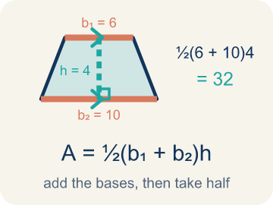 | Area of Trapezoids Área de trapecios  The space inside a trapezoid. Formula: A = 1/2(b₁ + b₂)h.  Example: A = 1/2(b₁ + b₂)h
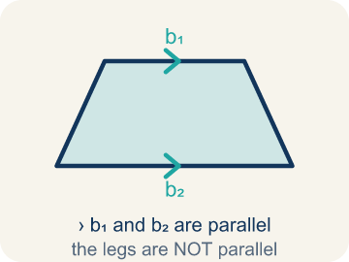 | Trapezoid Trapecio  A four-sided shape with just one pair of parallel sides.  Example: A table top wider than the bottom shelf — the top and bottom edges are parallel, the two sides slant inward
 | Parallel Paralelas  Two lines or sides that stay the same distance apart and never meet.  Example: The top and bottom of a parallelogram never get closer together — matching arrowheads (›) mark one parallel pair, double arrowheads (››) mark the other.
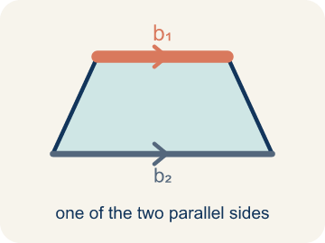 | Base 1 (b1) Base 1 (b1)  One of the two parallel sides of a trapezoid.  Example: If the bottom of the trapezoid is 10 ft, then b₁ = 10 ft in the formula A = ½(b₁ + b₂) × h
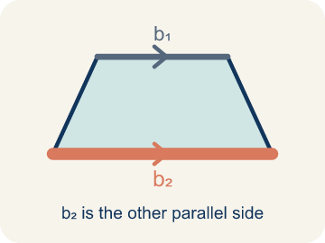 | Base 2 (b2) Base 2 (b2)  The other parallel side of a trapezoid.  Example: If the top of the trapezoid is 6 ft, then b₂ = 6 ft; both bases are parallel to each other
 | Height Altura  The straight-up distance between the two parallel sides.  Example: A dashed vertical line from the top base straight down to the bottom base at a 90° angle — NOT the slanted side
 | Perpendicular Perpendicular  Two lines that meet to make a square corner (90 degrees).  Example: The dashed height meets the base at a square corner — the small 90° box is what makes it perpendicular, not slanted.
 | Area Área  How much space is inside a flat shape.  Example: A trapezoid with b₁ = 10, b₂ = 6, h = 4 has area = ½(10 + 6) × 4 = 32 sq units
 | Decompose Descomponer  Break a figure into simpler shapes.  Example: A trapezoid = a rectangle + 2 triangles.
Right trapezoid Trapecio rectángulo
A trapezoid with two square corners.
Example: One side stands straight up from the base.

Guided Notes
Fill in each blank as we go. Use the Word Bank to help you.
WORD BANK
Area of Trapezoids • Trapezoid • Parallel • Base 1 (b1) • Base 2 (b2) • Height • Perpendicular • Area • Decompose • Right trapezoid

1. The space inside a trapezoid, found with A = ½(b₁ + b₂)h, is the ________________.
2. A quadrilateral with exactly one pair of parallel sides is a ________________.
3. Two sides that stay the same distance apart and never meet are ________________.
4. One of the two parallel sides of a trapezoid is ________________.
5. The other parallel side of a trapezoid is ________________.
6. The perpendicular distance between the two parallel bases is the ________________.
7. Two lines that meet at a 90° square corner are ________________.
8. The amount of flat space inside the trapezoid is its ________________.
9. Breaking a figure into simpler shapes is called ________________.
10. A trapezoid with two square corners is a ________________.

Write About the Math
How many bags of concrete does the builder need?
¿Cuántas bolsas de concreto necesita el constructor?
Say your answer to a partner first. Then write it, using at least two of these words:
☐ Trapezoid · Trapecio
☐ Parallel · Paralelas
☐ Base 1 (b1) · Base 1 (b1)
☐ Base 2 (b2) · Base 2 (b2)
☐ Height · Altura
Model: We use both bases because the top and bottom are different lengths. — Students explain a trapezoid has two parallel sides of different lengths, so using only one would over- or under-count the area; strong answers mention averaging the bases.

Start Most language support
Complete the frames. Use the word bank.
Completa las oraciones. Usa el banco de palabras.
The driveway's area is ___ sq ft because A = 1/2 x (___ + ___) x ___. He needs ___ bags because ___ / 6 = ___.
My answer is ___ because ___.
Mi respuesta es ___ porque ___.

Build Some language support
Write two connected sentences. Use because, so, or but.
Escribe dos oraciones conectadas. Usa porque, entonces o pero.
My claim is ___.
Mi afirmación es ___.
My evidence is ___, so ___.
Mi evidencia es ___, entonces ___.

Explain Light language support
Write a claim, give math evidence, and explain your reasoning.
Escribe una afirmación, da evidencia matemática y explica tu razonamiento.

Check Your Explanation three quick checks
☐ I answered the question.
☐ I used math evidence: numbers, an equation, or a model.
☐ I used at least two math words.

Worked Example

Watch & Read I Do — follow along with your teacher
Blueprint Review
Your architecture firm is designing a trapezoidal window for a modern building. The glass supplier charges by the square foot, so the team must calculate the exact area. The window has a top edge of 4 feet, a bottom edge of 8 feet, and a height of 5 feet.

Think about:
• What shape is the window?
• How many parallel sides does it have?
• What measurements are given?
• Why does the formula use two bases instead of one?
• What would happen if both bases were the same length?

Solved Example I Do — watch each step
Problem: What is the area of a trapezoid with bases 6 cm and 10 cm, and height 4 cm?
A) 24 sq cm
B) 32 sq cm
C) 40 sq cm
D) 64 sq cm
Step 1: A = ½ × (b₁ + b₂) × h = ½ × (6 + 10) × 4 = ½ × 16 × 4 = 32 sq cm.
Answer: B. 32 sq cm

Exit Ticket
Answer on your own. This shows what you learned today.
★ A trapezoid has bases of 9 inches and 5 inches, and a height of 6 inches. What is its area?
A) 27 sq in
B) 42 sq in
C) 42 in
D) 84 sq in

Answer Key & Teacher Guide
Teacher reference — remove or fold back before distributing to students.

Guided Notes (Fill-in)
Notes 1: Area of Trapezoids
Notes 2: Trapezoid
Notes 3: Parallel
Notes 4: Base 1 (b1)
Notes 5: Base 2 (b2)
Notes 6: Height
Notes 7: Perpendicular
Notes 8: Area
Notes 9: Decompose
Notes 10: Right trapezoid

Worked Notes (I Do / We Do)
I Do: B. 32 sq cm
We Do: B. 5 ft

Independent Practice
Watch for this mistake: A common mistake in Area of Trapezoids is forgetting the ½ in A = ½ × (b1 + b2) × h. After adding the bases and multiplying by the height, students stop there instead of taking half — for example, with bases 6 ft and 10 ft and a height of 4 ft, they compute (6 + 10) × 4 = 64 sq ft instead of taking half to get the correct 32 sq ft. That unhalved number is really the area of the parallelogram made from two trapezoids, not the area of one trapezoid. Before you submit, always ask: "Did I take half of my last answer?"

Level 1 Support
1. C) Add the two bases together — The formula is A = ½ × (b₁ + b₂) × h. The first step is to add the two parallel bases.
2. C) 42 sq in — A = ½ × (5 + 9) × 6 = ½ × 14 × 6 = ½ × 84 = 42 sq in.

Exit Ticket
B) 42 sq in — A = 1/2 x (b1 + b2) x h = 1/2 x (9 + 5) x 6 = 1/2 x 14 x 6 = 42 square inches.

Math Writing Criteria
The support level changes the amount of language scaffolding, not the mathematical expectation.
☐ The answer to the math question is correct.
☐ The evidence is real lesson mathematics (numbers, equation, or model), not restated claim.
☐ The support level changed the language scaffolding, never the mathematical expectation.

