UNIT 6 · LESSON 2 STANDARD 6.NOS.1

Division Expressions with Fractions and Mixed Numbers
Student Notes Packet
Name: ______________________ Date: ____________ Period: ________
Level 3 · Enrichment

Today's Goals
Content: I can divide a fraction by a fraction and divide with mixed numbers by multiplying by the reciprocal.
Language: I can explain the steps using the words reciprocal, improper fraction, mixed number, and simplify.

Key Vocabulary
Look at the picture, read the word, then read what it means.
 | Divide Fractions Dividir fracciones  Multiply the first fraction by the reciprocal of the second fraction.  Example: 2/3 ÷ 1/4 = 2/3 × 4/1 = 8/3
 | Dividend Dividendo  The total number being divided into equal groups (the number inside the division bracket).  Example: In 3/4 ÷ 1/2, the dividend is 3/4 — the total amount being split
 | Divisor Divisor  The number of equal groups you are dividing into (the number outside the division bracket).  Example: In 3/4 ÷ 1/2, the divisor is 1/2 — the size of each group
 | Reciprocal Recíproco  A fraction turned upside down.  Example: The reciprocal of 2/3 is 3/2. To divide by 2/3, multiply by 3/2.
 | Quotient Cociente  The answer when you divide.  Example: In 3/4 ÷ 1/4 = 3, the quotient is 3 — three 1/4-size pieces fit into 3/4
 | Simplify Simplificar  To write a fraction with smaller numbers that names the same amount, like 2/4 = 1/2.  Example: 8/12 → GCF is 4 → 8÷4 / 12÷4 = 2/3
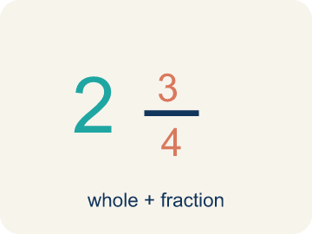 | Mixed number Número mixto  A whole number and a fraction written together, like 2 1/2. It must be rewritten as an improper fraction before dividing.  Example: 2 1/2 = 5/2
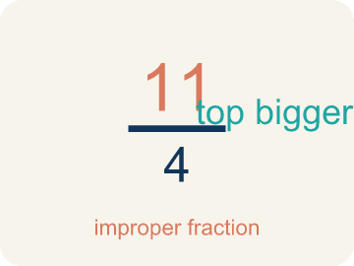 | Improper fraction Fracción impropia  A fraction whose numerator is greater than or equal to its denominator, like 5/2.  Example: 5/2 is the same amount as 2 1/2

Guided Notes
Fill in each blank as we go. Use the Word Bank to help you.
WORD BANK
Divide Fractions • Dividend • Divisor • Reciprocal • Quotient • Simplify • Mixed number • Improper fraction

1. Keep the first fraction, change ÷ to ×, and flip the ________________.
2. In 3/4 ÷ 1/2, the fraction 3/4 being divided is the ________________.
3. In 3/4 ÷ 1/2, the fraction 1/2 we divide by is the ________________.
4. To divide by 1/2, I multiply by its ________________, which is 2.
5. The answer to a division problem is the ________________.
6. Writing a fraction with smaller numbers that names the same amount, like 4/8 = 1/2, is to ________________ it.
7. A whole number and a fraction written together is a ________________ ________________.
8. A fraction whose numerator is at least its denominator is an ________________ ________________.

Write About the Math
How does dividing fractions help the carpenter?
¿Cómo ayuda dividir fracciones a la carpintera?
Say your answer to a partner first. Then write it, using at least two of these words:
☐ Dividend · Dividendo
☐ Divisor · Divisor
☐ Reciprocal · Recíproco
☐ Quotient · Cociente
☐ Simplify · Simplificar
Model: She will get many portions because 1/8 pound is much smaller than 3/4 pound. — Students recognize the divisor 1/8 is smaller than the dividend 3/4, so the quotient is greater than 1.

Start Most language support
Complete the frames. Use the word bank.
Completa las oraciones. Usa el banco de palabras.
The carpenter can cut ___ pieces because 5/6 ÷ 1/12 = ___.
My answer is ___ because ___.
Mi respuesta es ___ porque ___.

Build Some language support
Write two connected sentences. Use because, so, or but.
Escribe dos oraciones conectadas. Usa porque, entonces o pero.
My claim is ___.
Mi afirmación es ___.
My evidence is ___, so ___.
Mi evidencia es ___, entonces ___.

Explain Light language support
Write a claim, give math evidence, and explain your reasoning.
Escribe una afirmación, da evidencia matemática y explica tu razonamiento.

Check Your Explanation three quick checks
☐ I answered the question.
☐ I used math evidence: numbers, an equation, or a model.
☐ I used at least two math words.

Worked Example

Watch & Read I Do — follow along with your teacher
Detective Agency Case File
Agent Rivera is dividing a 3/4-pound evidence bag into portions that each weigh 1/8 pound. She needs to know exactly how many portions she can make for testing. Can you solve the case?

Think about:
• What is the total weight being divided?
• What is the size of each portion?
• Will the answer be more or less than 1?
• How is dividing fractions different from multiplying them?
• Why does 'keep, change, flip' work?

Solved Example I Do — watch each step
Problem: What is the reciprocal of 3/5?
A) 1/3
B) 3/5
C) 5/3
D) 5/5
Step 1: To find the reciprocal, flip the fraction.
Step 2: The reciprocal of 3/5 is 5/3.
Answer: C. 5/3

Exit Ticket
Answer on your own. This shows what you learned today.
★ What is 5/6 ÷ 1/12?
A) 5/72
B) 5/6
C) 10
D) 72/5

