UNIT 7 · LESSON 7 STANDARD 6.NOS.9

Represent Polygons on the Coordinate Plane
Student Notes Packet
Name: ______________________ Date: ____________ Period: ________
Level 3 · Enrichment

Today's Goals
Content: I can draw polygons from their vertex coordinates on the coordinate plane, and use coordinates to find side lengths and solve perimeter and area problems.
Language: I can explain how I found a distance using the words vertices, coordinates, and absolute value.

Key Vocabulary
Look at the picture, read the word, then read what it means.
 | vertex vértice  A corner point of a polygon, named by an ordered pair on the coordinate plane.  Example: The park's corner at (2, 4) — one corner, named by an ordered pair.
 | polygon polígono  A closed figure made of line segments; on the plane you draw it by plotting the vertices and connecting them in order.  Example: Plot (2, 4), (5, 4), (5, −4), (2, −4) and join them — a rectangle appears.
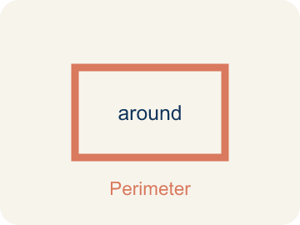 | perimeter perímetro  The total distance around a polygon — the sum of all its side lengths.  Example: 2(9.5) + 2(6.75) = 32.5 units around the deck.
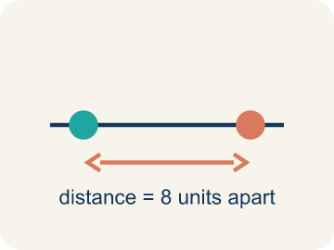 | distance between vertices distancia entre vértices  When two vertices share an x- or y-coordinate, the distance between them is the absolute difference of the other coordinates.  Example: (2, 4) and (5, 4) share y, so the side is |5 − 2| = 3 units.
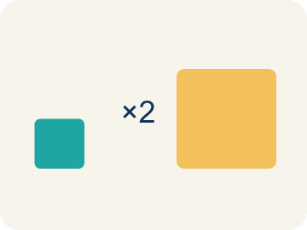 | scale escala  What one grid unit stands for in the real situation.  Example: Each grid unit = 100 feet, so 8 units of map is 800 real feet.
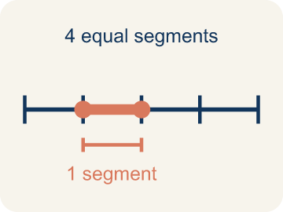 | Side length Longitud del lado  The distance between two vertices that are joined by a side.  Example: Found with absolute value when the points share a coordinate.

Guided Notes
Fill in each blank as we go. Use the Word Bank to help you.
WORD BANK
vertex • polygon • perimeter • distance between vertices • scale • Side length

1. A corner point of a polygon, named by an ordered pair, is a ________________.
2. A closed figure made of line segments is a ________________.
3. The total distance around a polygon is its ________________.
4. When two vertices share a coordinate, subtract the other and take the ________________ ________________.
5. What one grid unit stands for in the real situation is the ________________.
6. The distance between two joined vertices is a ________________.

Write About the Math
Where do the other two vertices go — and how do the known coordinates, the scale, and the area work together to tell you?
¿A dónde van los otros dos vértices — y cómo trabajan juntas las coordenadas conocidas, la escala y el área para decírtelo?
Say your answer to a partner first. Then write it, using at least two of these words:
☐ vertex · vértice
☐ polygon · polígono
☐ perimeter · perímetro
☐ distance between vertices · distancia entre vértices
☐ scale · escala
Model: When two vertices share the same y-coordinate, the segment between them is horizontal, so its length comes from the DIFFERENCE in the coordinate that changes — the x-coordinates. — A strong answer explains that the SHARED coordinate tells you the direction of the side, and the DIFFERING coordinate is what you subtract. A weak answer just says 'subtract the numbers' without identifying which pair.

Start Most language support
Complete the frames. Use the word bank.
Completa las oraciones. Usa el banco de palabras.
The park's width is ___ feet. Using the area formula, its length is ___ feet, which is ___ units on the map — so the new vertices sit that many units below the known ones.
My answer is ___ because ___.
Mi respuesta es ___ porque ___.

Build Some language support
Write two connected sentences. Use because, so, or but.
Escribe dos oraciones conectadas. Usa porque, entonces o pero.
My claim is ___.
Mi afirmación es ___.
My evidence is ___, so ___.
Mi evidencia es ___, entonces ___.

Explain Light language support
Write a claim, give math evidence, and explain your reasoning.
Escribe una afirmación, da evidencia matemática y explica tu razonamiento.

Check Your Explanation three quick checks
☐ I answered the question.
☐ I used math evidence: numbers, an equation, or a model.
☐ I used at least two math words.

Worked Example

Watch & Read I Do — follow along with your teacher
Unit 7 · Lesson 7
A polygon's vertices are given as coordinates: (-4.5, 3), (5, 3), (5, -3.75), and (-4.5, -3.75). What is its perimeter?

Solved Example I Do — watch each step
Problem: Vertices (-4.5, 3) and (5, 3) share y = 3. What is the distance between them?
A) 0.5 units
B) 1.5 units
C) 8 units
D) 9.5 units
Step 1: They differ only in x: |5 − (−4.5)| = 5 + 4.5 = 9.5 units.
Answer: D. 9.5 units

Independent Practice

On Your Own You Do — show your work
Solve each problem. Show your thinking in the work box.

Level 2 Enrichment stretch your thinking
1. Maria is choosing between two store spaces on a grid where each unit is 1 foot and each grid line is 5 feet apart. Space A is a rectangle 25 ft by 40 ft; Space B is 30 ft by 30 ft. Which has more floor area?
A) Space A — 1,000 sq ft vs 900 sq ft
B) Space B — 900 sq ft vs 850 sq ft
C) They are equal
D) Space B — because a square always beats a rectangle

2. A square has vertices (a, b) and (a, b + s) on one side. Which operation gives the side length for ANY values?
A) Add all four coordinates
B) Subtract the y-coordinates and take the absolute value
C) Multiply a × b
D) Average the coordinates

3. The park design used width from coordinates, then length from the area, then the scale to place the missing vertices. Design your own version: pick an area and a scale, mark two vertices, and show where the other two go.
4. Check the deck's perimeter of 32.5 units a DIFFERENT way than adding the four sides in order.

Exit Ticket
Answer on your own. This shows what you learned today.
★ A rectangle has vertices (-1, 4), (5, 4), (5, 1), (-1, 1). What is its perimeter?
A) 6 units
B) 9 units
C) 18 units
D) 18 square units

Answer Key & Teacher Guide
Teacher reference — remove or fold back before distributing to students.

Guided Notes (Fill-in)
Notes 1: vertex
Notes 2: polygon
Notes 3: perimeter
Notes 4: distance between vertices
Notes 5: scale
Notes 6: Side length

Worked Notes (I Do / We Do)
I Do: D. 9.5 units
We Do: C. 6.75 units

Independent Practice
Watch for this mistake: Subtracting coordinates without the absolute value — from y = 3 down to y = −3.75 the distance is 3 + 3.75 = 6.75 units, not 3.75 − 3 = 0.75. Distances that cross zero are the whole reason the absolute value is there.

Level 1 Support
1. C) 32.5 units — Perimeter = 2(9.5) + 2(6.75) = 19 + 13.5 = 32.5 units.
2. D) A rectangle's opposite sides are equal, so each length appears on two sides — The two 9.5 sides and the two 6.75 sides each come in pairs — that is what the 2 counts.
3. D) Plot each ordered pair, then connect them in order with segments — Graph the points on the plane and connect them in order — the closed figure that appears is the polygon.
4. Answers vary.

On Level
5. D) 300 feet — 3 units × 100 feet per unit = 300 feet.
6. B) 800 feet — Length = area ÷ width = 240,000 ÷ 300 = 800 feet.

Exit Ticket
C) 18 units — Width |5 − (−1)| = 6, height |4 − 1| = 3. Perimeter = 2(6) + 2(3) = 18 units.

Math Writing Criteria
The support level changes the amount of language scaffolding, not the mathematical expectation.
☐ The answer to the math question is correct.
☐ The evidence is real lesson mathematics (numbers, equation, or model), not restated claim.
☐ The support level changed the language scaffolding, never the mathematical expectation.

