Name |  | Date |  | Period

Lesson 2-1 · Session 2
Homework
Dot Plots and Shape
Maryland Standard 6.SP.B.4 · Learning target — I can build a dot plot and describe the shape of the data it shows.
Show a model, calculation, or explanation for each exercise. Label units and answer every part.
Exercises 1–12 earn 1 point for a correct response and 1 for supporting work. Spiral Review and Test Practice earn 1 point each.
REMEMBER review this before you start
• A dot plot shows each value in a data set as a dot above a number line.
• Shapes can be symmetric, skewed left, or skewed right; look for clusters, gaps, and peaks.
• Watch out — a repeated value gets its own dot, so stacks grow taller instead of dots overlapping.
• Check it — the total number of dots must equal the number of data values you were given.
WORKED EXAMPLE the same steps you practiced in class
Building a Dot Plot and Reading It Twelve students named how many books they finished: 0, 2, 1, 2, 3, 2, 4, 1, 2, 3, 0, 2.
Step 1 Draw a number line from 0 to 4 and label every whole number.
Step 2 Stack one dot above a value for each student who gave that answer.
Step 3 The tallest stack sits above 2, so 2 is the most common answer.
Step 4 The line runs from the least value, 0, to the greatest value, 4.
Answer The plot has one dot per student; 2 books is most common and the values run from 0 to 4.
EXERCISES 12 exercises · 24 points
1. The number of siblings for 10 students is: 0,1,1,1,2,2,2,2,3,4. Draw and label a number line, then use it to make a dot plot of the data.

Dot plot. Stack one dot per value above its number.​
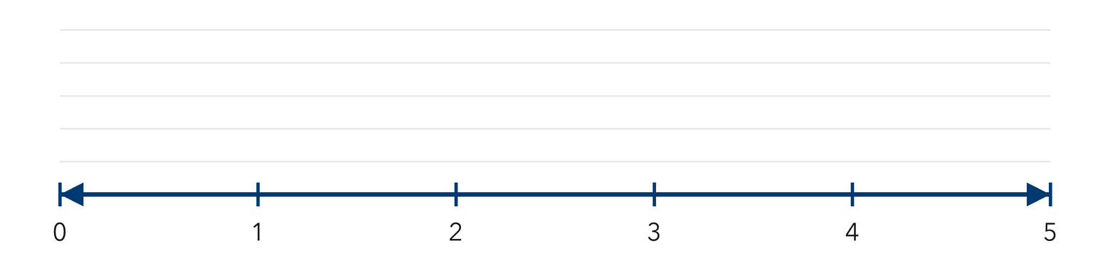
Show your work.
Answer
2. Using your dot plot, identify: the value with the most dots (the peak) ______ , any gaps in the data ______

Show your work.
Answer
3. Describe the overall shape of the dot plot (symmetric, skewed left, or skewed right). Explain how you know.

Show your work.
Answer
4. Use the data 3, 5, 3, 4, 6, 3, 5 to fill each blank.
a. Least value ______
b. Greatest value ______
c. Dots that would sit above 3 ______
d. Most common value ______
e. How many values in all ______

Answer
5. Trading Cards. Nine students told how many cards they brought: 4, 6, 5, 6, 7, 6, 5, 4, 6. Draw a dot plot and name the most common value.

Dot plot. Stack one dot per value above its number.​
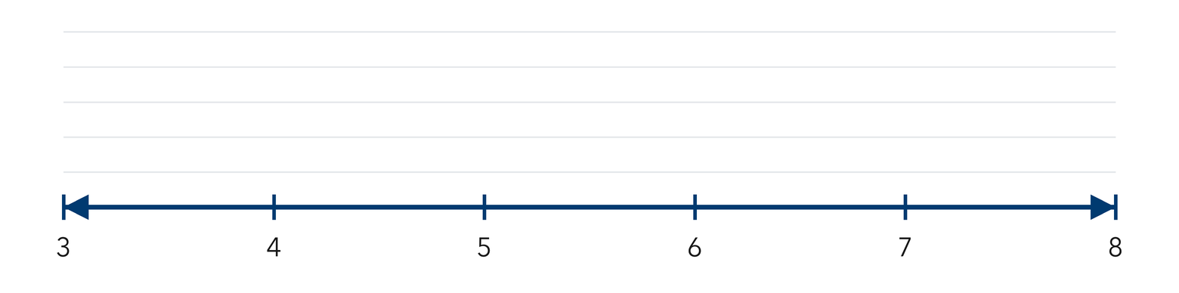
Show your work.

Answer
6. Jump Rope. A dot plot of jumps shows 2 dots above 20, 5 dots above 25, 2 dots above 30, and 1 dot above 45. Describe the shape and name any gap.

Show your work.

Answer
7. New Member. A dot plot shows these ages of club members: 11, 12, 12, 13, 13, 13, 14. Then a member who is 18 joins. Describe how the shape changes.

Show your work.

Answer
8. Counting Dots. Wendy says a dot plot with 12 dots must come from 12 different values. Explain why she is wrong, then write a set of 12 values that uses only 3 different values.

Show your work.

Answer
9. Nine students named the number of movies they saw: 0, 1, 1, 2, 1, 3, 2, 1, 0. Make a dot plot and name the most common value.

Dot plot. Stack one dot per value above its number.​
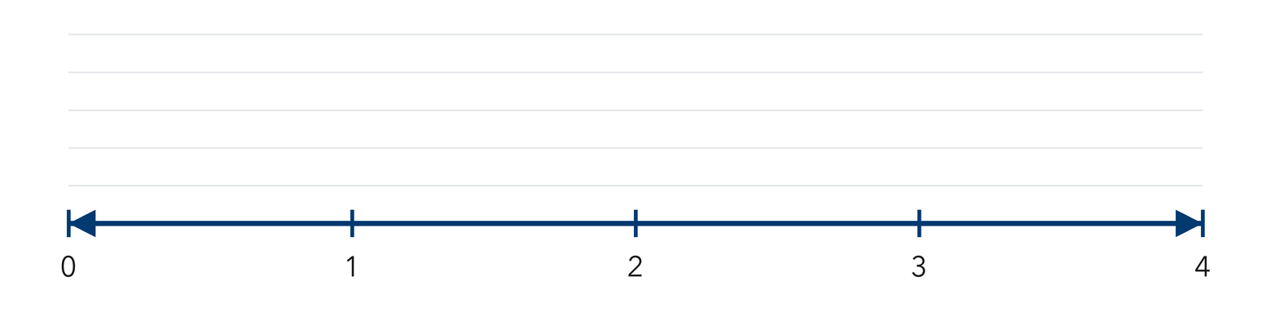
Show your work.
Answer most common value
10. A dot plot has stacks of 3, 6, 2, and 4 dots. How many data values does it show?

Show your work.
Answer data values
11. Describe It. A dot plot of sit-ups shows dots from 10 to 30 with a tall stack at 20 and even sides. Describe the shape and the most common value.

Show your work.
Answer shape and most common value
12. Find the Mistake. Jamal drew one dot for the value 4 even though 4 appeared three times. Explain the mistake and tell what his dot plot should show.

Show your work.
Answer the mistake and the fix
SPIRAL REVIEW earlier skills · 1 point each
13. From Lesson 2-1 Session 1. Write one statistical question about your class.
Answer
14. Grade 5. Find 8.4 ÷ 4.
Answer
15. Grade 5. Find the area of a rectangle 12 m by 7 m.
Answer
TEST PRACTICE multiple choice · fill one box · 1 point each
16. A dot plot stack of 6 dots over the value 3 means —
□ A. 3 students chose 6 | □ B. 6 students chose 3 | □ C. the mean is 3 | □ D. the range is 6
17. Which value is most common in 5, 7, 7, 7, 9?
□ A. 5 | □ B. 9 | □ C. 7 | □ D. 28
18. A dot plot is built on a —
□ A. table of words | □ B. circle | □ C. grid of squares | □ D. number line
CHECK YOURSELF Score: ______ / 30
□ Solved on my own | □ Needed a hint | □ Need help on Question # ______
Check one response against the data. State which measure or feature supports your answer.

