Name |  | Date |  | Period
Lesson 2-1 · Session 2 · Version 2
Guided Practice · Version 2
Dot Plots and Shape
VOCABULARY read and say each word before you begin
dot plot | A number line with one dot for each data value. | One dot = one answer
data distribution  Spanish: distribución de datos | How the data sits and how spread out it is. | Most dots near the middle
most common value | The value with the tallest stack of dots. | Tallest stack sits above 2
symmetric  Spanish: simétrico | Nearly the same on the left and right sides. | Dots balance around the peak
least and greatest | The smallest and largest values in the set. | From 0 to 4
EXPLORE TOGETHER Class Launch · 8–10 min
1. Water Bottle Count  Ms. Rivera asked nine students how many water bottles they filled at school on Tuesday: 3, 1, 4, 3, 5, 2, 3, 4, 3.  a. Organize. List the values in order from least to greatest: __________  b. Plot. On the dot plot below, stack one dot for each student's response.  c. Read. Least: ______ Greatest: ______ Most common value: ______ | d. Shape. Is the plot nearly symmetric? ______ Explain using the stacks: __________  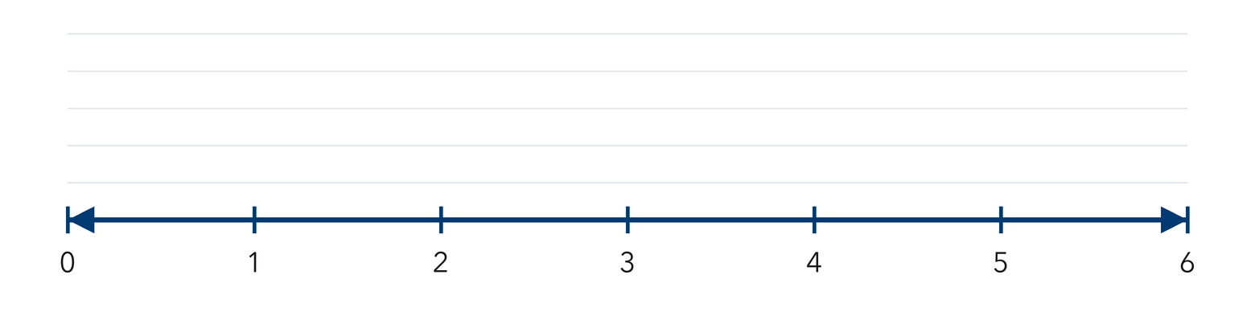​
  TURN AND TALK
  How does a dot plot show at a glance which answer came up most often?
PRACTICE WITH A PARTNER You Do Together · 10–12 min
2. Free Throws Made. Seven players made these free throws during practice: 6, 9, 7, 6, 8, 6, 10.  a. Order the data, then draw a dot plot from 6 to 10 __________  b. Most common __________ | c. Dot plot. Place one dot for each player's result above its number on the scale below.  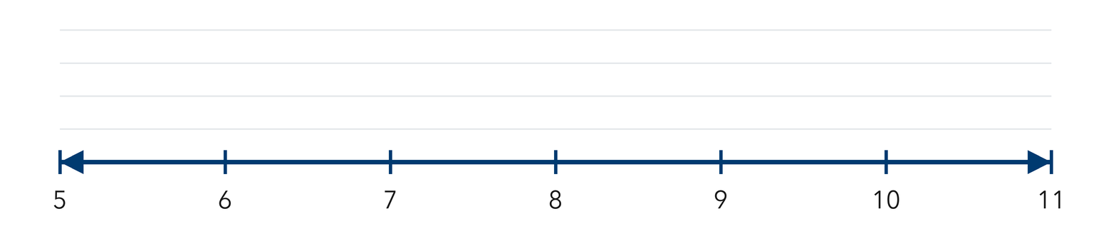
  PARTNER TALK
  What does one single dot on your plot stand for?

3. Siblings Survey. Eight students told how many siblings they have: 1, 0, 2, 3, 1, 2, 1, 4.  a. Draw the dot plot, then write the most common number of siblings __________  b. Nearly symmetric? __________ | c. Dot plot. Place one dot for each player's result above its number on the scale below.  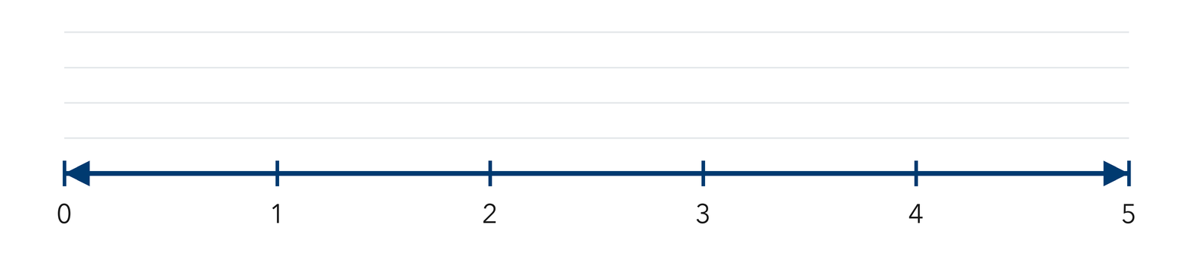
  PARTNER TALK
  How would the shape of your plot change if one more student answered 4?

4. Stickers Earned. Eight students earned these numbers of stickers: 3, 5, 4, 3, 6, 3, 4, 7.
a. Draw the dot plot from 4 to 8, then name the most common value __________
b. Greatest value __________
PARTNER TALK
Two students share the same stack. What does that stack tell you about them?

PRACTICE ON YOUR OWN You Do · 8 problems · 18–20 min
5. Piano Practice. Six students practiced piano for these numbers of minutes: 20, 30, 20, 40, 30, 20.  Plot one dot for each student's practice time, then write the most common value.  Hint Use marks spaced by tens on the number line, then stack dots above the matching values.  Answer most common number of minutes | Dot plot. Place one dot for each practice time above its number on the scale below.  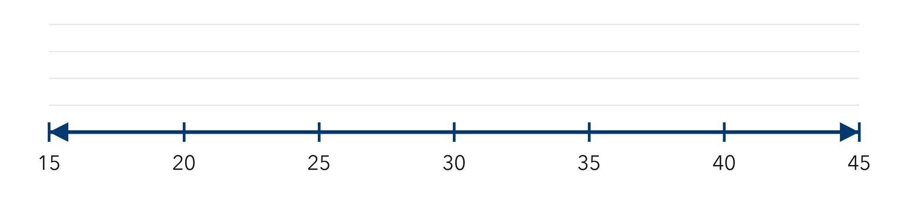
  Show your work.

6. Shape Claim. A dot plot shows these quiz scores: 7, 8, 8, 9, 8, 7, 9. Jonas says the shape is nearly symmetric.  Justify or correct Amira's claim using the dots.  Hint Compare the stacks at equal distances to the left and right of the tallest stack.  Answer Is Amira right? Explain | 7. One More Reader. A dot plot shows pages read: 12, 15, 12, 18, 12, 15. Then one more student reports reading 18 pages.  Find the most common value after the new report and explain whether the greatest value changes.  Hint Add a dot above 12, then compare the stack heights and check the greatest value.  Answer most common value; greatest value

8. Soccer Goals. Seven players scored these numbers of goals this season: 2, 5, 2, 3, 2, 4, 5.  Draw a dot plot for the tomato counts, then write the most common value  Hint Label every whole number from 3 to 6 first, then stack one dot per gardener.  Answer most common number of tomatoes | 9. Bracelet Beads. A dot plot shows these bead counts: 9, 10, 10, 11, 11, 11, 12.  Name the most common number of photos, then describe the shape of the plot  Hint Compare the stacks at equal distances to the left and right of the tallest stack.  Answer most common value; shape

10. Library Books. Ten students finished these numbers of books: 1, 3, 2, 3, 4, 3, 2, 5, 3, 2. Make a dot plot, then name the most common value.  Hint Tally the number of students for each book count before drawing the dots.  Answer the most common value | Dot plot. Place one dot for each practice time above its number on the scale below.
  Show your work.

11. Read the Stacks. On a dot plot, the value 6 has a stack of 5 dots and the value 7 has a stack of 2 dots.  a. How many students completed 3 puzzles? __________  b. How many students are represented by the two stacks together? __________  Hint Each dot represents one student.  Answer a and b | 12. Describe the Shape. A dot plot of daily texts has dots spread evenly from 4 to 12 with a tall stack at 8. Describe the shape and name the most common value.  Hint Compare the stacks at equal distances on either side of the middle peak.  Answer shape and most common value
ANALYZE THE ERROR 5 min
13. Read the work below. Explain the mistake, then show the correct reasoning.
ELI'S WORK

For the data 3, 3, 6, 9, Marcus drew one dot above 3, one dot above 6, and one dot above 9.
a. Explain the mistake. Eli has four data values but only three dots. What did he leave out? Complete: Eli forgot to plot __________. | b. Show correct work  Correct answer
  Show the correct work.
STRETCH YOUR THINKING multi-step reasoning · 8 min
14. Two Dot Plots. Class A’s dot plot of pets per student has a tall stack at 1 and a few dots at 4 and 5. Class B’s has dots spread evenly from 0 to 5.
a. Which group has the more common single answer? Explain using the stack heights.
b. Which group shows more variability? Explain using the spread of the values.
c. Describe one thing both dot plots reveal about the data that a single number could not.
Answer both comparisons and your explanation
TEST PRACTICE multiple choice · fill one box · 6 min
15. On a dot plot, what does the height of a stack tell you? | 16. A dot plot shows stacks of 2, 5, 3, and 1 dots. How many data values are plotted?
  □ A. the largest value | □ B. how many times | □ C. the average | □ D. the range
  □ A. 4 | □ B. 5 | □ C. 11 | □ D. 24

17. A dot plot’s tallest stack sits over 9. The value 9 is the — | 18. Data values are 2, 2, 3, 5, 5, 5. Which stack is tallest on the dot plot?
  □ A. total | □ B. range | □ C. least value | □ D. most common value
  □ A. over 5 | □ B. over 3 | □ C. over 2 | □ D. they are equal
SPIRAL REVIEW earlier skills · keep them sharp · 6 min
19. From Lesson 2-1 Session 1. Is “How many minutes did each student practice?” a statistical question?  Answer | 20. Grade 5. Find 3.6 + 1.45.  Answer

21. Grade 5. Find 15 × 12.  Answer | 22. Grade 5. Write 2/5 as a decimal.  Answer
CHECK YOUR UNDERSTANDING 5 min
23. Neighborhood Pets. Seven neighbors reported their number of pets: 2, 1, 2, 0, 3, 2, 4.  a. Draw the dot plot, then write the most common value __________  b. Least __________  Hint Use the scale from the smallest pet count to the largest, then plot one dot per neighbor.  Answer | c. Dot plot. Place one dot for each player's result above its number on the scale below.
  Show your work.

□ 4 — Can teach it | □ 3 — Got it | □ 2 — Need hint | □ 1 — Need help
Circle your confidence. Star one problem that shows your learning.

