Name Date Period
Lesson 2-2 · Homework Packet · Sheet 1 of 2
Building a Histogram
Maryland Standard 6.SP.B.4 · Learning target — I can group data into equal intervals and build a histogram from a frequency table.

REMEMBER  • A histogram groups data into equal intervals, like 0–9, 10–19, 20–29.  • The frequency is how many values fall in an interval. It sets the bar height.  • Intervals do not overlap, and the bars touch. | WORKED EXAMPLE  Minutes of practice: 4, 15, 22, 9, 18, 27, 13, 16, 21, 11. Make a frequency table.  Step 1 0–9: 4, 9, so the frequency is 2.  Step 2 10–19: 15, 18, 13, 16, 11, so it is 5.  Step 3 20–29: 22, 27, 21, so it is 3.  Answer 2, 5, 3
PRACTICE show your work · label units
1. Points Scored. A player scored these points in 12 games: 8, 14, 21, 5, 17, 12, 25, 19, 11, 23, 16, 9. Complete the frequency table.
Points | Tally | Frequency
0–9
10–19
20–29

2. Draw the histogram for Problem 1. Bars should touch.  a. Which interval has the tallest bar?  b. Games with 10 or more points: | 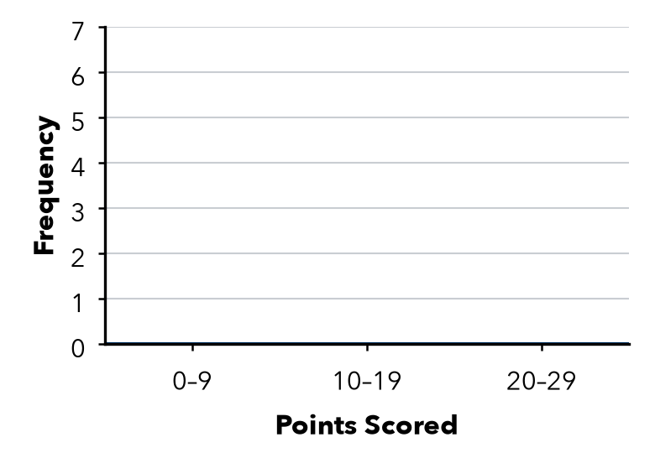

3. Picnic Ages. 34, 22, 41, 38, 27, 45, 31, 36, 29, 48 years. Find each frequency.
a. 20–29: | b. 30–39: | c. 40–49:

4. Missing Bar. A histogram shows the long-jump distances of 24 students. Three bars have heights 5, 9, and 3. There is one more bar. How tall is it?
Answer students

5. Find the Error. Marcus used the intervals 0–9, 10–14, and 15–29. Explain his mistake and fix it.

CHECK YOURSELF | □ I can do this on my own | □ I need a little help | □ I have a question about #
AT HOME Ask family members how many minutes they read today. Group the answers in intervals of 10.
Name Date Period
Lesson 2-2 · Homework Packet · Sheet 2 of 2
Describing Histogram Shape
Maryland Standard 6.SP.B.4 · Learning target — I can describe the shape of a histogram using its peak, spread, and balance.

REMEMBER  • Peak: the tallest bar. Symmetric: sides match.  • Skewed right: the tail stretches right. Skewed left: the tail stretches left.  • A histogram shows counts, not exact values. | WORKED EXAMPLE  Bars of height 2, 7, 4, 2, 1 over 0–9, 10–19, 20–29, 30–39, 40–49. Shape?  Step 1 The peak is 10–19, near the left.  Step 2 The bars shrink to the right: a tail on the right.  Answer Skewed right
PRACTICE show your work · label units

1. Test Scores. The histogram shows the scores on a class test.  a. Number of students:  b. Peak interval:  c. Shape:  d. Scores of 80 or more: | 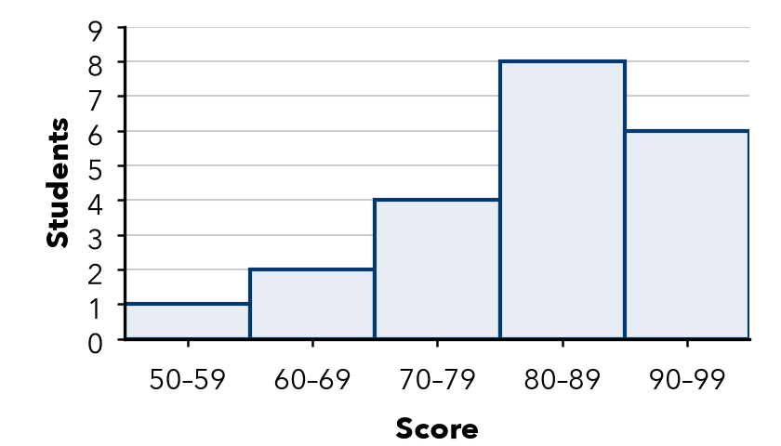

2. Bar heights are listed from left to right. Name each shape.
a. 1, 4, 8, 4, 1 | b. 9, 6, 3, 2, 1 | c. 1, 2, 3, 6, 10
d. 3, 5, 9, 5, 3 | e. 12, 8, 5, 3, 2 | f. 2, 3, 5, 8, 12

3. Race Times. Bars of 3, 8, 11, 6, 2 show 30 runners’ times: 20–24, 25–29, 30–34, 35–39, 40–44 min.
a. How many runners finished in less than 30 minutes?
b. How many finished in 35 minutes or more?

4. Stretch. Write 5 bar heights, from left to right, for a histogram of 20 values that is skewed left.
Bar heights

5. Explain. Ramon says the Test Scores histogram shows a score of 85. Is he right? Explain.

TEST PRACTICE choose the best answer
6. Bar heights are listed from left to right. Which histogram is skewed right?
A 2, 5, 9, 5, 2 | B 10, 7, 4, 2, 1 | C 1, 2, 4, 7, 10 | D 5, 5, 5, 5, 5

7. Bars of height 4, 7, and 5 sit over 0–9, 10–19, and 20–29. How many values are 10 or more?
A 7 | B 11 | C 12 | D 16

CHECK YOURSELF | □ I can do this on my own | □ I need a little help | □ I have a question about #

