Name |  | Date |  | Period
Lesson 2-2 · Session 1 · Version 2
Guided Practice · Version 2
Building a Histogram
VOCABULARY read and say each word before you begin
histogram | A graph that groups data into equal intervals. | Bars that touch
interval  Spanish: intervalo | A range of numbers used to group data. | 10-19 is one interval
frequency  Spanish: frecuencia | How many data values fall in one interval. | Bar height shows the count
frequency table | A table listing each interval and its count. | 10-19 . . . 3
distribution  Spanish: distribución | How the data spreads across the intervals. | Tallest bar in the middle
EXPLORE TOGETHER Class Launch · 8–10 min
1. Minutes on the Bus  Nine students on Route 4 recorded how many minutes their bus ride took: 5, 14, 22, 11, 8, 17, 26, 3, 19.  a. Intervals. Use 0-9, 10-19, 20-29. Are they the same width? ______ Do any overlap? ______  b. Tally. Count the rides in each interval. 0-9: ______ 10-19: ______ 20-29: ______  c. Graph. Draw a histogram in the frame below with three touching bars at those heights. | d. Read. Which interval holds the fewest rides? ______ How does the graph show it? __________  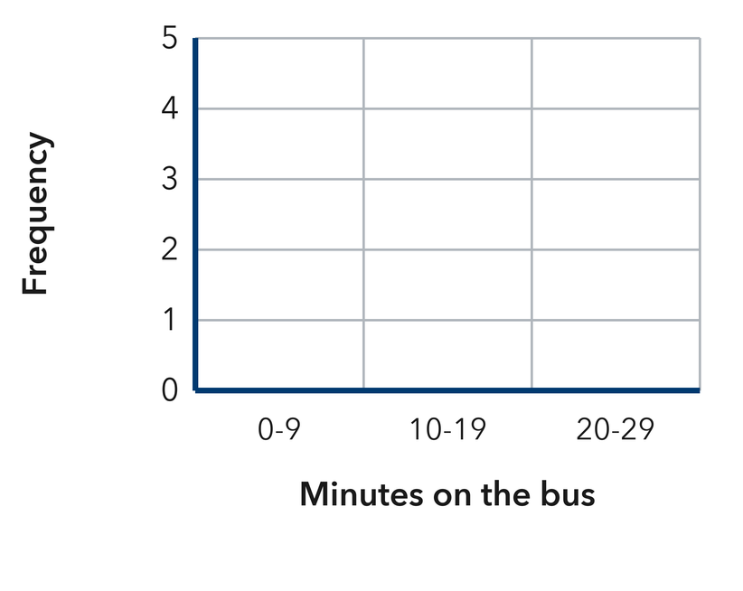​
  TURN AND TALK
  Why must the intervals be the same width and never overlap?
PRACTICE WITH A PARTNER You Do Together · 10–12 min
2. Pushup Challenge. Eight students did these numbers of pushups: 22, 15, 9, 27, 13, 18, 26, 24.  a. Frequencies for 0-9, 10-19, 20-29 __________  b. Add your three counts. What total should you get, and why? __________ | c. Histogram. Draw one touching bar per interval at the height you counted. Use the intervals 0-9, 10-19 and 20-29.​  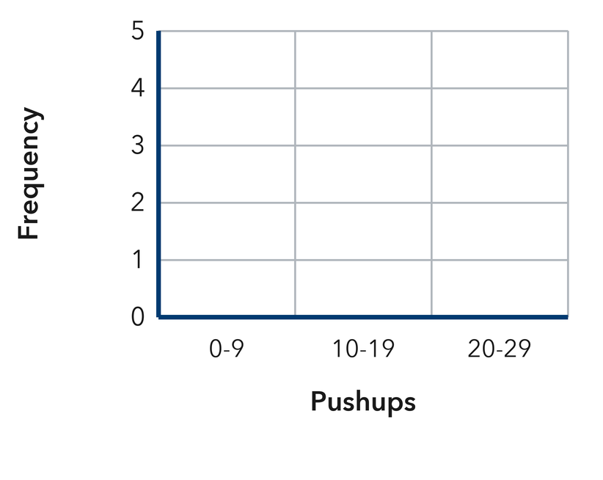
  PARTNER TALK
  How do the bar heights together compare with the number of students surveyed?

3. Song Lengths. Eight songs last these numbers of seconds: 118, 134, 126, 145, 121, 139, 155, 137.  a. Frequencies for 210-229, 230-249, 250-269 __________  b. Draw the histogram. Which bar is tallest? __________ | 4. Craft Club Beads. Eight bracelets used these numbers of beads: 21, 34, 46, 29, 38, 52, 31, 44.  a. Frequencies for 40-49, 50-59, 60-69, 70-79 __________  b. What number should your four counts add to? __________
  PARTNER TALK
  Why do the bars of a histogram touch when the bars of a bar graph do not?
  PARTNER TALK
  Why does every bracelet land in exactly one bar and never in two?
PRACTICE ON YOUR OWN You Do · 8 problems · 18–20 min
5. Rainfall Totals. Seven weeks brought these rainfall totals in mm: 3, 16, 11, 28, 9, 21, 14.  Find the frequency for each interval 0-9, 10-19, 20-29, then draw the histogram.  Hint Put the totals in order first so each one falls into exactly one interval as you tally.  Answer frequency for each interval | 6. Overlapping Bins. Lena groups the values 5, 11, 16, 20, 24 using the intervals 5-10, 10-15, 15-20, 20-25.  Explain what is wrong with Darius’s intervals, then write a set that works.  Hint Look at the endpoints. Ask which single bar a value like 30 would have to go in.  Answer the flaw; a corrected set of intervals

7. Missing Bar. A histogram of 9 reading logs has a bar of height 2 over 0-19, a bar of height 4 over 20-39, and one more bar over 40-59.  Find the height of the third bar and explain how you know.  Hint Every quiz score lands in exactly one bar, so the bar heights account for all of them.  Answer height of the third bar | 8. Saturday Car Wash. Seven Saturdays brought these car counts: 12, 27, 18, 33, 24, 9, 30.  Find the frequency for each interval 0-9, 10-19, 20-29, 30-39, then draw the histogram  Hint Put the sales in order first so each one drops into exactly one interval as you tally.  Answer frequency for each interval

9. Unequal Bins. Malachi groups the values 8, 13, 19, 26, 40 using the intervals 5-9, 10-19, 20-39, 40-59.
Explain what is wrong with Priya’s intervals, then write a set that works
Hint Find the width of each interval before you tally anything.
Answer the flaw; a corrected set of intervals

10. Plant Heights. Eight plants grew 62, 75, 68, 81, 77, 64, 79, and 85 cm. Use the intervals 60–69, 70–79, and 80–89 and give the frequency of each.  Hint Count how many heights land in each interval.  Answer three frequencies | Histogram. Draw one touching bar per interval at the height you counted.​  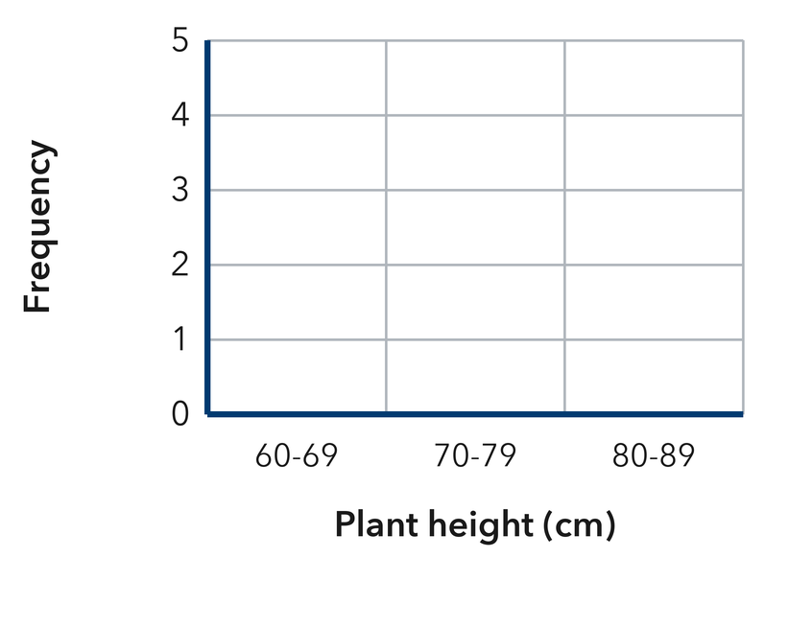
  Show your work.

11. Read the Table. A frequency table shows 40–49: 5, 50–59: 8, 60–69: 4, 70–79: 3.  a. How many values are in the table altogether? __________  b. Which interval has the tallest bar? __________  Hint Add the frequencies; the biggest frequency makes the tallest bar.  Answer a and b | 12. Choose the Intervals. Test scores run from 51 to 98. Name four equal intervals of width 10 that cover every score.  Hint Start at a multiple of 10 at or below the least value.  Answer four intervals
ANALYZE THE ERROR 5 min
13. Read the work below. Explain the mistake, then show the correct reasoning.
NADIA’S WORK

For the values 4, 12, 18, 26, Ibrahim drew bars over 0-9, 10-19 and 20-29 with a space between each bar.
a. Explain the mistake. Look at the gaps between Nadia’s bars. What does a histogram require instead? | b. Show correct work  Correct answer
  Show the correct work.
STRETCH YOUR THINKING multi-step reasoning · 8 min
14. Field Day Times. Twelve runners finished in 31, 44, 38, 52, 47, 35, 41, 56, 39, 48, 33, and 45 seconds.  a. Build a frequency table using the intervals 30–39, 40–49, and 50–59.  b. Which interval holds the fewest runners?  c. Explain why a histogram shows the times better than a list of the 12 numbers.  Answer the table, the busiest interval, and your explanation | d. Histogram. Draw one touching bar per interval at the height you counted. Use equal intervals of width 10.​  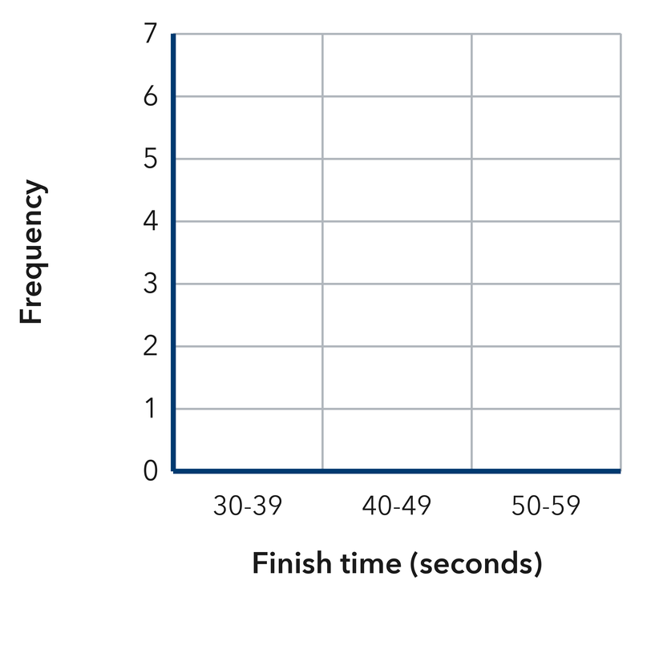
  Show your work.
TEST PRACTICE multiple choice · fill one box · 6 min
15. In a histogram, the height of a bar shows the — | 16. Which set of intervals is correct for a histogram?
  □ A. interval width | □ B. largest value | □ C. frequency | □ D. median
  □ A. 0–9, 10–25, 26–30 | □ B. 0–9, 5–14, 10–19 | □ C. 0–10, 20–30, 40–50 | □ D. 0–9, 10–19, 20–29

17. A frequency table shows 3, 7, 5, and 2. How many values were collected? | 18. Histogram bars touch each other because the intervals are —
  □ A. 17 | □ B. 7 | □ C. 4 | □ D. 21
  □ A. the same height | □ B. next to each other | □ C. always equal | □ D. in a circle
SPIRAL REVIEW earlier skills · keep them sharp · 6 min
19. From Lesson 2-1 Session 2. A dot plot has stacks of 4, 2, and 6 dots. How many values does it show?  Answer | 20. From Lesson 2-1 Session 1. Is “How tall is our school’s flagpole?” statistical?  Answer

21. Grade 5. Find 96 ÷ 8.  Answer | 22. Grade 5. Find 6.5 × 3.  Answer
CHECK YOUR UNDERSTANDING 5 min
23. Field Day Jumps. Eight students jumped these distances in cm: 106, 122, 115, 131, 119, 127, 110, 118.  a. Frequencies for 100-109, 110-119, 120-129, 130-139 __________  b. Which interval is the most common? __________  Hint Tally one jump at a time and cross it off, so no value gets counted in two intervals.  Answer | c. Histogram. Draw one touching bar per interval at the height you counted. Use the intervals shown.​  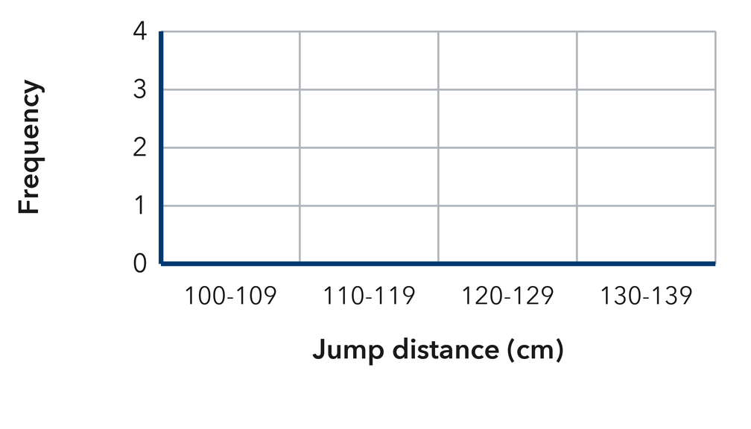
  Show your work.

□ 4 — Can teach it | □ 3 — Got it | □ 2 — Need hint | □ 1 — Need help
Circle your confidence. Star one problem that shows your learning.

