Name |  | Date |  | Period

Lesson 2-2 · Session 2
Homework
Describing Histogram Shape
Maryland Standard 6.SP.B.4 · Learning target — I can describe the shape of a histogram using its peak, spread, and balance.
Show a model, calculation, or explanation for each exercise. Label units and answer every part.
Exercises 1–12 earn 1 point for a correct response and 1 for supporting work. Spiral Review and Test Practice earn 1 point each.
REMEMBER review this before you start
• Histogram shapes: symmetric, skewed left, skewed right, uniform (bars about the same height), or bimodal (two peaks).
• The tallest bar(s) show where most of the data values are clustered.
• Watch out — the direction of the skew is named for the long tail, not for the tall bars.
• Check it — describe shape with three words: peak, spread, and symmetric or skewed.
WORKED EXAMPLE the same steps you practiced in class
Reading the Shape of a Histogram A histogram has a bar of height 2 over 60-69, height 4 over 70-79, and height 2 over 80-89.
Step 1 Sketch the bars at heights 2, 4, and 2 over the three intervals, touching with no gaps.
Step 2 Find the peak: the tallest bar covers the interval 70-79.
Step 3 Compare sides: the bar left of the peak and the bar right of it are the same height.
Step 4 Matching sides mean the data is nearly symmetric around the peak.
Answer The histogram peaks over 70-79 and is symmetric, so a typical value falls in 70-79.
EXERCISES 12 exercises · 24 points
1. A histogram of ages at a party has short bars on both ends and one tall bar in the middle. Describe its shape. ______

Show your work.
Answer
2. The 10 quiz scores from Session 1 group as 60s:2, 70s:3, 80s:3, 90s:2. Is this shape closer to symmetric or skewed? Explain.

Show your work.
Answer
3. Sketch a histogram that is skewed right, with bars for intervals 0-9, 10-19, 20-29, 30-39.

Histogram. Draw one touching bar per interval. Make it skewed right: the tall bar on the left, a tail to the right.​
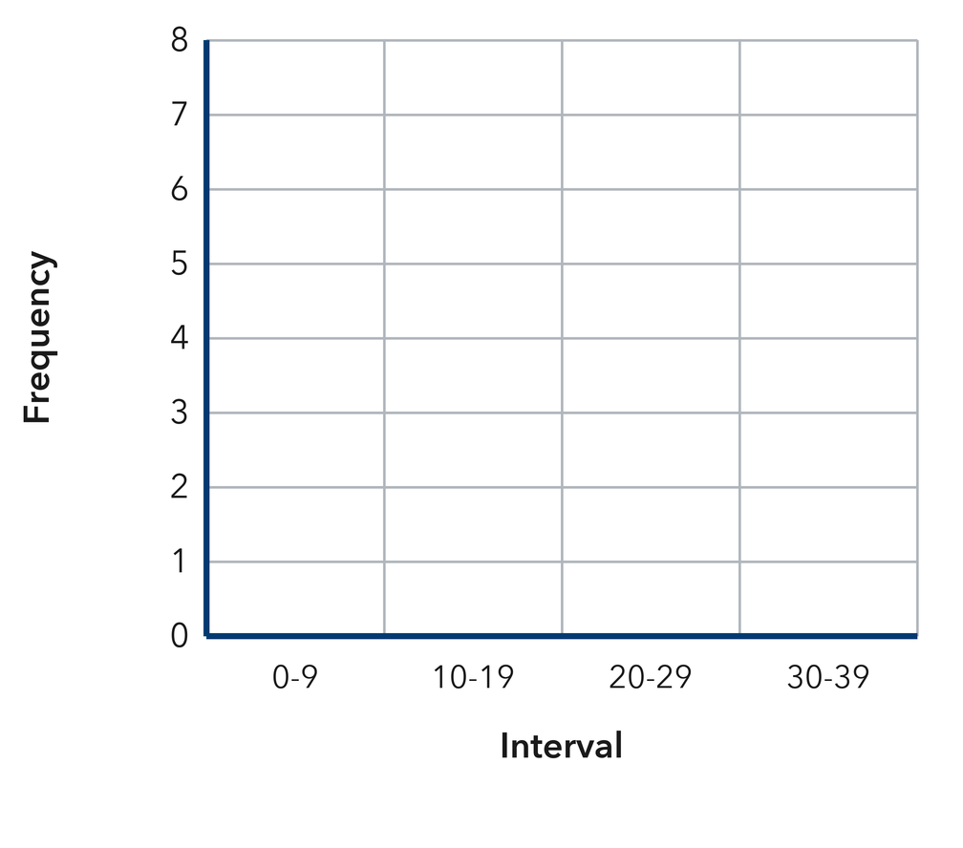
Show your work.
Answer
4. A histogram has bars of height 3 over 0-9, 8 over 10-19, 3 over 20-29, and 1 over 30-39.
a. Peak interval ______
b. Total values ______
c. Symmetric or skewed right? ______
d. Interval with the fewest values ______

e. Read the histogram. This is the histogram the problem describes.​
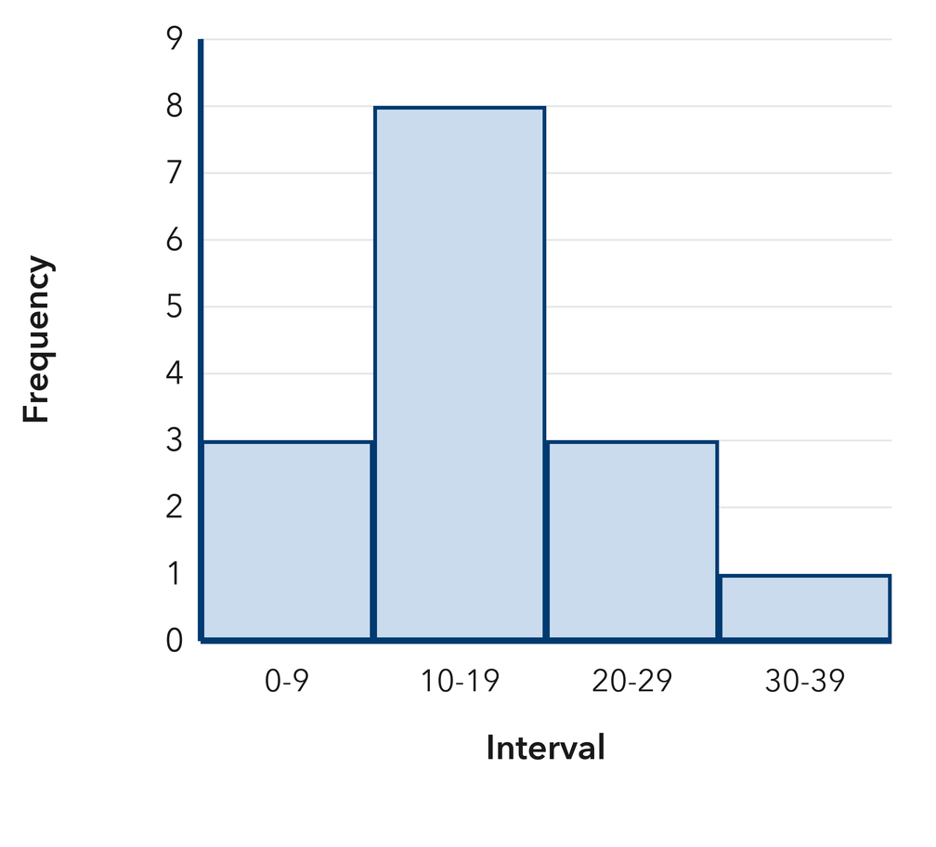
Answer
5. Field Trip Miles. A histogram has bars of height 5 over 0-19, 5 over 20-39, 5 over 40-59, and 5 over 60-79. Name the shape and explain how you know.

Show your work.

Answer
6. Reading Logs. A histogram of pages read has bars of height 1 over 0-9, 2 over 10-19, 4 over 20-29, 7 over 30-39, and 9 over 40-49. Describe the shape and name the interval holding a typical value.

Read the histogram. This is the histogram the problem describes.​
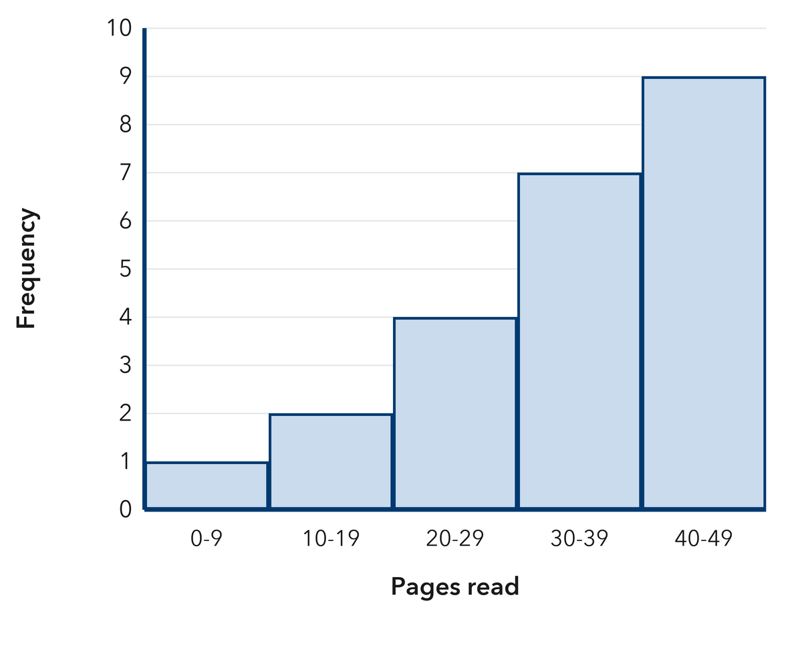
Show your work.

Answer
7. Empty Bars. A histogram of prices has bars of height 4 over $0-$4, 6 over $5-$9, 0 over $10-$14, 0 over $15-$19, and 3 over $20-$24. Describe the shape and explain what the two empty bars mean.

Read the histogram. This is the histogram the problem describes.​
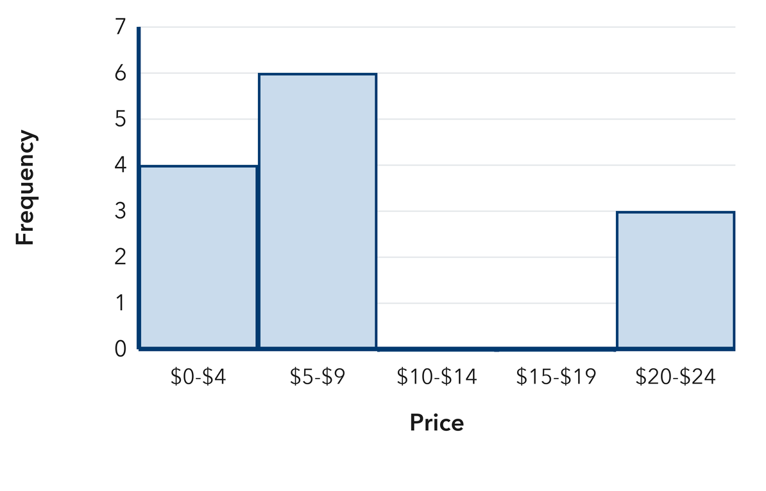
Show your work.

Answer
8. Naming the Tail. Reggie says a histogram with a tall bar on the left and short bars trailing to the right is skewed left. Explain his mistake and name the correct shape.

Show your work.

Answer
9. A histogram has bars of height 3, 9, and 4. Name the peak interval position and the total number of values.

Show your work.
Answer peak position and total
10. Bars of height 1, 3, 9, 3, 1 describe what shape? Explain.

Show your work.
Answer shape and why
11. Name the Skew. Bars of height 11, 6, 3, 2, 1 from least to greatest describe what shape? Where do most values sit?

Show your work.
Answer shape and where most values sit
12. Find the Mistake. Andre says a histogram with bars 9, 5, 2, 1 is skewed left because the tall bar is on the left. Explain his mistake.

Show your work.
Answer the mistake
SPIRAL REVIEW earlier skills · 1 point each
13. From Lesson 2-2 Session 1. Which intervals are correct: 0–9, 10–19, 20–29 or 0–10, 10–20, 20–30?
Answer
14. From Lesson 2-1 Session 1. Is “How many pets does each student own?” statistical?
Answer
15. Grade 5. Find 7.5 − 2.8.
Answer
TEST PRACTICE multiple choice · fill one box · 1 point each
16. A long tail toward the larger values means the data is —
□ A. skewed right | □ B. symmetric | □ C. skewed left | □ D. flat
17. Bars of height 2, 5, 8, 5, 2 describe a shape that is —
□ A. skewed right | □ B. symmetric | □ C. skewed left | □ D. random
18. The peak of a histogram tells you —
□ A. the interval width | □ B. the total count | □ C. where most data sits | □ D. the least value
CHECK YOURSELF Score: ______ / 30
□ Solved on my own | □ Needed a hint | □ Need help on Question # ______
Check one response against the data. State which measure or feature supports your answer.

