Name |  | Date |  | Period
Lesson 2-2 · Session 2
Guided Practice
Describing Histogram Shape
VOCABULARY read and say each word before you begin
shape of the data | The pattern the bars make across the intervals. | Tall middle, short sides
peak | The tallest bar in the display. | The middle bar is the peak
symmetric  Spanish: simétrico | The two sides of the display look about the same. | Matching bars on each side
frequency  Spanish: frecuencia | How many data values fall in one interval. | Bar height shows the count
distribution  Spanish: distribución | How the data spreads across the intervals. | Most values near the peak
EXPLORE TOGETHER Class Launch · 8–10 min
1. Tomato Plant Heights  Nine tomato plants measured these heights in cm: 14, 22, 18, 26, 17, 21, 12, 20, 24.  a. Table. Counts for 10-14, 15-19, 20-24, 25-29: ______ ______ ______ ______  b. Graph. Draw four touching bars at those heights in the frame below. Label each interval under its bar.  c. Peak. Which interval is the peak? ______ How many plants are in it? ______ | d. Shape. Nearly symmetric? ______ Describe the two sides: __________  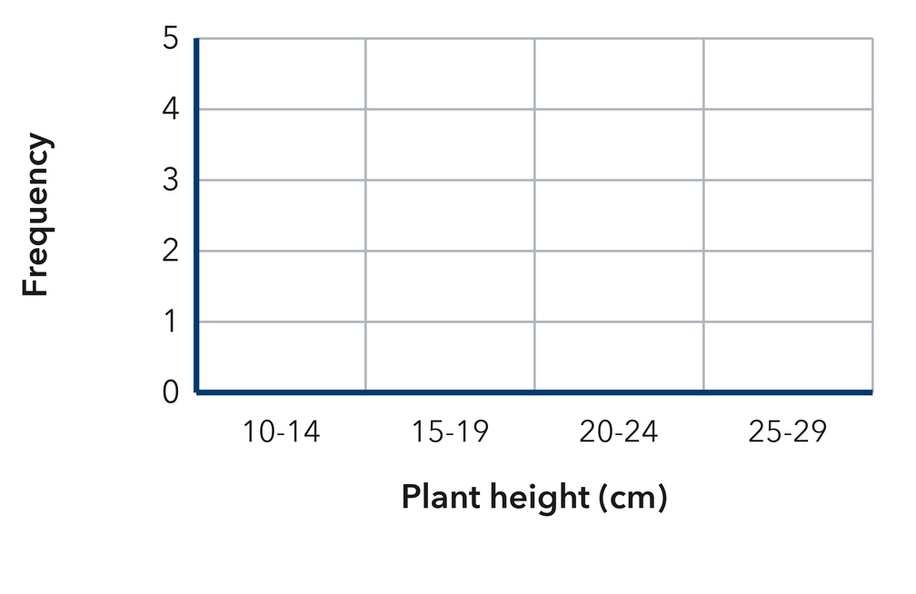​
  TURN AND TALK
  What does the peak of a histogram tell you about a typical plant in this group?
PRACTICE WITH A PARTNER You Do Together · 10–12 min
2. Movie Lengths. Eight movies run these numbers of minutes: 108, 142, 155, 121, 134, 117, 149, 166.  a. Frequencies for 100-119, 120-139, 140-159, 160-179 __________  b. Describe the shape in one sentence __________ | 3. Laps Walked. Seven students walked these numbers of laps: 3, 11, 7, 15, 9, 13, 5.  a. Frequencies for 0-4, 5-9, 10-14, 15-19 __________  b. Which interval is the peak? __________
  PARTNER TALK
  Why is a histogram easier to read than a dot plot when the values are spread far apart?
  PARTNER TALK
  How does the shape of your graph shape your idea of what a typical student walked?

4. Cabbage Weights. A histogram shows bars of height 2 over 1-2 lb, 6 over 3-4 lb, 5 over 5-6 lb, and 1 over 7-8 lb.  a. Which interval is the peak? __________  b. Describe the shape in one sentence __________ | c. Read the histogram. This is the cabbage-weight histogram the problem describes.​  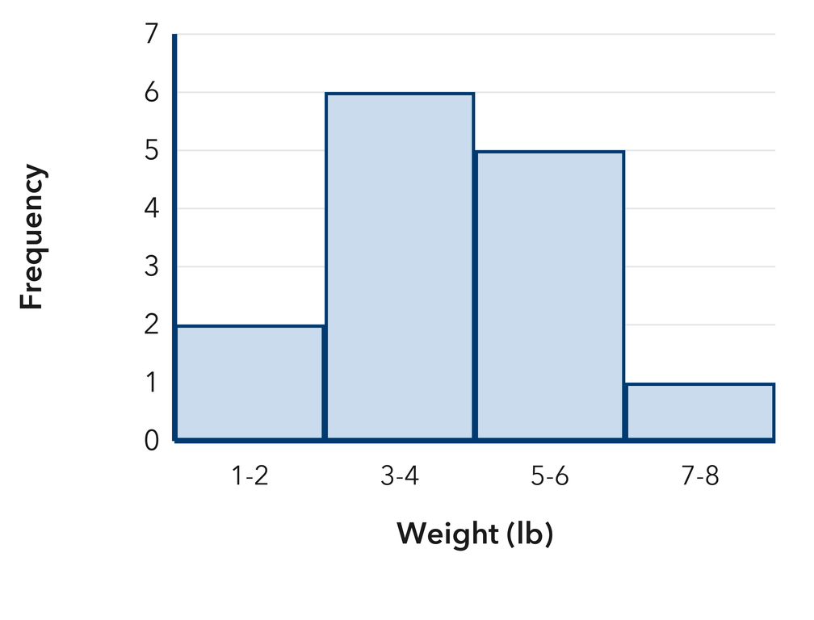
  PARTNER TALK
  How does the peak help you name a typical cabbage without listing every weight?
PRACTICE ON YOUR OWN You Do · 8 problems · 18–20 min
5. Museum Visitors. A histogram of daily visitors has bars of height 3 over 20-29, 8 over 30-39, 3 over 40-49, and 1 over 50-59.  Describe the shape, then explain which interval holds a typical day.  Hint Locate the peak first, then compare how quickly the bars drop on each side of it.  Answer shape; interval of a typical day | Read the histogram. This is the visitor histogram the problem describes.​  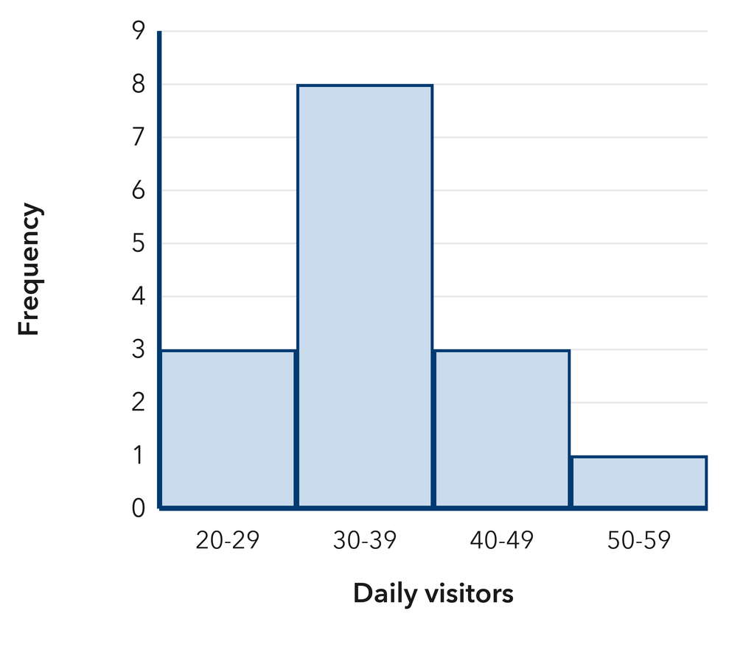
  Show your work.

6. Display Choice. Tariq recorded 120 temperatures, each to the nearest tenth of a degree, and plans to draw a dot plot.
Explain which display fits this data better and why.
Hint Picture how many separate marks a dot plot needs when almost no value repeats.
Answer better display, with a reason

7. Symmetry Claim. A histogram has bars of height 1 over 0-9, 2 over 10-19, 9 over 20-29, 2 over 30-39, and 1 over 40-49. Ramona calls the shape symmetric.  Justify or correct Ramona’s claim.  Hint Match each bar left of the peak with the bar the same distance to the right of it.  Answer Is Ramona right? Explain | Read the histogram. This is the histogram Ramona is describing.​  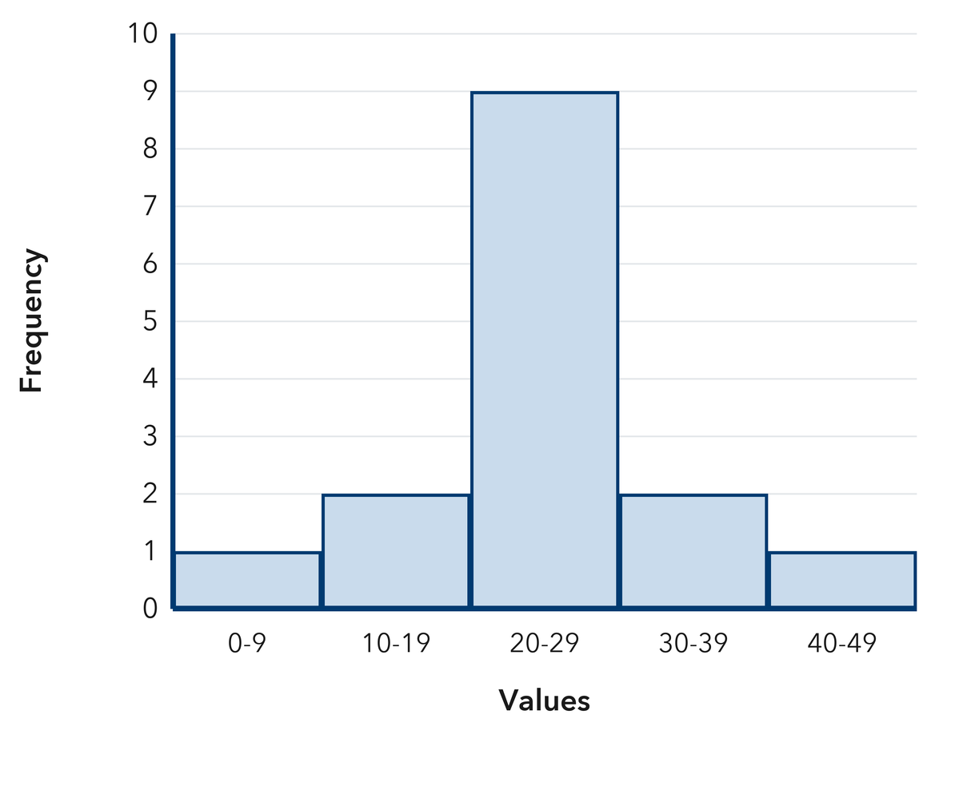
  Show your work.

8. Snow Totals. A histogram of snowfall has bars of height 1 over 0-2 in., 3 over 3-5 in., 7 over 6-8 in., 3 over 9-11 in., and 1 over 12-14 in.
Describe the shape, then name the interval that holds a typical total
Hint Match each bar left of the peak with the bar the same distance to the right of it.
Answer shape; interval of a typical total

9. Two Peaks. A histogram of ticket prices has bars of height 6 over $0-$9, 2 over $10-$19, 1 over $20-$29, 6 over $30-$39, and 2 over $40-$49.  Explain why this shape is not symmetric and tell how many peaks it has  Hint Look for more than one tall bar before you decide on a single peak.  Answer number of peaks; why it is not symmetric | Read the histogram. This is the ticket-price histogram the problem describes.​  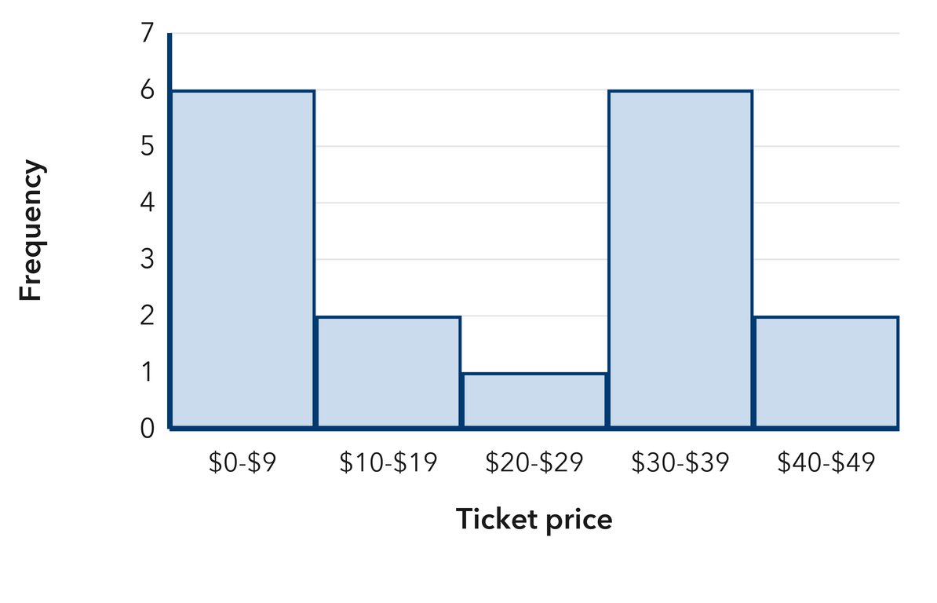
  Show your work.

10. Read the Bars. A histogram has bars of height 2 over 60–69, 7 over 70–79, and 3 over 80–89. Name the peak interval and the total number of values.  Hint The tallest bar is the peak; add the heights for the total.  Answer peak interval and total | 11. Symmetric or Skewed? A histogram has bars of height 1, 4, 8, 4, and 1 across five equal intervals. Describe its shape.  Hint Compare the left side with the right side.  Answer the shape

12. Long Tail. A histogram of donation amounts has bars of height 9, 5, 2, 1, and 1 from least to greatest. Describe the shape and tell where most donations fall.
Hint A tail that stretches toward the larger values is skewed right.
Answer shape and where most values fall
ANALYZE THE ERROR 5 min
13. Read the work below. Explain the mistake, then show the correct reasoning.
COLETTE’S WORK

A histogram has bars 2, 9, 2. Colette wrote: ‘The tallest bar means one single value showed up 9 times.’
a. Explain the mistake. The tallest bar covers an interval, not one value. What should Colette say instead? | b. Show correct work  Correct answer
  Show the correct work.
STRETCH YOUR THINKING multi-step reasoning · 8 min
14. Two Histograms. Histogram P has bars 2, 6, 9, 6, 2. Histogram Q has bars 10, 6, 4, 3, 2.  a. Describe the shape of each histogram.  b. Which one has most of its data in the lowest interval?  c. Both histograms show 25 values. Explain how two sets with the same count can look so different.  Answer both shapes, the answer to b, and your explanation | d. Read histogram P.​  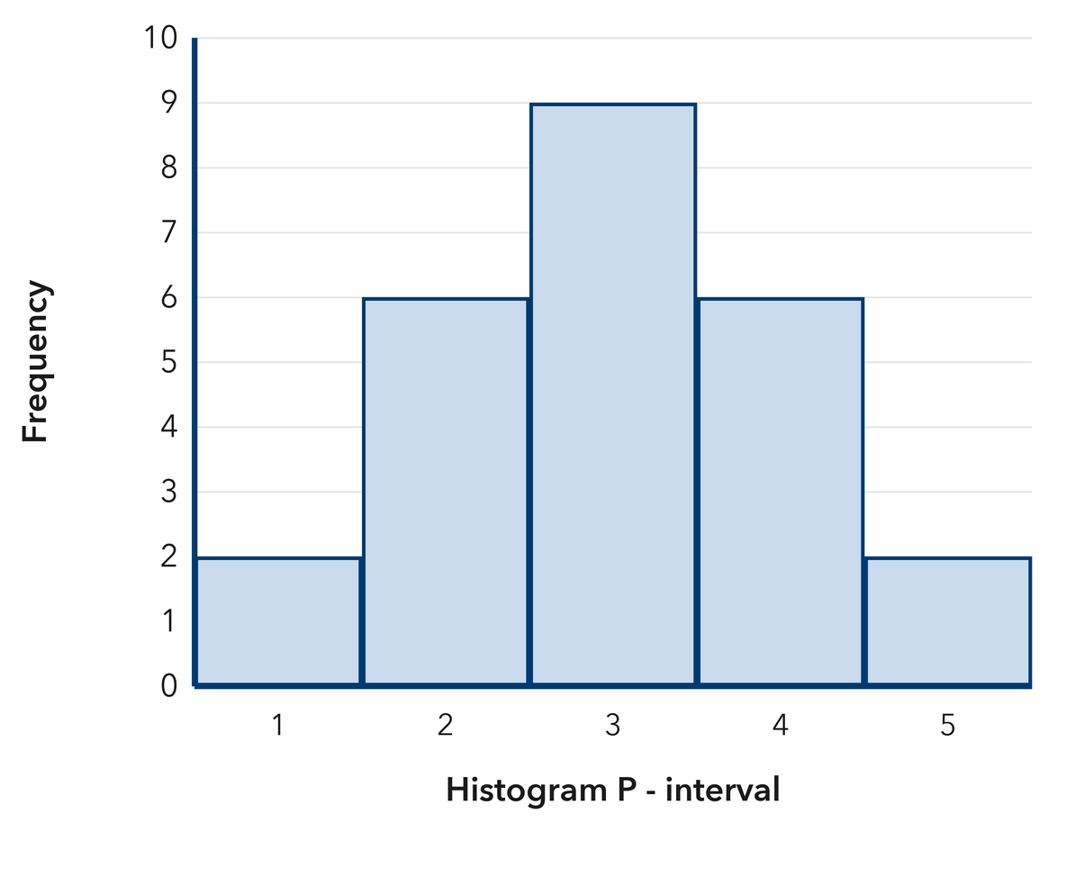  Read histogram Q.​  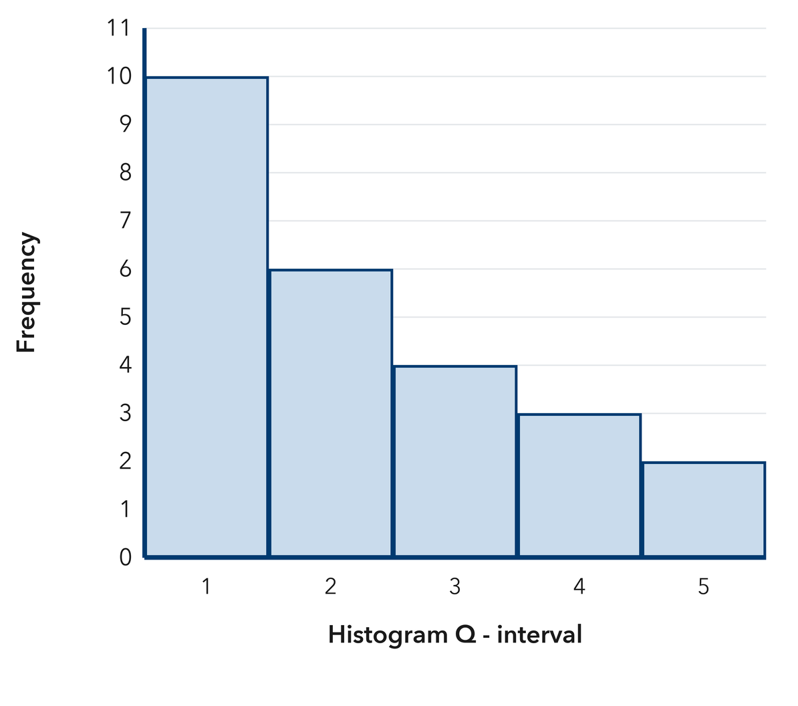
  Show your work.
TEST PRACTICE multiple choice · fill one box · 6 min
15. A histogram with matching left and right sides is — | 16. Bars of height 8, 4, 2, 1 from least to greatest describe a shape that is —
  □ A. symmetric | □ B. skewed left | □ C. skewed right | □ D. flat
  □ A. symmetric | □ B. skewed right | □ C. skewed left | □ D. a circle

17. The peak of a histogram is the interval with the — | 18. Bars of height 2, 3, 5, 9 from least to greatest describe a shape that is —
  □ A. least value | □ B. widest bar | □ C. tallest bar | □ D. most intervals
  □ A. flat | □ B. skewed right | □ C. symmetric | □ D. skewed left
SPIRAL REVIEW earlier skills · keep them sharp · 6 min
19. From Lesson 2-2 Session 1. Frequencies are 4, 6, and 5. How many values are in the table?  Answer | 20. From Lesson 2-1 Session 2. A dot plot stack of 7 dots over 5 means what?  Answer

21. Grade 5. Find 144 ÷ 12.  Answer | 22. Grade 5. Find 2.5 × 8.  Answer
CHECK YOUR UNDERSTANDING 5 min
23. Backpack Weights. Nine backpacks weigh these numbers of pounds: 12, 18, 15, 21, 14, 16, 19, 16, 17.  a. Frequencies for 12-14, 15-17, 18-20, 21-23 __________  b. Name the peak and describe the shape __________  Hint Sort the weights first, then tally them into the four intervals before you describe the shape.  Answer | c. Histogram. Draw one touching bar per interval at the height you counted. Use the intervals 10-14, 15-19 and 20-24.​  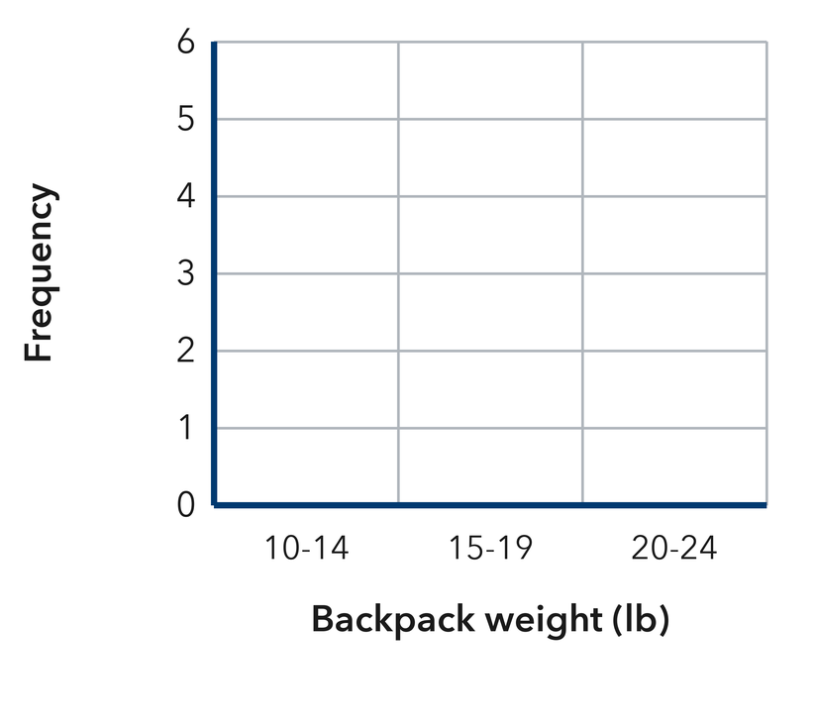
  Show your work.

□ 4 — Can teach it | □ 3 — Got it | □ 2 — Need hint | □ 1 — Need help
Circle your confidence. Star one problem that shows your learning.

