Name Date Period
Lesson 2-4 · Homework Packet · Sheet 1 of 2
Building a Box Plot
Maryland Standard 6.SP.B.4 · Learning target — I can find the five-number summary of a data set and use it to build a box plot.

REMEMBER  • Five-number summary: minimum, Q1, median, Q3, maximum.  • Q1 is the median of the lower half; Q3 of the upper half. Odd count: leave the median out.  • The box goes from Q1 to Q3, with a line at the median. Whiskers reach the min and max. | WORKED EXAMPLE  Find the five-number summary of 4, 6, 9, 10, 13, 15, 18.  Step 1 Min = 4, max = 18, median = 10  Step 2 Lower half 4, 6, 9, so Q1 = 6  Step 3 Upper half 13, 15, 18, so Q3 = 15  Answer 4, 6, 10, 15, 18
PRACTICE show your work · label units
1. Push-ups. Nine students did 22, 40, 10, 34, 18, 46, 25, 14, and 30 push-ups. Find the five-number summary.
Min | Q1 | Median | Q3 | Max

2. Draw a box plot of the push-up data from Problem 1.
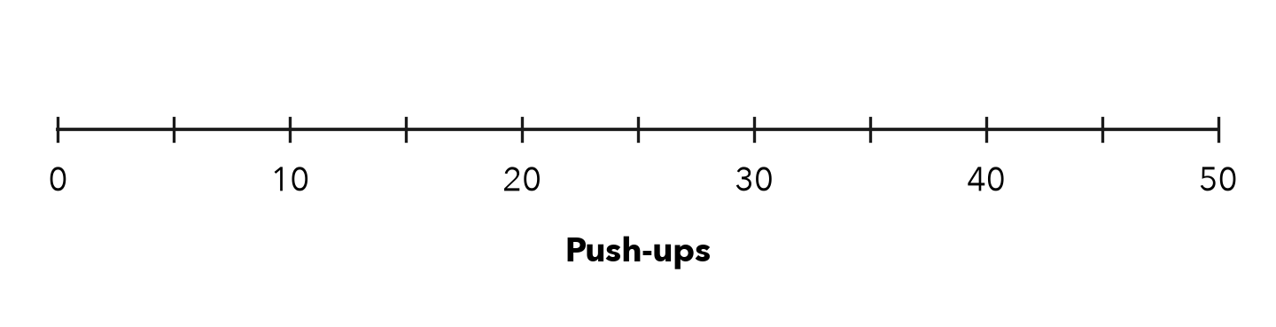

3. Temperatures. The box plot shows daily high temperatures (°F) for a month.  a. Median: °F  b. Q1 and Q3:  c. Fraction of days from 58 to 70°F: | 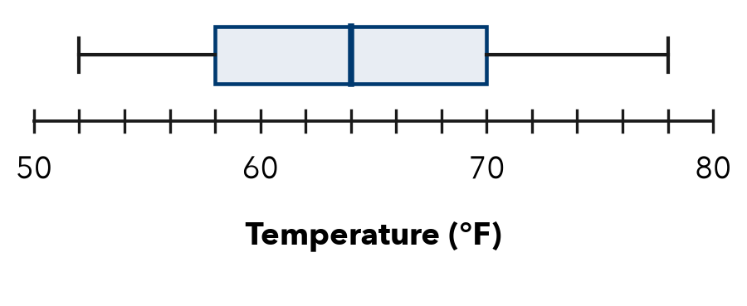

4. Homework Minutes. 26, 14, 39, 20, 11, 32, 18, 28. Find each value.
a. Q1: | b. Median: | c. Q3:

5. Find the Error. Grace says Q1 of 2, 5, 7, 8, 12, 14, 20 is 6. She used 2, 5, 7, 8 as the lower half. Explain her error and find Q1.

CHECK YOURSELF | □ I can do this on my own | □ I need a little help | □ I have a question about #
AT HOME Explain to someone at home what the box in a box plot shows.
Name Date Period
Lesson 2-4 · Homework Packet · Sheet 2 of 2
Comparing Box Plots
Maryland Standard 6.SP.B.4 · Learning target — I can compare two groups by reading the medians and box widths of their box plots.

REMEMBER  • Compare centers: use the medians.  • Compare spread: box width and range.  • A narrower box (Q3 − Q1) is more consistent. | WORKED EXAMPLE  A: median 18, box 14–22. B: median 24, box 20–26.  Step 1 Center: 24 > 18, so B scored higher.  Step 2 Box widths: A is 22 − 14 = 8; B is 26 − 20 = 6.  Answer B is higher and more consistent
PRACTICE show your work · label units

1. Reading Time. Minutes of reading per day for Class A and Class B.  a. Greater median: by min  b. Box widths: A B  c. More consistent: | 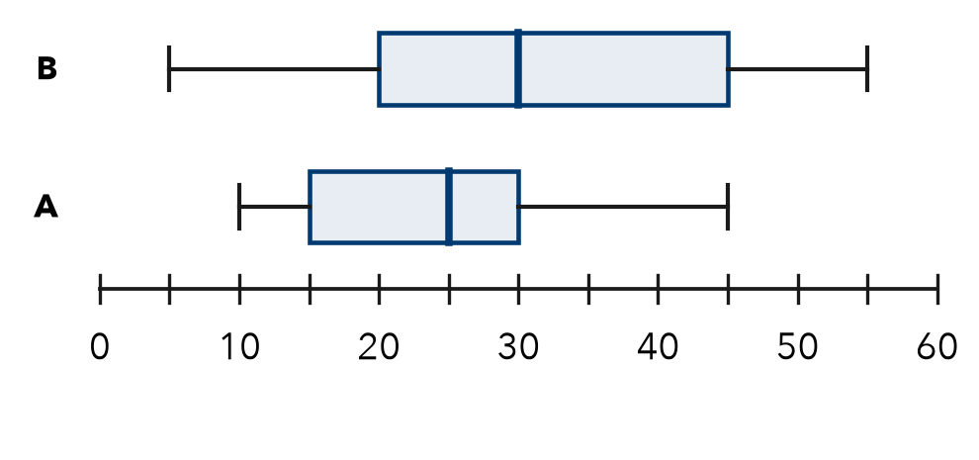

2. Find each measure of spread.
a. Q1 = 12, Q3 = 30. Box width: | b. Min = 5, max = 41. Range:

3. Bowling. Complete the table for two bowlers’ scores.
 | Min | Q1 | Median | Q3 | Max | Box width | Range
Maya | 80 | 95 | 102 | 110 | 125
Leon | 70 | 90 | 105 | 112 | 140
Who is more consistent?

4. Plant Heights. Both medians are 14 cm. Box S: 12–16 cm. Box T: 8–20 cm. Which varies more?
□ Group S | □ Group T

5. Choose a Bus. Both medians are 20 min. Boxes: A 18–22, B 14–26 min. Which is more reliable?

TEST PRACTICE choose the best answer
6. X: Q1 = 22, Q3 = 34. Y: Q1 = 25, Q3 = 31. Which middle half is more consistent?
A X | B Y | C They are equal | D Cannot tell

7. A box plot has the summary 8, 12, 15, 21, 30. How wide is the box?
A 9 | B 22 | C 15 | D 3

CHECK YOURSELF | □ I can do this on my own | □ I need a little help | □ I have a question about #

