Name |  | Date |  | Period

Lesson 2-4 · Session 1
Homework
Building a Box Plot
Maryland Standard 6.SP.B.4 · Learning target — I can find the five-number summary of a data set and use it to build a box plot.
Show a model, calculation, or explanation for each exercise. Label units and answer every part.
Exercises 1–12 earn 1 point for a correct response and 1 for supporting work. Spiral Review and Test Practice earn 1 point each.
REMEMBER review this before you start
• The five-number summary is: minimum, Q1 (lower quartile), median, Q3 (upper quartile), maximum.
• A box plot uses these five numbers to show the spread of the data.
• Watch out — with an odd count, the median is not part of either half when you find Q1 and Q3.
• Check it — the five numbers must read in order: min ≤ Q1 ≤ median ≤ Q3 ≤ max.
WORKED EXAMPLE the same steps you practiced in class
Finding the Five-number Summary Seven daily high temperatures in degrees are 58, 71, 64, 83, 66, 77, 61. Build the box plot.
Step 1 Order the values: 58, 61, 64, 66, 71, 77, 83.
Step 2 Mark the median, 66 — the middle value of the seven.
Step 3 Lower half 58, 61, 64 gives quartile 1 as 61. Upper half gives quartile 3 as 77.
Step 4 Draw a box from 61 to 77 with a line at 66, then whiskers out to 58 and to 83.
Answer Five-number summary: 58, 61, 66, 77, 83. The box covers the middle half of the data.
EXERCISES 12 exercises · 24 points
1. Data set: 2, 4, 5, 7, 8, 9, 11, 12, 15. Find the five-number summary.
Min ______ Q1 ______ Median ______ Q3 ______ Max ______

Show your work.
Answer
2. Draw and label a number line, then make a box plot for the data in problem 1.

Box plot. Mark all five values on the scale, then draw the box and both whiskers.​
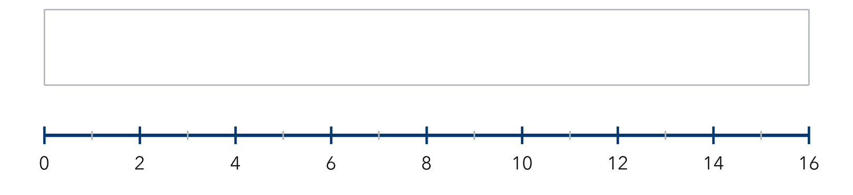
Show your work.
Answer
3. What does the length of the box (from Q1 to Q3) tell you about the middle 50% of the data?

Show your work.
Answer
4. Use the ordered data 6, 10, 14, 18, 22, 26, 30.
a. Minimum ______
b. Q1 ______
c. Median ______
d. Q3 ______
e. Maximum ______

Answer
5. Apple Harvest. Seven baskets hold 24, 31, 19, 40, 27, 36, 22 apples. Find the five-number summary.

Show your work.

Answer
6. Swim Times. Eight swim times in seconds are 41, 47, 39, 53, 45, 49, 43, 55. Find the five-number summary.

Show your work.

Answer
7. Reading the Box. A box plot of daily temperatures shows minimum 48, quartile 1 at 56, median 61, quartile 3 at 70, maximum 82. Find the width of the box and explain what share of the days falls inside it.

Read the box plot. This is the temperature plot the problem describes.​
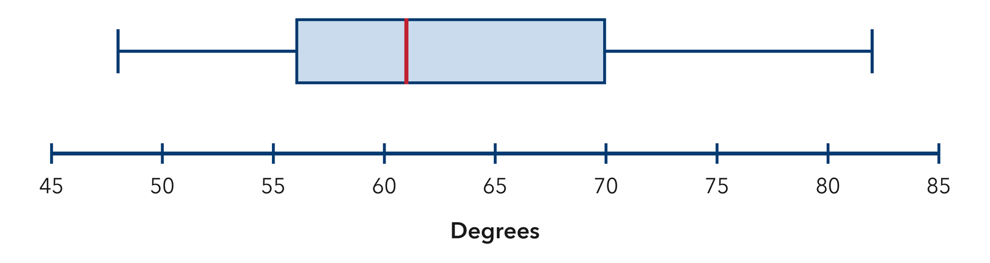
Show your work.

Answer
8. Halfway Claim. Percy says the median of a box plot always sits exactly halfway between Q1 and Q3. Use the summary 12, 15, 17, 25, 30 to explain why he is wrong.

Show your work.

Answer
9. Find the five-number summary of 20, 34, 27, 41, 23, 38, and 30.

Show your work.
Answer min, Q1, median, Q3, max
10. A box plot has min 5, Q1 11, median 15, Q3 22, max 28. How long is the box?

Show your work.
Answer units
11. Eight Values. Find the five-number summary of 62, 55, 71, 58, 66, 74, 60, and 68.

Show your work.
Answer min, Q1, median, Q3, max
12. Find the Mistake. Devon included the median in both halves when finding Q1 and Q3 for a set of 7 values. Explain why that is wrong.

Show your work.
Answer the explanation
SPIRAL REVIEW earlier skills · 1 point each
13. From Lesson 2-3 Session 2. Find the median of 11, 17, 23, 29.
Answer
14. From Lesson 2-2 Session 2. Bars of height 2, 4, 9, 4, 2 describe what shape?
Answer
15. Grade 5. Find 9.6 ÷ 8.
Answer
TEST PRACTICE multiple choice · fill one box · 1 point each
16. The whiskers of a box plot reach the —
□ A. minimum and maximum | □ B. quartiles | □ C. mean | □ D. median
17. Q3 is the median of the —
□ A. lower half | □ B. upper half | □ C. whole set | □ D. box
18. For 10, 20, 30, 40, 50, 60, 70, what is Q1?
□ A. 10 | □ B. 30 | □ C. 20 | □ D. 40
CHECK YOURSELF Score: ______ / 30
□ Solved on my own | □ Needed a hint | □ Need help on Question # ______
Check one response against the data. State which measure or feature supports your answer.

