Name Date Period
Lesson 3-2 · Homework Packet · Sheet 1 of 2
Understanding Unit Rates
Maryland Standard 6.RP.A.2 · Learning target — I can find a unit rate and use rate language such as “per hour” or “each.”

REMEMBER  • A rate compares two quantities with different units, like 150 miles in 3 hours.  • A unit rate is the amount for 1 unit. Divide the first amount by the second.  • Use rate words: per, each, for every 1. Always label the units. | WORKED EXAMPLE  A printer prints 72 pages in 4 minutes. Find the pages per minute.  Step 1 Write the rate: 72 pages for 4 minutes  Step 2 Divide: 72 ÷ 4 = 18  Answer 18 pages per minute
PRACTICE show your work · label units
1. Find each unit rate.
a. 135 miles in 3 hours mi per hour | b. $48 for 6 tickets per ticket
c. 280 words in 4 minutes words per min | d. 84 apples in 7 bags apples per bag

2. Dog Walking. Jaylen earns the same amount each hour. Complete the double number line. Then write the unit rate.
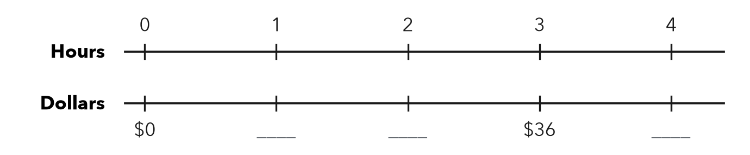
Unit rate

3. Smoothie Stand. A smoothie stand sells 156 smoothies in 6 hours at a steady pace. Find the unit rate. At this rate, how many smoothies does it sell in 9 hours?

Show your work.
Answer

4. Two Unit Rates. A baker uses 12 cups of flour for 4 loaves of bread.
a. How many cups of flour per loaf? cups per loaf
b. How many loaves per cup of flour? loaf per cup

5. Find the Error. Ivy types 150 words in 3 minutes. Ben wrote 3 ÷ 150 = 0.02 words per minute. Explain his mistake and find the correct unit rate.

CHECK YOURSELF | □ I can do this on my own | □ I need a little help | □ I have a question about #
AT HOME Find a rate on a label or sign at home (miles per hour, cost per pound). Say what “per” means.
Name Date Period
Lesson 3-2 · Homework Packet · Sheet 2 of 2
Comparing Unit Prices (Best Buy)
Maryland Standard 6.RP.A.2 · Learning target — I can compare unit prices to decide which package is the better buy.

REMEMBER  • Unit price = total cost ÷ number of units.  • The lower unit price is the better buy. | WORKED EXAMPLE  Pack A has 6 granola bars for $4.20. Pack B has 10 bars for $6.50. Which is the better buy?  Step 1 A: $4.20 ÷ 6 = $0.70 per bar  Step 2 B: $6.50 ÷ 10 = $0.65 per bar  Answer $0.65 < $0.70, so Pack B is the better buy.
PRACTICE show your work · label units
1. Find each unit price.
a. 5 lb of rice for $7.50 per lb | b. 8 juice boxes for $4.00 per box

2. Complete the table. Circle the better buy.
 | Price | Size | Unit price (per oz)
Small box | $3.60 | 12 oz
Large box | $5.04 | 18 oz

3. Paint. A 2-gallon can of paint costs $46. A 5-gallon bucket costs $107.50.
a. Unit price of the can: per gallon
b. Unit price of the bucket: per gallon
c. How much do you save on each gallon with the bucket? per gallon

4. Notebooks. Store A sells 4 notebooks for $5.00. Store B sells 6 notebooks for $7.80.
a. Unit price: Store A per notebook Store B per notebook
b. Which store has the better buy?

5. Reasoning. Carmen says a 32-oz jar for $5.12 is a better buy than a 16-oz jar for $2.40 because bigger is cheaper. Is she right? Explain.

TEST PRACTICE choose the best answer
6. Which bag of apples is the best buy?
A 3 lb for $4.50 | B 5 lb for $7.00 | C 2 lb for $3.20 | D 4 lb for $6.40

7. A pack of 12 water bottles costs $5.40. What is the price per bottle?
A $0.45 | B $2.22 | C $4.50 | D $64.80

CHECK YOURSELF | □ I can do this on my own | □ I need a little help | □ I have a question about #
AT HOME Compare two sizes of the same item at home or in a store ad. Which is the better buy?

