Name |  | Date |  | Period
Lesson 3-4 · Session 1
Guided Practice
Graphing Ratios on Coordinate Planes
VOCABULARY read and say each word before you begin
coordinate plane | The grid where points are plotted. | x across, y up
ordered pair  Spanish: par ordenado | Two numbers naming one point: (x, y). | (2, 14)
origin  Spanish: origen | The point (0, 0) where the axes meet. | 0 pages, 0 stickers
x-axis / y-axis | x runs across (the thing you count); y runs up (the result). | x = pages, y = stickers
EXPLORE TOGETHER Class Launch · 8–10 min
1. Soccer Equipment Bags  Each bag holds 6 soccer balls. Let x = bags and y = total balls.  a. Table. Complete the table: (1 bag, 6 balls), (2 bags, 12 balls), (3 bags, 18 balls).  b. Ordered Pairs. Write points: (1, 6), (2, 12), (3, 18), (4, ______)  c. Graph Shape. All points form a straight ray that passes through the origin (0, 0). | d. Graph. Plot the ordered pairs on the coordinate plane, then draw a straight line through the points and the origin.​  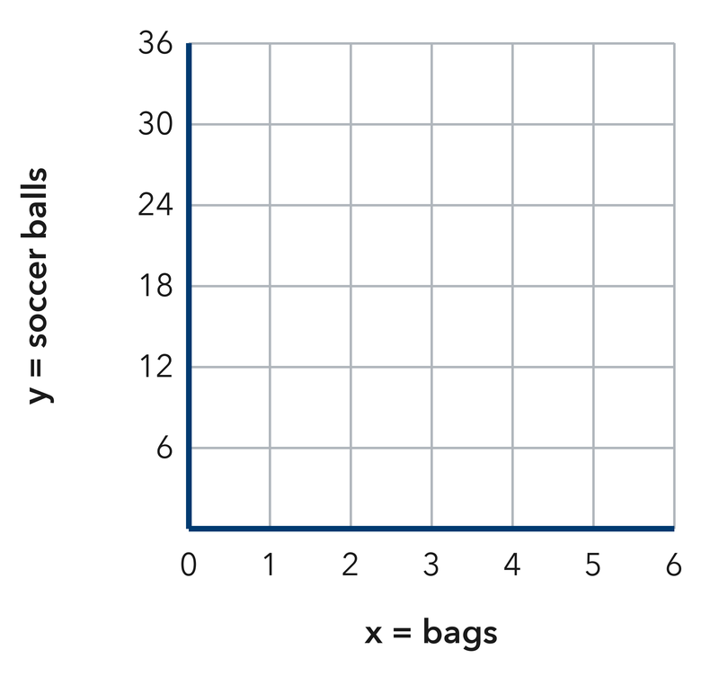
  Bags (x) | 1 | 2
  Balls (y) | 6 | 12
  Point (x, y) | (1, 6) | (2, 12)
  TURN AND TALK
  What does the origin (0, 0) mean in this situation?
  Sentence frame: “The point (0, 0) means that 0 bags contain…”
PRACTICE WITH A PARTNER You Do Together · 10–12 min
2. Hiking Trail Climb. Hikers climb at a steady rate of 3 miles every 1 hour (x = hours, y = miles).  a. Write ordered pairs for 1, 2, 3, and 4 hours: (1, 3), (2, 6), (3, ______ ), (4, ______ )  b. What point shows the distance after 6 hours? (6, __________ | c. Graph. Plot the ordered pairs on the coordinate plane, then draw a straight line through the points and the origin.​  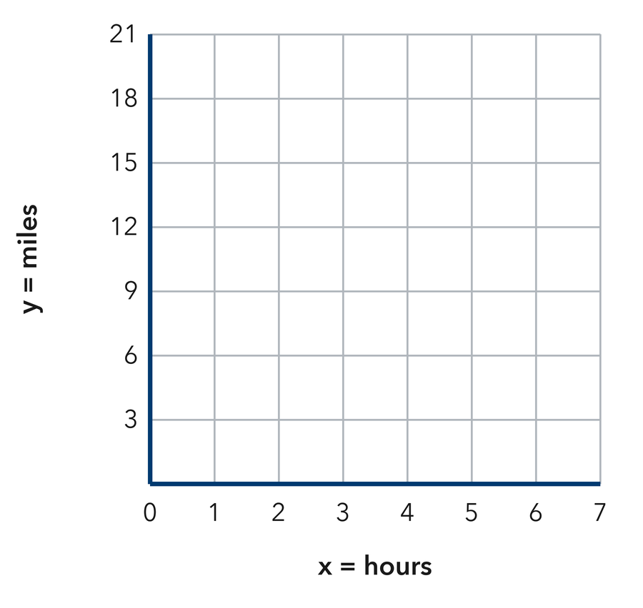
  Hours (x) | 1 | 2 | 3 | 4
  Miles (y) | 3 | 6
  PARTNER TALK
  Does multiplying x by 3 give y for every single point?

3. File Downloads. A computer downloads 5 GB every 2 minutes (x = minutes, y = GB).  a. Ordered pairs for 2, 4, 6 min: (2, 5), (4, 10), (6, __________  b. How many GB are downloaded in 10 minutes? __________ | 4. Street Tree Planting. A city crew plants 7 trees on every block. Let x = blocks and y = trees.  a. Ordered pairs (1, 7), (2, ______ ), (3, ______ )  b. Point for 6 blocks (6, __________
  PARTNER TALK
  How many 2-minute blocks fit in 10 minutes? Compare your GB answers.
  PARTNER TALK
  Does multiplying the x-value by 7 give the y-value for every point you wrote?
PRACTICE ON YOUR OWN You Do · 8 problems · 18–20 min
5. Allowance Savings. Maya saves $4 each week (x = weeks, y = dollars).  a. Write ordered pairs for 1, 2, 3, 5 weeks: (1, 4), (2, ______ ), (3, ______ ), (5, ______ ).  b. Find y for the point (8, y): y = __________  Hint Multiply weeks by 4.  Answer dollars in 8 weeks | c. Graph. Plot the ordered pairs on the coordinate plane, then draw a straight line through the points and the origin. Label the point for 8 weeks.​  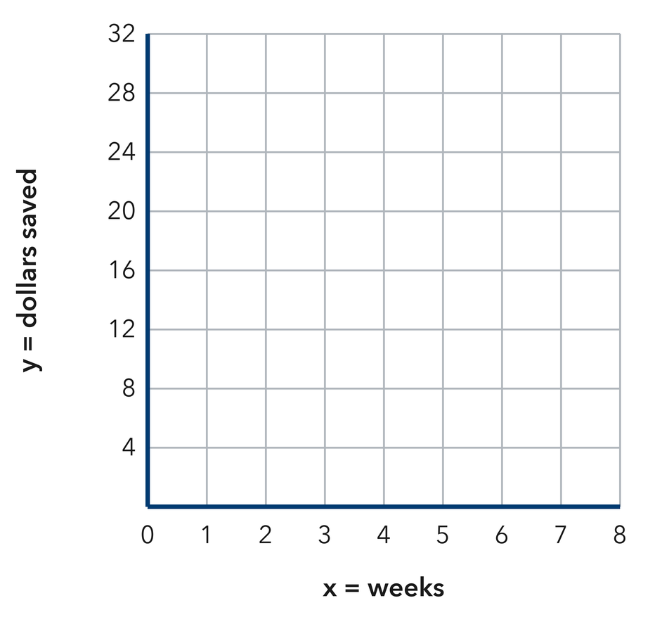
  Show your work.

6. Poster Printing. A printer prints 8 posters each minute.  a. Write the equation: y = __________  b. What does (0, 0) mean here?  Hint y = (rate) • x.  Answer equation and meaning | 7. Scooter Range. A scooter goes 15 miles per battery charge. Which point is on its graph: (2, 25), (3, 45), or (4, 55)?  Hint Test each point with y = 15x. Does 15 times the x-value give the y-value?  Answer correct point

8. Recess Jump Ropes. Each bin holds 5 jump ropes. Let x = bins and y = jump ropes.  Write the ordered pairs for 1, 4, and 9 bins, then find y for the point (12, y)  Hint Multiply the number of bins by 5 to get the jump ropes.  Answer pairs and the y-value for 12 bins | 9. Garden Hose Fill. A hose adds 11 gallons to a barrel every minute. Let x = minutes and y = gallons.  Write the equation for this graph, then decide which point is on it: (3, 30), (5, 55), or (7, 84)  Hint Write y = 11x, then test each point by multiplying its x-value by 11.  Answer equation and the correct point

10. Sticker Sheets. A sheet holds 7 stickers. Let x = sheets and y = stickers. Give the ordered pairs for 1, 2, 3, and 4 sheets.  Hint Multiply each x by 7 to get y.  Answer four ordered pairs | 11. Read the Pairs. A ratio graph passes through (2, 10) and (5, 25).  a. What is the y-value when x = 1? __________  b. What is the y-value when x = 8? __________  Hint Both pairs simplify to the same unit ratio.  Answer a and b

12. Plot and Describe. A recipe uses 3 cups of water for every 1 cup of rice. Give three ordered pairs (rice, water), then describe the graph.  Hint Start at (1, 3) and scale up.  Answer pairs and your description | Graph. Plot your three ordered pairs on the coordinate plane, draw the line through the origin, then describe the graph below.​  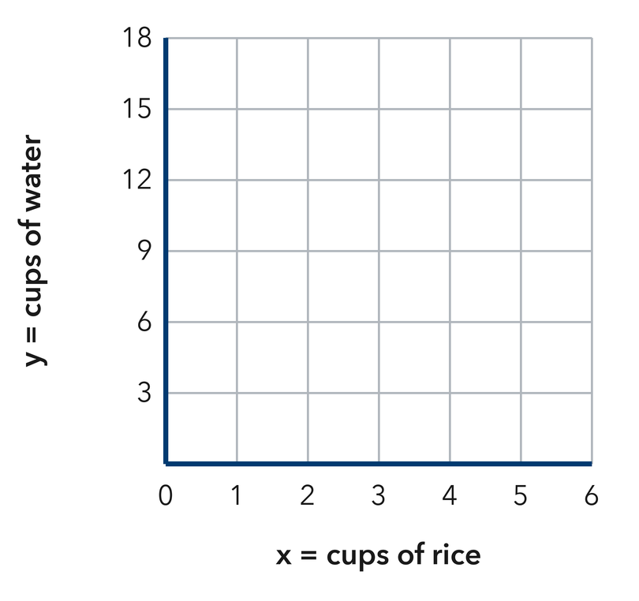
  Show your work.
ANALYZE THE ERROR 5 min
13. Read the work below. Explain the mistake, then show the correct reasoning.
CHLOE’S WORK
A car travels 50 mph. Chloe plotted the points backwards as (50, 1) and (100, 2).

a. Explain the mistake. What mistake did Chloe make?  Sentence frame: “Chloe flipped x and y; time goes on the x-axis, so points should be (1, 50) and (2, 100)…” | b. Show correct work  Correct answer
  Show the correct work.
STRETCH YOUR THINKING multi-step reasoning · 8 min
14. Two Stores. Store A sells notebooks at 3 for $6. Store B sells them at 4 for $10.  a. Give two ordered pairs (notebooks, cost) for each store.  b. Which store’s line would be steeper? Explain what steeper means here.  c. Find the cost of 12 notebooks at each store.  Answer the pairs, the steeper line, and both costs | d. Graph both stores. Plot each store’s pairs on the same plane and draw both lines. Label them A and B.​  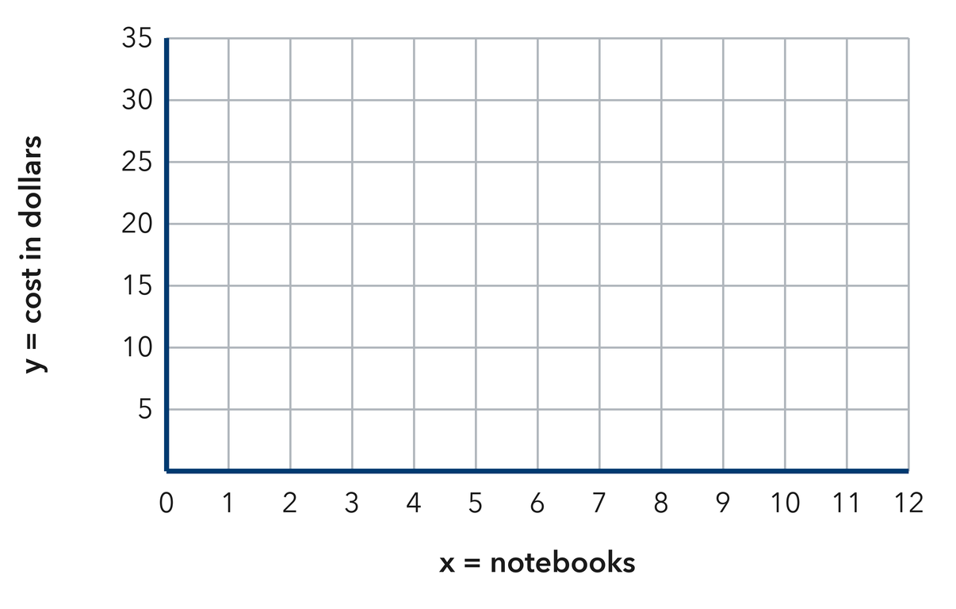
  Show your work.
TEST PRACTICE multiple choice · fill one box · 6 min
15. In the ordered pair (4, 12), the number 4 is the — | 16. A ratio of 1 : 6 gives which ordered pair when x = 3?
  □ A. x-value | □ B. y-value | □ C. origin | □ D. slope
  □ A. (18, 3) | □ B. (3, 18) | □ C. (3, 6) | □ D. (6, 3)

17. Points from equivalent ratios always form a — | 18. A ratio graph always passes through —
  □ A. curve | □ B. circle | □ C. straight line | □ D. square
  □ A. (1, 0) | □ B. (1, 1) | □ C. (0, 1) | □ D. (0, 0)
SPIRAL REVIEW earlier skills · keep them sharp · 6 min
19. From Lesson 3-3 Session 2. For 6 : 15, how much goes with 10?  Answer | 20. From Lesson 3-2 Session 1. A machine fills 240 bottles in 5 minutes. Find the unit rate.  Answer

21. From Lesson 3-1 Session 2. Share 55 in the ratio 3 : 8. Find both shares.  Answer | 22. From Lesson 2-3 Session 1. Find the median of 34, 29, 41, 37, 31.  Answer
CHECK YOUR UNDERSTANDING 5 min
23. Bread Baking Graph. A bakery bakes 4 loaves per batch.  a. Write ordered pairs for 1, 2, and 5 batches __________  b. What does the point (6, 24) mean in words? __________  Hint Multiply batches by 4.  Answer | c. Graph. Plot the ordered pairs on the coordinate plane, then draw a straight line through the points and the origin.​  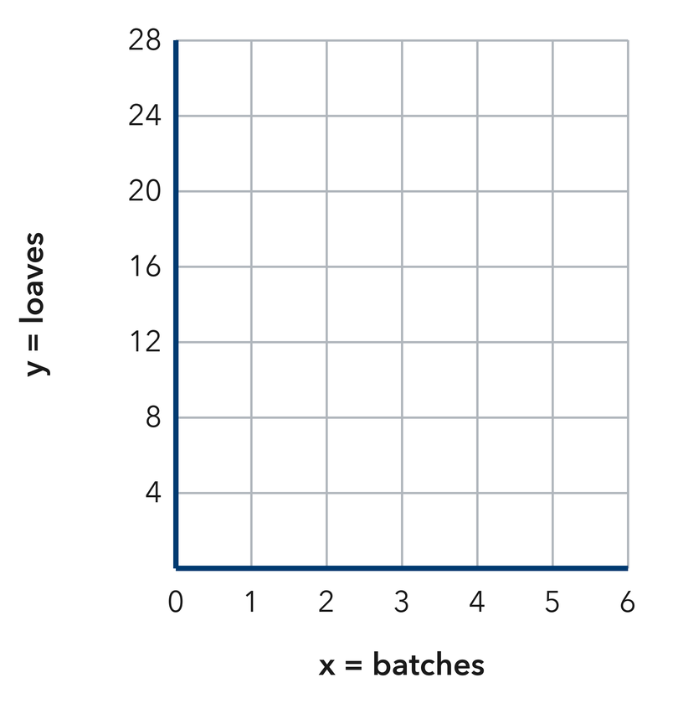
  Show your work.

□ 4 — Can teach it | □ 3 — Got it | □ 2 — Need hint | □ 1 — Need help
Circle your confidence. Star one problem that shows your learning.

