Name |  | Date |  | Period
Lesson 3-4 · Session 2
Guided Practice
Interpreting Points on Ratio Graphs
VOCABULARY read and say each word before you begin
unit rate point | The point (1, r) — r is the amount for ONE. | (1, 9) 9 for each 1
origin  Spanish: origen | The point (0, 0): zero of one means zero of the other. | (0, 0)
interpret  Spanish: interpretar | Say what a point MEANS in words. | “4 boxes hold 36 crayons”
coordinates  Spanish: coordenadas | The x-value and y-value of a point. | x first, then y
EXPLORE TOGETHER Class Launch · 8–10 min
1. Lucy’s Bracelet Charms  A graph shows bracelet charms (x = bracelets, y = charms). The line passes through (0, 0), (1, 5), and (3, 15).  a. The Origin. (0, 0) means 0 bracelets need 0 charms.  b. Unit Rate Point. (1, 5) represents the unit rate: 1 bracelet needs 5 charms.  c. General Point. (4, 20) means 4 bracelets need 20 charms.  d. Predict. How many charms are needed for 9 bracelets? 9 × 5 = ______ charms (point: (9, ______)). | e. Read the graph. This is the graph the problem describes. Use it to answer parts a-d.​  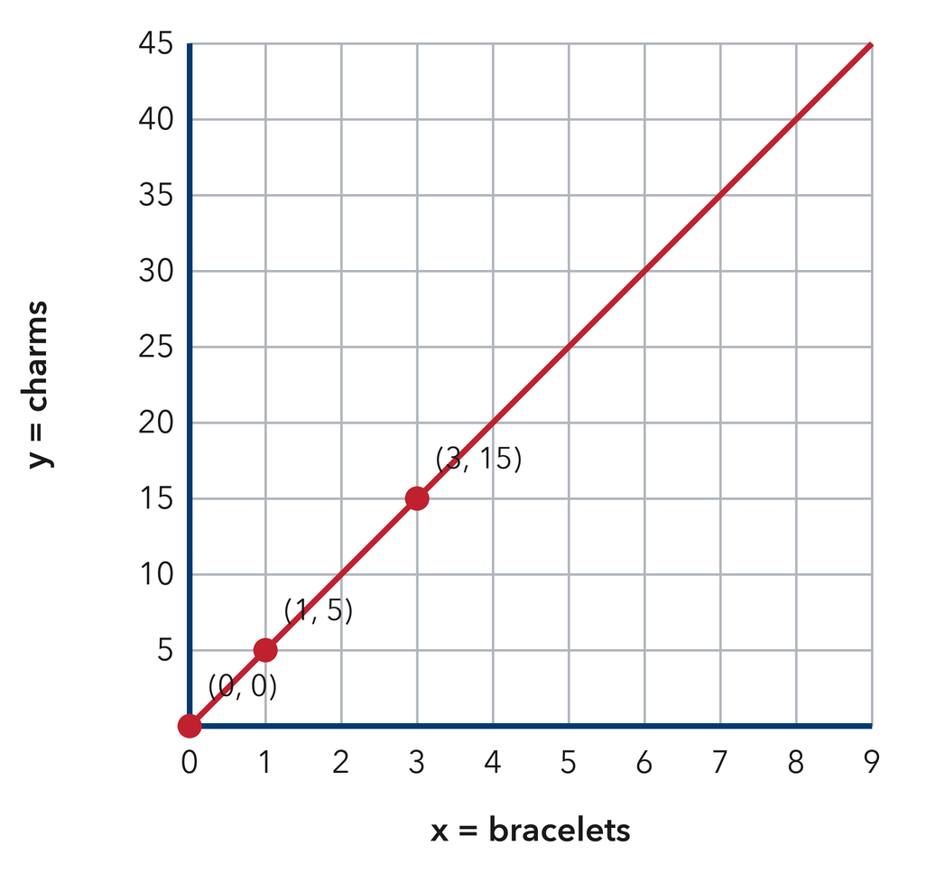
  TURN AND TALK
  Why is the point (1, r) the most important point on a ratio graph?
  Sentence frame: “The point (1, r) is the most important because ‘r’ gives the unit rate…”
PRACTICE WITH A PARTNER You Do Together · 10–12 min
2. Water Pump Rate. A graph shows water pumped into a tank (x = minutes, y = gallons). Line passes through (1, 8) and (5, 40).  a. What is the unit rate? Which point shows it? __________  b. What does (5, 40) mean? __________  c. How long to pump 72 gallons? 72 ÷ 8 = __________ | d. Graph. Plot (1, 8) and (5, 40) on the plane, draw the line through the origin, then use the graph to check part c.​  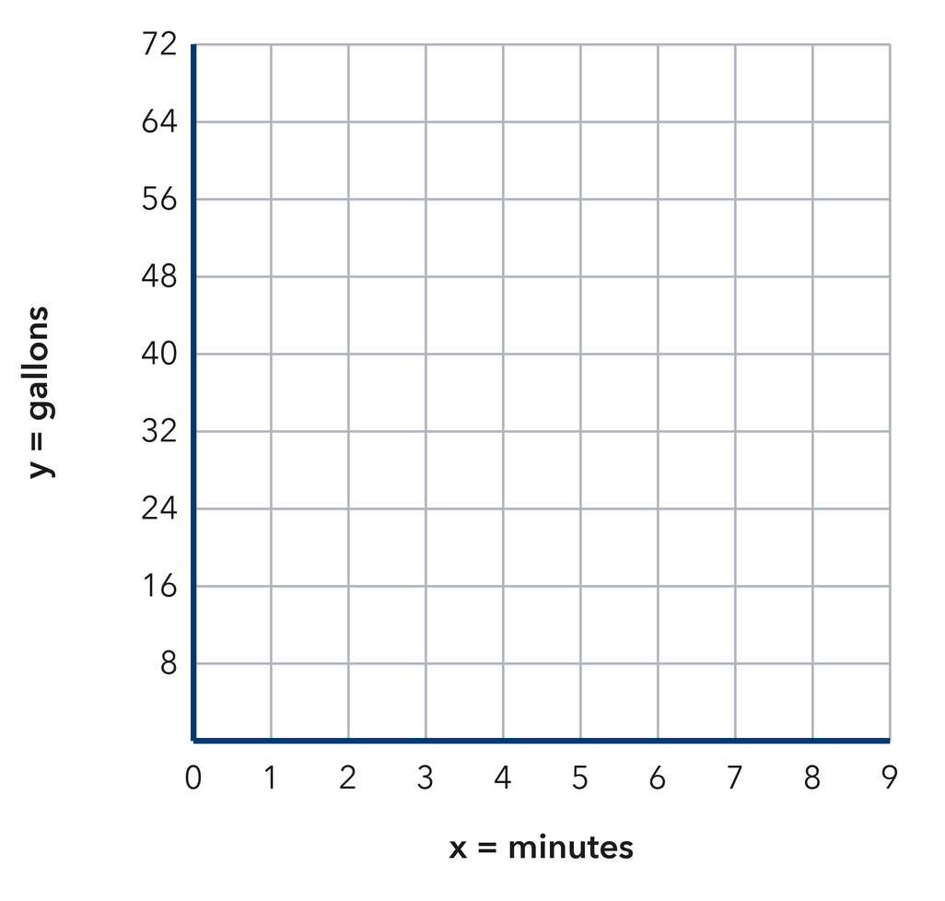
  PARTNER TALK
  Explain how you can use the unit rate to find gallons or minutes.

3. Road Trip Graph. A car trip graph passes through (0, 0), (1, 55), and (4, 220).  a. Unit rate: 1 hour = __________  b. What does (4, 220) mean? In __________ | c. Read the graph. This is the trip graph. Mark the unit rate point (1, r) on it.​  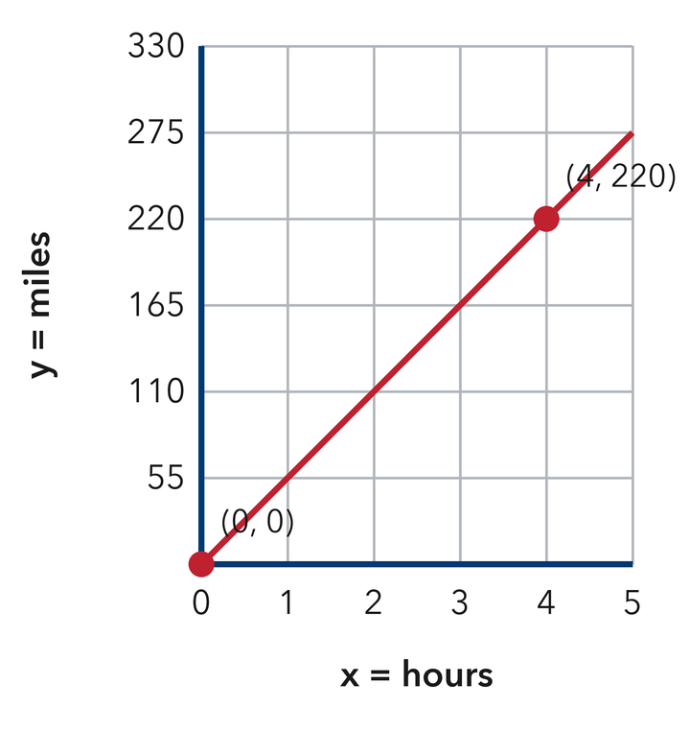
  PARTNER TALK
  Divide to check the unit rate. Do you both get the same mph?

4. Snow Shoveling Pay. A graph shows shoveling pay, where x = driveways and y = dollars. The line passes through (0, 0), (1, 9), and (4, 36).
a. Unit rate and the point that shows it __________
b. What (4, 36) means in words __________
PARTNER TALK
How can the unit rate point help you find the pay for 11 driveways without drawing the graph?

PRACTICE ON YOUR OWN You Do · 8 problems · 18–20 min
5. Drone Flight. A drone graph shows seconds on x and meters on y. It passes through (1, 12).  a. Drone speed __________  b. What are coordinates for distance in 8 seconds? (8, __________  Hint Multiply 8 by 12.  Answer speed and coordinates | c. Graph. Plot (1, 12) and draw the drone’s line through the origin. Then read the point for 8 seconds off your graph.​  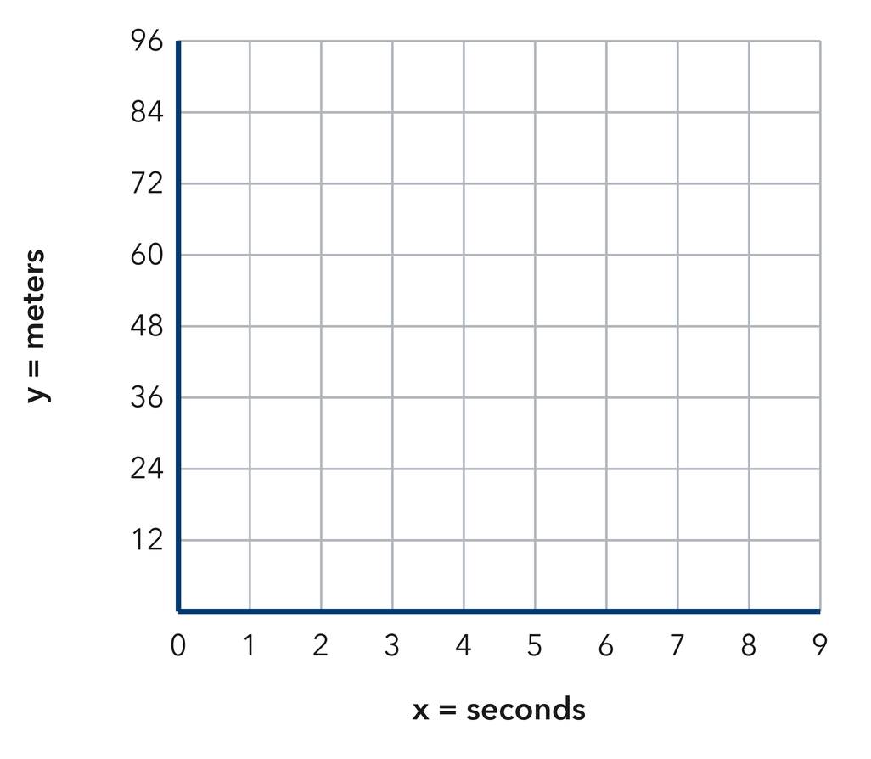
  Show your work.

6. Babysitting Earnings. A line passes through (1, 15).  a. What does (1, 15) mean?  b. Is the point (6, 90) on this line? Why or why not?  Hint Multiply 6 by the unit rate, then compare with 90.  Answer meaning and verification | 7. Robot Speed. A robot graph passes through (3, 12).  a. Find unit rate (1, r): 12 ÷ 3 = __________  b. How far in 10 seconds? __________  Hint Multiply unit rate by 10.  Answer unit rate and distance

8. Copy Machine. A graph shows copies made, where x = minutes and y = copies. The line passes through (1, 45).  Tell what (1, 45) means in words, then find the point for 8 minutes  Hint The y-value when x = 1 is the unit rate; multiply that rate by 8.  Answer meaning and the point for 8 minutes | 9. Bike Rack Spaces. A graph passes through (4, 28), where x = racks and y = parking spaces.  Find the unit rate point (1, r), then decide whether (9, 63) is on the line  Hint Divide 28 by 4 to find r, then multiply 9 by r and compare the result with 63.  Answer unit rate point and yes or no

10. Crayon Boxes. A graph shows crayons in boxes (x = boxes, y = crayons) and passes through (4, 32). Explain what this point means and give the unit rate.  Hint Divide y by x to find the amount for one box.  Answer meaning and unit rate | 11. Find the Unit Point. A ratio graph for cost and pounds passes through (6, 15).  a. What are the coordinates of the point where x = 1? __________  b. What does that point mean in the situation? __________  Hint Divide both coordinates by 6.  Answer a and b

12. Two Points. A ratio graph for a printer passes through (2, 70) and (5, 175). Explain what each point means and confirm they show the same rate.  Hint Find y ÷ x for both points.  Answer both meanings and the rate | Read the graph. This is the printer graph. Mark (2, 70) and (5, 175) and show that both give the same rate.​  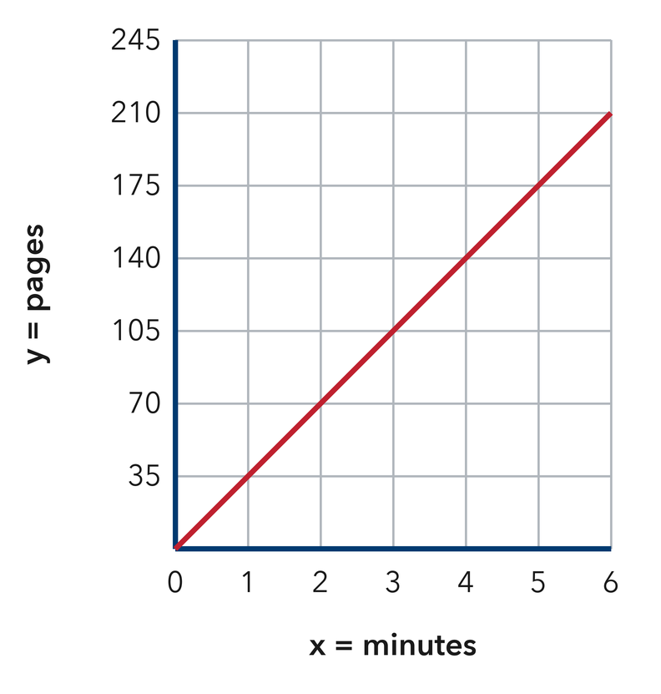
  Show your work.
ANALYZE THE ERROR 5 min
13. Read the work below. Explain the mistake, then show the correct reasoning.
NOAH’S WORK
A cost graph passes through (1, 8). Noah says: ‘This means 8 items cost 1 dollar.’

a. Explain the mistake. What mistake did Noah make?  Sentence frame: “Noah flipped the coordinates; (1, 8) means 1 item costs 8 dollars…” | b. Show correct work  Correct answer
  Show the correct work.
STRETCH YOUR THINKING multi-step reasoning · 8 min
14. Two Bike Riders. Rider 1’s graph passes through (3, 36) and Rider 2’s through (4, 40). Both graph distance in kilometres against hours.  a. Find each rider’s unit rate.  b. Whose line is steeper, and what does that mean for the ride?  c. How far ahead is the faster rider after 6 hours?  Answer both rates, the steeper line, and the gap | d. Graph both riders. Draw each rider’s line on the same plane and label them 1 and 2. Show the gap at 6 hours.​  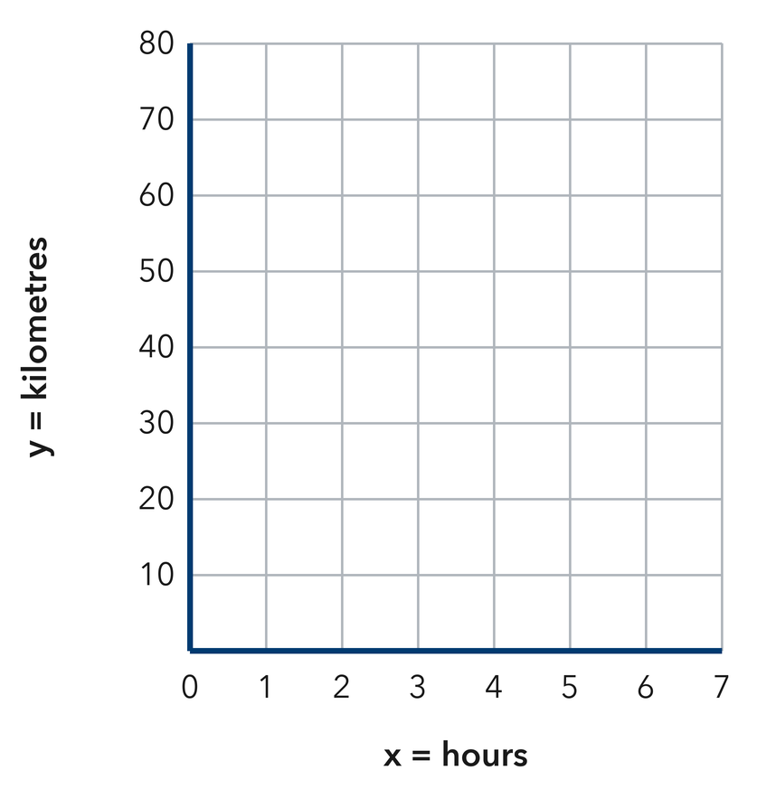
  Show your work.
TEST PRACTICE multiple choice · fill one box · 6 min
15. On a ratio graph, the point (1, 9) gives the — | 16. A point (3, 24) on a boxes-to-pens graph means —
  □ A. range | □ B. total | □ C. unit rate | □ D. origin
  □ A. there are 27 items | □ B. 24 boxes hold 3 pens | □ C. 3 pens cost 24 | □ D. 3 boxes hold 24 pens

17. For a graph through (5, 20), the unit rate is — | 18. On a ratio graph, the origin means —
  □ A. 4 | □ B. 5 | □ C. 20 | □ D. 100
  □ A. one of each | □ B. none of either quantity | □ C. the unit rate | □ D. the total
SPIRAL REVIEW earlier skills · keep them sharp · 6 min
19. From Lesson 3-4 Session 1. A ratio graph passes through (3, 15). What is y when x = 7?  Answer | 20. From Lesson 3-3 Session 2. For 5 : 8, how much goes with 15?  Answer

21. From Lesson 3-2 Session 1. A runner covers 96 km in 8 hours. Find the unit rate.  Answer | 22. From Lesson 2-5 Session 1. Q1 = 20 and Q3 = 38. Find the IQR.  Answer
CHECK YOUR UNDERSTANDING 5 min
23. Heating Liquid Graph. A heating experiment graph passes through (1, 3) and (6, 18).
a. What is the unit rate of temperature increase? __________
b. What does (6, 18) mean in words? __________
c. Temperature rise after 10 minutes __________
Hint Find the unit rate first — use the point where x = 1 minute.
Answer

□ 4 — Can teach it | □ 3 — Got it | □ 2 — Need hint | □ 1 — Need help
Circle your confidence. Star one problem that shows your learning.

