Name Date Period
Lesson 4-1 · Homework Packet · Sheet 1 of 2
Percent Means Per Hundred
Maryland Standard 6.RP.A.3c · Learning target — I can write a ratio as a percent by finding the equivalent ratio out of 100.

REMEMBER  • Percent means “per hundred.” 37% = 37 out of 100.  • On a hundred grid, each square is 1%.  • Make an equivalent ratio out of 100: multiply both terms by the same number. | WORKED EXAMPLE  Out of every 20 students, 7 ride the bus. What percent of the students ride the bus?  Step 1 20 × 5 = 100, so multiply both terms by 5.  Step 2 7 × 5 = 35, so 7 out of 20 = 35 out of 100.  Step 3 35 out of 100 = 35%.  Answer 35%
PRACTICE show your work · label units

1. The grid has 100 equal squares.  a. What percent of the grid is shaded? %  b. What percent is not shaded? % | 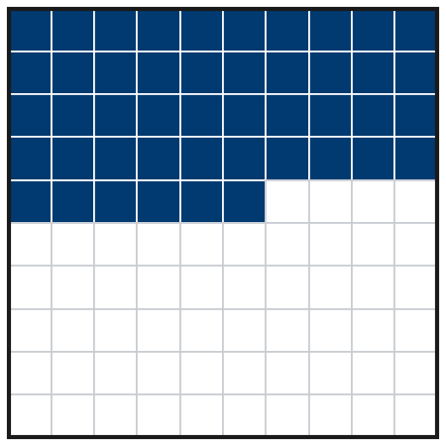

2. Write each ratio as a percent. First scale it to an equivalent ratio out of 100.
a. 3 out of 10 = % | b. 7 out of 25 = % | c. 1 out of 2 = %
d. 17 out of 50 = % | e. 2 out of 5 = % | f. 3 out of 20 = %
g. 13 out of 25 = % | h. 9 out of 10 = %

3. Animal Shelter. Out of every 25 dogs at a shelter, 9 are puppies. Complete the ratio table. Then write the percent of dogs that are puppies.
Puppies | 9 | 18
All dogs | 25 | 50 | 75 | 100
Percent of puppies %

4. Garden Plants. A garden has 50 plants. 22 of them are tomato plants.
a. What percent are tomato plants? %
b. What percent are not tomato plants? %

5. Find the Error. To write 7 out of 20 as a percent, Ana added 80 to both numbers. She got 87 out of 100, so she wrote 87%. Explain her mistake and find the correct percent.

CHECK YOURSELF | □ I can do this on my own | □ I need a little help | □ I have a question about #
AT HOME Find a percent on a label, sign, or screen at home. Tell someone what it means “out of 100.”
Name Date Period
Lesson 4-1 · Homework Packet · Sheet 2 of 2
Percents Greater Than 100%
Maryland Standard 6.RP.A.3c · Learning target — I can use percents greater than 100% to describe an amount larger than the whole.

REMEMBER  • 100% is one whole. Over 100% is more than the whole.  • 200% = 2 times the whole. 150% = 1.5 times.  • “Times as much” to percent: multiply by 100. 2.5 times = 250%. | WORKED EXAMPLE  A puppy grew from 10 lb to 13 lb. Write 13 lb as a percent of 10 lb (the whole).  Step 1 Scale by 10: 13 to 10 = 130 to 100.  Step 2 130 out of 100 = 130%, more than the whole.  Answer 130%
PRACTICE show your work · label units
1. Write each amount as a percent of the whole.
a. 3 times as much = % | b. 1.75 times as much = %

2. Library Books. Monday (40 books) is the whole. Tuesday: 70 books. Fill in the double number line. Write Tuesday as a percent of Monday.
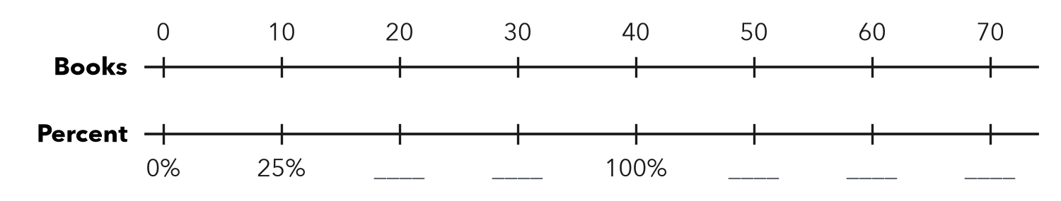
Tuesday %

3. Bake Sale. A class set a goal of $200. They raised $260. What percent of the goal did they raise?
Answer %

4. Chess Club. Last year a chess club had 20 members (the whole). This year it has 33 members. Write this year’s members as a percent of last year’s.
Answer %

5. Find the Error. Malik says 60 cm is 60% of 30 cm. Explain his mistake and fix it.

TEST PRACTICE choose the best answer
6. 45 points is what percent of 30 points?
A 15% | B 45% | C 115% | D 150%

7. 250% of an amount is how many times the amount?
A 0.25 times | B 2.5 times | C 25 times | D 250 times

CHECK YOURSELF | □ I can do this on my own | □ I need a little help | □ I have a question about #
AT HOME Tell someone at home what 200% of their age would be.

