Name Date Period
Lesson 4-3 · Homework Packet · Sheet 1 of 2
Estimate with Benchmarks
Maryland Standard 6.RP.A.3c · Learning target — I can estimate a percent by comparing an amount to benchmark percents.

REMEMBER  • Benchmarks: 10%, 25%, 50%, 75%, 100%.  • Find benchmark amounts of the whole. Which one is the part about equal to?  • A double number line lines up amounts with percents. | WORKED EXAMPLE  A water jug holds 40 cups. There are 29 cups left. About what percent of the jug is left?  Step 1 Benchmarks of 40: 50% = 20 and 75% = 30.  Step 2 29 is very close to 30.  Step 3 So 29 out of 40 is about 75%.  Answer about 75%
PRACTICE show your work · label units
1. Reading Goal. Jada’s goal is to read 160 pages. She has read 42 pages. Fill in the double number line. Then estimate the percent of her goal she has read.
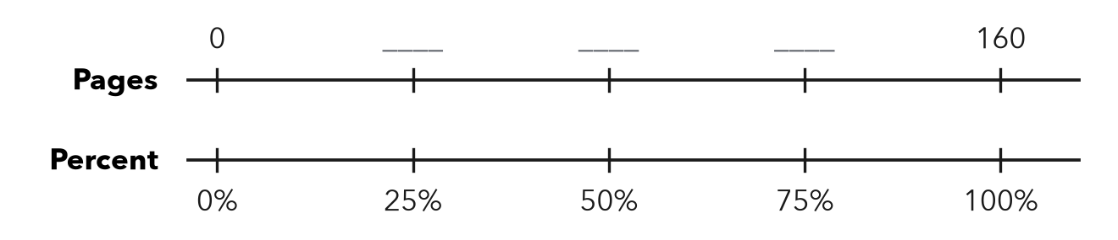
About %

2. About what percent? Name the closest benchmark: 10%, 25%, 50%, 75%, or 100%.
a. 7 out of 60 ≈ % | b. 38 out of 50 ≈ % | c. 23 out of 90 ≈ %
d. 19 out of 40 ≈ % | e. 49 out of 50 ≈ % | f. 11 out of 45 ≈ %
g. 16 out of 150 ≈ % | h. 61 out of 80 ≈ %

3. Class Fundraiser. A class wants to raise $500. So far they have raised $96. Use 10% of the goal to estimate the percent they have raised.
a. 10% of $500 =
b. About what percent have they raised? %

4. Bus Seats. A bus has 48 seats. 35 seats are filled. About what percent of the seats are filled? Name the benchmark you used.
About %

5. Compare. Which is closer to 50%: 26 out of 50, or 26 out of 60? Explain how you know.

CHECK YOURSELF | □ I can do this on my own | □ I need a little help | □ I have a question about #
AT HOME Look at a battery icon or a gas gauge. Estimate the percent it shows and explain your benchmark to someone at home.
Name Date Period
Lesson 4-3 · Homework Packet · Sheet 2 of 2
Estimate a Percent of a Number
Maryland Standard 6.RP.A.3c · Learning target — I can estimate a percent of a number using friendly percents and rounded amounts.

REMEMBER  • Round to friendly numbers first.  • 10%: divide by 10. 5% = half of 10%.  • 25% = 1/4, 50% = 1/2, 75% = 3/4. | WORKED EXAMPLE  Estimate 24% of 83.  Step 1 Round: 25% of 80.  Step 2 25% = 1/4, and 80 ÷ 4 = 20.  Answer about 20
PRACTICE show your work · label units
1. Estimate. Round to friendly numbers first.
a. 11% of 59 ≈ | b. 74% of 41 ≈ | c. 26% of 203 ≈

2. Sneaker Sale. Sneakers cost $198 and are 30% off. Round to $200. Each part of the tape is 10% of $200.
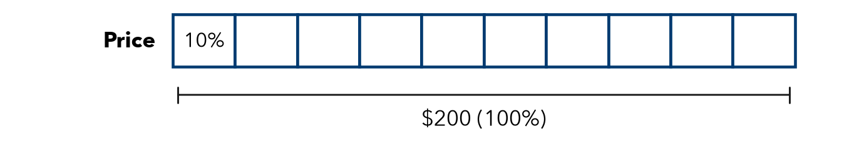
a. About how many dollars is one part (10%)?
b. About how much is the discount (30%)?

3. School Lunch. About 48% of 412 students buy lunch. About how many students is that?
About students

4. Apple Orchard. A farm picked 798 apples. About 24% of them were too small to sell. About how many apples were too small?
About apples

5. Find the Error. Mia estimated 19% of 512 by writing 20 × 500 = 10,000. Explain her mistake. Give a good estimate.

TEST PRACTICE choose the best answer
6. Which is the best estimate of 26% of 79?
A 2 | B 20 | C 26 | D 40

7. A coat costs $119. It is 40% off. Which is the best estimate of the discount?
A $4.80 | B $40 | C $48 | D $72

CHECK YOURSELF | □ I can do this on my own | □ I need a little help | □ I have a question about #
AT HOME Find a sale sign. Estimate the discount out loud with someone at home.

