Name |  | Date |  | Period
Lesson 4-3 · Session 1
Guided Practice
Estimate with Benchmarks
VOCABULARY read and say each word before you begin
estimate  Spanish: estimar | A close-enough answer found without exact math. | about 70% used
benchmark percent | A friendly landmark percent used for estimating. | 10%, 25%, 50%, 75%
double number line | Two lined-up lines: amounts above, percents below. | 0, 30, 60 GB over 0%, 50%
the whole | The amount that counts as 100% right now. | all of the storage
about | A signal that an answer is an estimate. | about one quarter full
EXPLORE TOGETHER Class Launch · 8–10 min
1. Phone Storage Check  A phone holds 120 GB. About 72 GB of it are used. Of that used space, about 54 GB are photos.  a. Whole. Which amount counts as one hundred percent for the first question? ______ GB  b. Estimate. Use the double number line below — the whole phone is 120 GB. About what percent of the phone is used? ______ %  c. New Whole. Now the used space is the whole. About what percent of it is photos? ______ % | d. Meaning. Why do these two questions use different wholes? __________  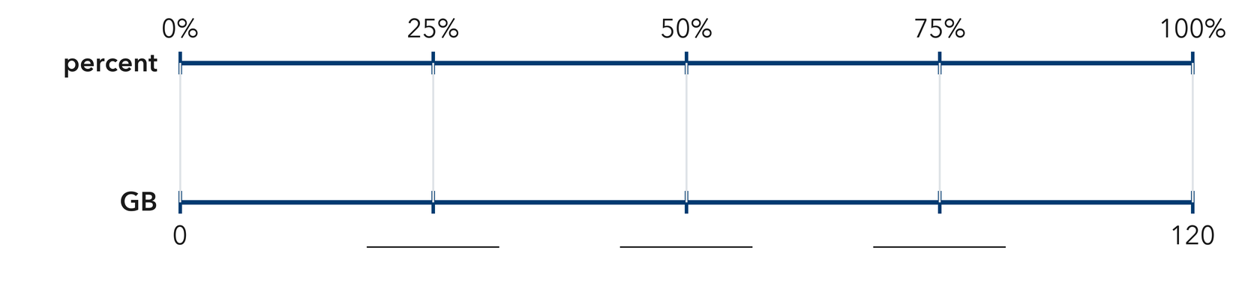​
  TURN AND TALK
  Why does naming the whole first change the percent that you estimate?
PRACTICE WITH A PARTNER You Do Together · 10–12 min
2. Reading Goal. Ana’s goal is 240 pages this month. So far she has read 118 pages.  a. Benchmarks on a double number line for 240 pages: 25% __________  b. About what percent of her goal is read? __________ | c. Double number line. Fill the bottom scale with the amounts that line up with each percent. Mark the benchmarks, then place 118 pages between two of them.​  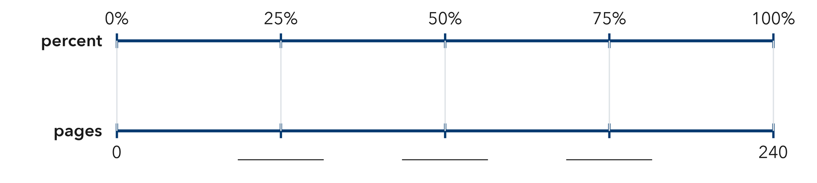
  PARTNER TALK
  How does a benchmark let you judge an answer without doing exact arithmetic?

3. Class Fundraiser. A class wants to raise $400 for a field trip. So far they have raised $310.  a. Benchmark amounts for the goal: 10% __________  b. About what percent is raised? __________ | 4. Gym Water Jug. A water jug for the gym holds 32 cups and has 17 cups left in it.  a. Benchmark Half of the jug, in cups __________  b. Estimate About what percent is left? __________
  PARTNER TALK
  Why is an estimate good enough for a progress report like this one?
  PARTNER TALK
  Why is an answer of about half close enough for a question like this one?
PRACTICE ON YOUR OWN You Do · 8 problems · 18–20 min
5. Bus Seats. A school bus has 44 seats and 21 of them are filled.  Estimate what percent of the seats are filled, and write the benchmark you used  Hint Work out the seat count that would be half the bus, then see which side of it the filled count lands on.  Answer estimated percent filled | 6. Estimate Check. Kwame says that 19 out of 60 is about 50%. Justify or correct his estimate using a benchmark.  Hint Work out which count would be half of sixty, then place Kwame’s count next to it on a number line.  Answer better estimate (Is Kwame right?)

7. Trail Progress. A hiking trail is 36 km long. A hiker has already walked 27 km of it.  Estimate the percent of the trail walked, then find the percent still left  Hint Quarter marks split the trail into four equal pieces. Find one quarter first, then count the pieces walked.  Answer percent walked, percent left | 8. Parking Lot. A parking lot has 80 spaces and 61 of them are taken.  Estimate the percent of the spaces that are taken, and name the benchmark you used  Hint Split 80 into four equal pieces of 20. Count how many pieces the taken spaces fill.  Answer estimated percent taken

9. Chorus Tickets. A chorus printed 480 tickets for its concert and has sold 47 of them.  Estimate the percent of the tickets sold, then estimate the percent not yet sold  Hint Ten percent of 480 is 48. Compare the sold count to that ten percent mark.  Answer percent sold, then percent not sold | 10. Tablet Storage. A tablet holds 64 GB and 47 GB are used. About what percent is used?  Hint Half of 64 is 32 and three fourths is 48. Which is 47 closer to?  Answer about what percent

11. Reading Progress. A reader has finished 62 pages of a 240-page book. About what percent is finished?  Hint One fourth of 240 is 60.  Answer about what percent | 12. Pick the Benchmark. A jar holds 80 marbles and 41 are blue.  a. Which benchmark percent is closest? __________  b. Explain how you decided. __________  Hint Half of 80 is 40.  Answer a and b
ANALYZE THE ERROR 5 min
13. Read the work below. Explain the mistake, then show the correct reasoning.
ELENA’S WORK

A drive holds 200 GB. Elena has used 150 GB, and 30 GB of that is music. She said music is about 75% of the drive.
a. Explain the mistake. Which whole does Elena’s 75% really describe? About what percent of the drive is music? | b. Show correct work  Correct answer
  Show the correct work.
STRETCH YOUR THINKING multi-step reasoning · 8 min
14. Class Fundraiser. A class set a goal of $500 and has raised $124.
a. Name the benchmark percent closest to the amount raised.
b. About how much more is needed to reach 50% of the goal?
c. Explain why an estimate is useful here even though the exact percent can be found.
Answer the benchmark, the amount needed, and your explanation
TEST PRACTICE multiple choice · fill one box · 6 min
15. 10% of an amount is the same as — | 16. 19 out of 40 is about —
  □ A. one fifth | □ B. one tenth | □ C. one half | □ D. one hundredth
  □ A. 75% | □ B. 25% | □ C. 50% | □ D. 10%

17. 25% is the same as — | 18. 31 out of 120 is about —
  □ A. one fifth | □ B. one third | □ C. one half | □ D. one fourth
  □ A. 25% | □ B. 50% | □ C. 75% | □ D. 10%
SPIRAL REVIEW earlier skills · keep them sharp · 6 min
19. From Lesson 4-2 Session 2. Which is greater, 0.7 or 68%?  Answer | 20. From Lesson 4-1 Session 1. Write 7 out of 25 as a percent.  Answer

21. From Lesson 3-7 Session 2. At 4 mg per kg, what dose does an 11-kg animal need?  Answer | 22. From Lesson 2-9 Session 1. Find the MAD of 20, 24, 28.  Answer
CHECK YOUR UNDERSTANDING 5 min
23. Sticker Sheet. A sticker sheet holds 160 stickers and 38 of them have already been used.
a. About what percent are used? __________
b. About what percent are still left? __________
Hint Find the quarter marks for the full sheet, then decide which mark the used count sits nearest to.
Answer

□ 4 — Can teach it | □ 3 — Got it | □ 2 — Need hint | □ 1 — Need help
Circle your confidence. Star one problem that shows your learning.

