Name Date Period
Lesson 4-5 · Homework Packet · Sheet 1 of 2
Find the Whole
Maryland Standard 6.RP.A.3c · Learning target — I can find the whole when I know a part and the percent it represents.

REMEMBER  • The part is what you know. The whole is 100%.  • Step down to a friendly percent, then build up to 100%.  • Percent below 100%? The whole is greater than the part. | WORKED EXAMPLE  24 is 40% of what number?  Step 1 40% is 24, so 10% is 24 ÷ 4 = 6.  Step 2 100% is 10 × 6 = 60.  Step 3 Check: 0.4 × 60 = 24, so it checks.  Answer 60
PRACTICE show your work · label units
1. Bike Helmet. Andre has saved $36. That is 40% of the cost of a bike helmet. Fill in the double number line. Then find the cost of the helmet.
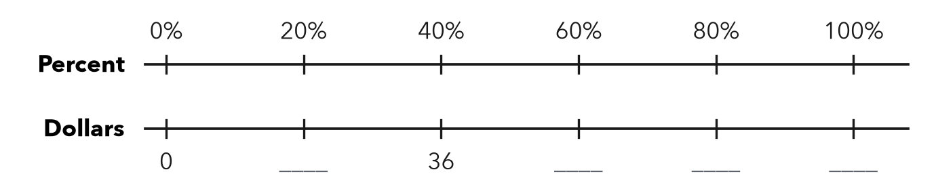
Cost dollars

2. Find each whole.
a. 13 is 10% of | b. 11 is 25% of | c. 21 is 30% of
d. 32 is 40% of | e. 7 is 5% of | f. 54 is 60% of

3. Water Tank. A water tank is 75% full. It holds 18 gallons now. Each part of the tape diagram is 25% of the full tank. How many gallons does the tank hold when it is full?
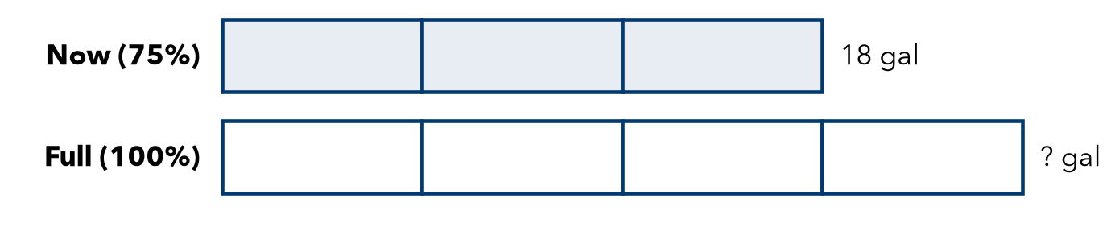
Answer gallons

4. Chapter Book. Lena has read 120 pages. That is 75% of her book. How many pages long is it?
Answer pages

5. Reason. 20 is 40% of number A. 20 is also 80% of number B. Without solving, which number is greater, A or B? Explain. Then find both numbers.

CHECK YOURSELF | □ I can do this on my own | □ I need a little help | □ I have a question about #
AT HOME Tell someone at home: if 10 is 50% of a number, what is the number? Explain how you know.
Name Date Period
Lesson 4-5 · Homework Packet · Sheet 2 of 2
Solve for the Whole
Maryland Standard 6.RP.A.3c · Learning target — I can write and solve an equation to find the whole from a part and a percent.

REMEMBER  • Write part = percent × whole, with w for the whole.  • Solve by dividing: w = part ÷ decimal.  • Check: decimal × whole should give the part. | WORKED EXAMPLE  $18 is 60% of a shirt’s first price. Find the first price.  Step 1 Write the equation: 0.6 × w = 18  Step 2 Divide: w = 18 ÷ 0.6 = 180 ÷ 6 = 30  Step 3 Check: 0.6 × 30 = 18, so it checks.  Answer $30
PRACTICE show your work · label units
1. Solve each equation for w.
a. 0.2 × w = 14 | b. 0.25 × w = 12 | c. 0.8 × w = 64

2. 33 is 55% of what number? Write an equation and solve it.
a. Equation:
b. w =

3. Field Trip. A class has collected $315 for a trip. That is 75% of the total cost. Find the total cost. How much more does the class need?

Show your work.
Total and still needed

4. Savings Goal. Tasha has saved $42. That is 35% of her goal. Write an equation and find her goal.
Equation and goal

5. Find the Error. Jamal solved “28 is 35% of w” as w = 28 ÷ 35 = 0.8. Explain his mistake. Solve and check.

TEST PRACTICE choose the best answer
6. 45 is 30% of a number w. Which equation can you use to find w?
A 0.3 × 45 = w | B 0.3 × w = 45 | C 45 × w = 30 | D w ÷ 45 = 0.3

7. A team won 18 games. That is 60% of its games. How many games did it play?
A 10.8 | B 24 | C 30 | D 78

CHECK YOURSELF | □ I can do this on my own | □ I need a little help | □ I have a question about #
AT HOME Explain to someone at home why the whole must be bigger than the part when the percent is less than 100%.

