Name |  | Date |  | Period
Lesson 4-5 · Session 1
Guided Practice
Find the Whole
VOCABULARY read and say each word before you begin
part | The amount you already know. | $42 is the sale price
whole  Spanish: entero | The full amount the percent is measured against. | the original price
double number line | Amounts on one line, percents on the other. | $0, $7, $70 · 0%, 10%, 100%
equivalent ratio  Spanish: razón equivalente | The same ratio, scaled up or down. | 42 : 60 = 7 : 10
scale | Multiply or divide both terms equally. | divide both rows by 6
EXPLORE TOGETHER Class Launch · 8–10 min
1. Field Trip Deposit  A class paid a $54 deposit toward a field trip. That deposit is 30% of the full cost of the trip.  a. Name. Which amount is the part? ______ Which percent stands for the whole? ______ %  b. Scale. Use the double number line below. The 30% mark is $54; work down to 10%, then up to 100%. What dollar amount matches ten percent? ______  c. Whole. Full cost of the trip: ______ Scaling you used: __________ | d. Check. Check forward: does that percent of your full cost give back the deposit? ______  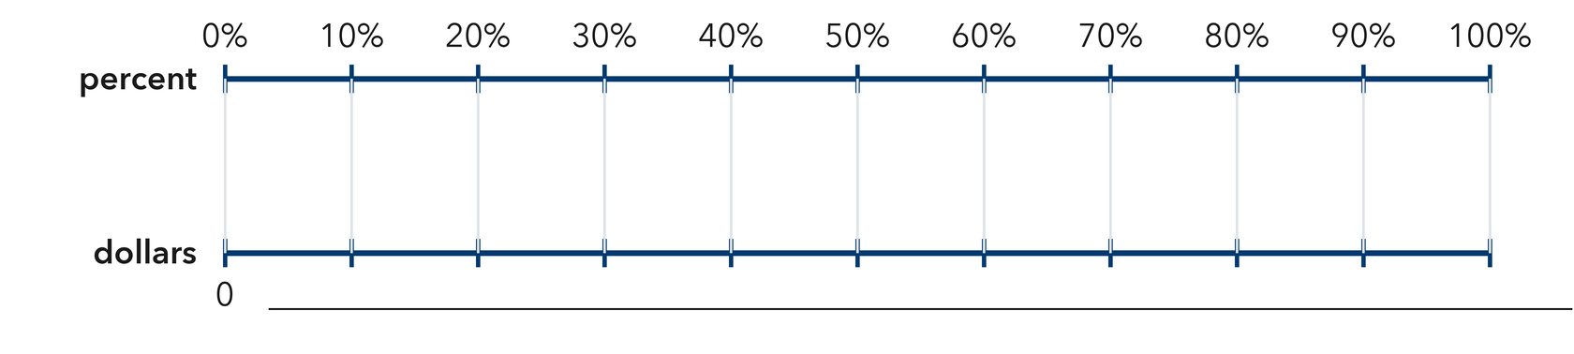​
  TURN AND TALK
  Why does finding ten percent first make the whole so much easier to build?
PRACTICE WITH A PARTNER You Do Together · 10–12 min
2. Puzzle Pieces. Nadia has placed 84 puzzle pieces so far, and that is 70% of the whole puzzle.  a. Ten percent of the puzzle is __________  b. Total pieces in the puzzle __________ | 3. Water Bottle. A bottle has 45 mL of water left in it, and that is 15% of the full bottle.  a. Five percent of the bottle is __________  b. Full bottle __________
  PARTNER TALK
  How does a double number line show the part and the whole at the same time?
  PARTNER TALK
  Why must both rows of your ratio table be scaled by the same number?

4. Library Books. A class has returned 48 library books, and that is 60% of the books it borrowed.
a. Ten percent Number of books worth ten percent __________
b. Whole Total books borrowed __________
PARTNER TALK
Before you scale up, how do you know the total has to be greater than 48?

PRACTICE ON YOUR OWN You Do · 8 problems · 18–20 min
5. Movie Tickets. A theater sold 96 tickets for a show, and that is 75% of all its seats.  Find the total number of seats using a double number line or a ratio table  Hint Step down to a small friendly percent first, then build back up to one hundred percent.  Answer total number of seats | Double number line. Fill the bottom scale with the amounts that line up with each percent. You know the 75% mark is 96 tickets.​  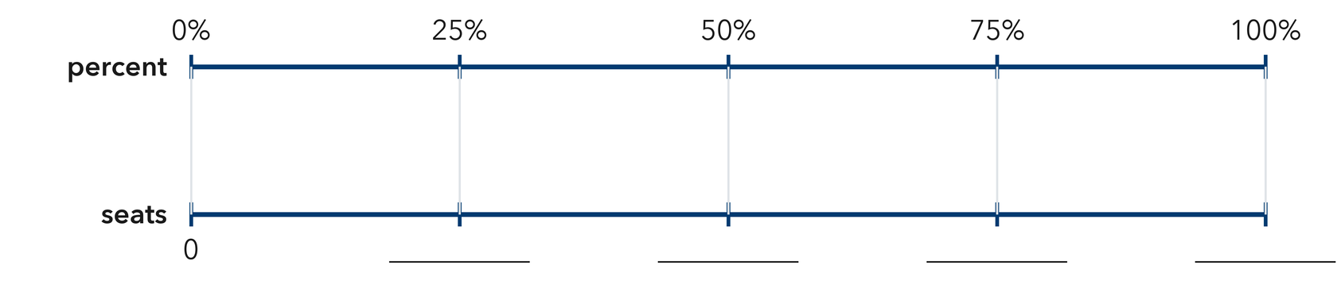
  Show your work.

6. Sale Claim. A hat sells for $21, which is 70% of its first price. Kip says the first price was $14.70. Justify or correct his claim.  Hint The whole has to be larger than the sale price. Check which direction Kip scaled his ratio.  Answer true first price (Is Kip right?) | 7. Reading Goal. Mia has read 56 pages of her book, and that is 20% of the whole book.  Find the total number of pages, then find how many pages are still left to read  Hint Step down to five percent, scale up to one hundred percent, then subtract at the very end.  Answer total pages, then pages left

8. Soccer Goals. A team has scored 27 goals so far, and that is 45% of the goals it scored all of last season.  Find last season’s goal total using a double number line or a ratio table  Hint Divide both terms until you reach five percent, then scale up to one hundred percent.  Answer last season’s goal total | Double number line. Fill the bottom scale with the amounts that line up with each percent. You know the 45% mark is 27 goals. Step down to 5% first.​  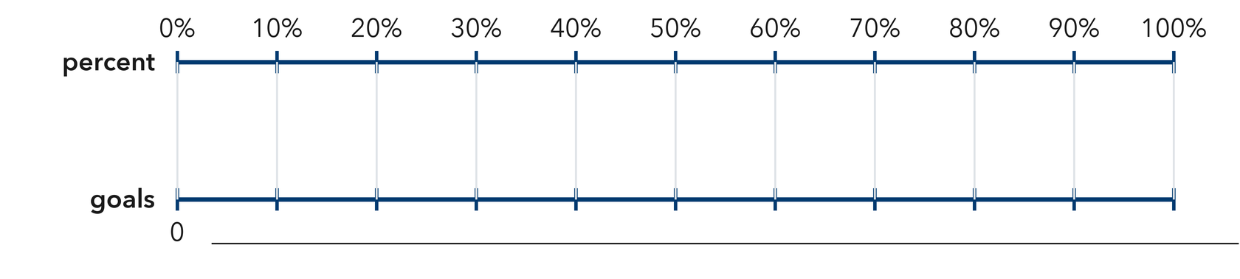
  Show your work.

9. Garden Fence. A crew has built 91 m of a garden fence, and that is 65% of the whole fence.  Find the total length of the fence, then find how many meters are still left to build  Hint Step down to five percent first, scale up to one hundred percent, then subtract at the end.  Answer total length, then meters left | 10. Games Played. A team has won 24 games, and that is 40% of the games it played. How many games did it play?  Hint One percent is 24 ÷ 40 = 0.6, so the whole is 60.  Answer games

11. Class Size. In a class, 18 students ride the bus, which is 75% of the class. How many students are in the class?  Hint Divide 18 by 0.75.  Answer students | 12. Two Steps. A jar holds red and blue marbles. There are 21 red marbles, which is 35% of the jar.  a. How many marbles are in the jar? __________  b. How many are blue? __________  Hint Find the whole first, then subtract the red marbles.  Answer a and b
ANALYZE THE ERROR 5 min
13. Read the work below. Explain the mistake, then show the correct reasoning.
CALEB’S WORK

A jacket is on sale for $36, which is 80% of its first price. Caleb wrote: ‘First price = 0.8 × 36 = $28.80.’
a. Explain the mistake. A first price should be larger than the sale price. What move did Caleb need instead? | b. Show correct work  Correct answer
  Show the correct work.
STRETCH YOUR THINKING multi-step reasoning · 8 min
14. Book Fair. A book fair sold 84 books on Friday, which was 28% of the week’s total sales.
a. How many books were sold in the whole week?
b. How many books were sold on the other days?
c. Explain how you can check your answer to part a in one step.
Answer the week’s total, the other days, and your check
TEST PRACTICE multiple choice · fill one box · 6 min
15. If 30 is 50% of a number, the number is — | 16. If 12 is 25% of a number, the number is —
  □ A. 80 | □ B. 15 | □ C. 30 | □ D. 60
  □ A. 48 | □ B. 3 | □ C. 37 | □ D. 24

17. To find the whole from a part and its percent you — | 18. If 45 is 90% of a number, the number is —
  □ A. multiply | □ B. divide | □ C. add | □ D. subtract
  □ A. 135 | □ B. 40 | □ C. 50 | □ D. 405
SPIRAL REVIEW earlier skills · keep them sharp · 6 min
19. From Lesson 4-4 Session 2. Which is better: 16 out of 20 or 20 out of 25?  Answer | 20. From Lesson 4-4 Session 1. Find 15% of 240.  Answer

21. From Lesson 4-2 Session 1. Write 0.95 as a percent.  Answer | 22. From Lesson 3-6 Session 2. Convert 6500 grams to kilograms.  Answer
CHECK YOUR UNDERSTANDING 5 min
23. Charity Walk. A walker has raised $132 in pledges, and that is 55% of her fundraising goal.
a. Five percent of the goal is __________
b. Her full goal is __________
Hint Step down to a percent that divides evenly, then scale up to one hundred percent.
Answer

□ 4 — Can teach it | □ 3 — Got it | □ 2 — Need hint | □ 1 — Need help
Circle your confidence. Star one problem that shows your learning.

