Name |  | Date |  | Period
Lesson 5-1 · Session 1
Guided Practice
Area of Parallelograms
VOCABULARY read and say each word before you begin
parallelogram  Spanish: paralelogramo | A four-sided shape with two pairs of parallel sides. | opposite sides never meet
base  Spanish: base | Any one side of a parallelogram you measure from. | b in A = b × h
height | The perpendicular distance between the base and opposite side. | h in A = b × h
perpendicular  Spanish: perpendicular | Two lines that meet in a square corner. | height ⟂ base
area  Spanish: área | How much flat space is inside a shape. | measured in cm², in², ft²
EXPLORE TOGETHER Class Launch · 8–10 min
1. School Banner Panel  A school banner is shaped like a parallelogram. Its base is 12 ft, the perpendicular height to that base is 5 ft, and the slanted side is 8 ft.  a. Sketch. Draw the banner. Label the base 12 ft, the height 5 ft, and the slanted side 8 ft.  b. Identify. Perpendicular height: ______ ft Slanted side: ______ ft Base: ______ ft  c. Compute. Use A = b × h. ______ × ______ = ______ Units: ______  d. Reasoning. Why is the 8 ft side not used in the area formula? __________ | e. Sketch. Draw and label the figure on the grid below. Let one square stand for a convenient number of units, and mark the perpendicular height with a square corner.​  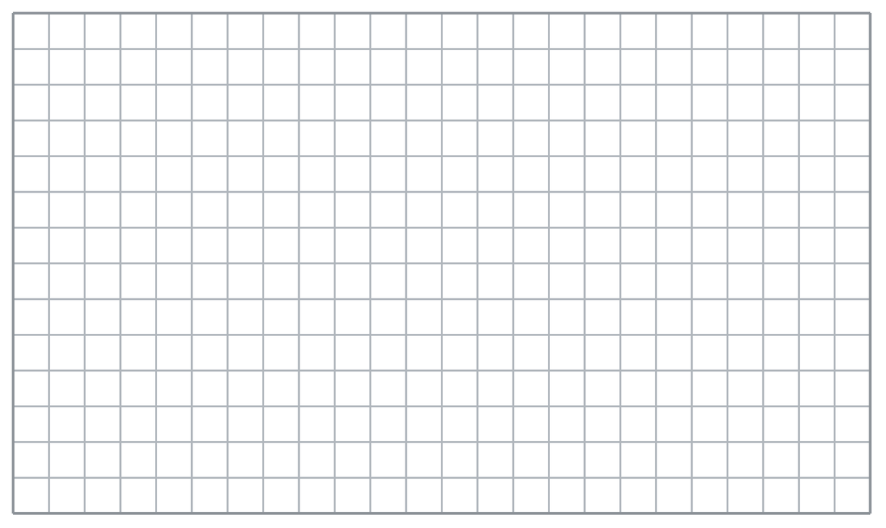
  TURN AND TALK
  Why must the height make a square corner with the base you chose?
PRACTICE WITH A PARTNER You Do Together · 10–12 min
2. Floor Tile. A floor tile is a parallelogram with a base of 15 cm and a perpendicular height of 10 cm.  a. Sketch and label the tile. Area __________  b. Three of these tiles in a row cover a total of __________ | c. Sketch. Draw and label the figure on the grid below. Let one square stand for a convenient number of units, and mark the perpendicular height with a square corner.​
  PARTNER TALK
  How does covering a floor with more tiles change the total area? Explain your thinking.

3. Missing Height. A parallelogram-shaped sign has an area of 90 in² and a base of 18 in. The height is not labeled.  a. Put the known values in the formula: 90 = 18 × __________  b. Height of the sign __________ | 4. Bulletin Board Strip. A paper strip is a parallelogram with a base of 16 cm and a perpendicular height of 7 cm. Its slanted side measures 9 cm.  a. Name the height __________  b. Area of the strip __________
  PARTNER TALK
  How is finding a missing height different from finding an area?
  PARTNER TALK
  Why does the 9 cm side stay out of the area work? Explain your thinking.
PRACTICE ON YOUR OWN You Do · 8 problems · 18–20 min
5. Garden Bed. A garden bed is shaped like a parallelogram with a base of 20 ft and a perpendicular height of 11 ft.  Sketch the bed, label it, and find its area  Hint Area of a parallelogram is base times perpendicular height. Label both measures on your sketch first.  Answer area in ft² | Sketch. Draw and label the figure on the grid below. Let one square stand for a convenient number of units, and mark the perpendicular height with a square corner.​
  Show your work.

6. Window Pane. A parallelogram-shaped window pane has an area of 96 in² and a base of 8 in.  Find the perpendicular height of the pane  Hint The area came from the base times the height, so ask what factor pairs with the base to reach the area.  Answer height in inches | 7. Two Panels. Panel X is a parallelogram with base 10 cm and height 13 cm. Panel Y is a parallelogram with base 26 cm and height 5 cm.  Find each area, then explain which panel covers more space.  Hint Use the formula on each panel separately, then line the two results up side by side and compare.  Answer area of X, area of Y, which covers more

8. Dog Park Sign. A parallelogram sign at the dog park has a base of 22 in. and a perpendicular height of 13 in.  Sketch the sign, label it, and find its area  Hint Label the base and the perpendicular height on your sketch first, then multiply the two.  Answer area in in² | Sketch. Draw and label the figure on the grid below. Let one square stand for a convenient number of units, and mark the perpendicular height with a square corner.​
  Show your work.

9. Mural Panel. A parallelogram mural panel covers 154 ft². Its perpendicular height is 11 ft, but the base is not labeled.  Find the base of the panel  Hint The area came from the base times the height, so divide the area by the height you know.  Answer base in feet | 10. Cafeteria Floor Tile. A floor tile is a parallelogram with a base of 18 cm and a perpendicular height of 7 cm. Find its area.  Hint Multiply 18 by 7.  Answer cm²

11. Missing Height. A parallelogram sign has an area of 96 in² and a base of 12 in. Find its perpendicular height.  Hint Area ÷ base = height. Divide 96 by 12.  Answer in. | 12. Sod for a Garden. A community garden bed is a parallelogram with a base of 14 ft and a height of 9 ft. Sod costs $3 for each square foot.  a. Find the area of the bed. __________  b. Find the total cost of the sod. $ __________  Hint Find the area first, then multiply the area by $3.  Answer area, then total cost
ANALYZE THE ERROR 5 min
13. Read the work below. Explain the mistake, then show the correct reasoning.
MARISOL’S WORK

A parallelogram has base 20 cm, slanted side 17 cm, and perpendicular height 15 cm. Marisol wrote: ‘A = 20 × 17 = 340 cm².’
a. Explain the mistake. Which measure did Marisol multiply by? Which one should she have used? | b. Show correct work  Correct answer
  Show the correct work.
STRETCH YOUR THINKING multi-step reasoning · 8 min
14. Hallway Mural. A mural is shaped like a parallelogram with a base of 12 ft and a height of 5 ft. One can of paint covers 20 ft².
a. Find the area of the mural. __________
b. How many full cans of paint are needed? Explain your reasoning.
c. A second mural has the same height but double the base (24 ft). Find its area and tell how it compares to the first.
Answer area, cans, and the comparison
TEST PRACTICE multiple choice · fill one box · 6 min
15. A parallelogram has a base of 15 m and a height of 6 m. What is its area? | 16. Which measurement do you multiply by the base to find the area of a parallelogram?
  □ A. 45 m² | □ B. 21 m² | □ C. 90 m | □ D. 90 m²
  □ A. the height | □ B. the slanted side | □ C. the perimeter | □ D. the longest side

17. A parallelogram has an area of 72 cm² and a height of 8 cm. What is its base? | 18. A parallelogram has a base of 25 ft and a height of 4 ft. What is its area?
  □ A. 64 cm | □ B. 9 cm | □ C. 576 cm | □ D. 9 cm²
  □ A. 29 ft² | □ B. 50 ft² | □ C. 100 ft² | □ D. 100 ft
SPIRAL REVIEW earlier skills · keep them sharp · 6 min
19. From Lesson 4-4. Find 25% of 84.  Answer | 20. From Lesson 3-2. A car travels 216 miles in 4 hours at a steady speed. Find the unit rate in miles per hour.  Answer

21. From Lesson 2-8. Find the mean of 12, 15, 18, and 15.  Answer | 22. From Lesson 2-7. Find 14.4 ÷ 6.  Answer
CHECK YOUR UNDERSTANDING 5 min
23. Tabletop. A tabletop is a parallelogram with a base of 24 in. and a perpendicular height of 10 in.  a. Sketch and label the tabletop. Area __________  b. A second tabletop has the same area but a base of 30 in. Its height __________  Hint For part b the area stays the same while the base grows, so use the formula in reverse to find the height.  Answer | c. Sketch. Draw and label the figure on the grid below. Let one square stand for a convenient number of units, and mark the perpendicular height with a square corner.​
  Show your work.

□ 4 — Can teach it | □ 3 — Got it | □ 2 — Need hint | □ 1 — Need help
Circle your confidence. Star one problem that shows your learning.

