UNIT 5 · LESSON 10 STANDARD 6.GR.2

Volume of Rectangular Prisms
Student Notes Packet
Name: ______________________ Date: ____________ Period: ________
Level 3 · Enrichment

Today's Goals
Content: I can find the volume of a rectangular prism, including ones with fractional edge lengths, using base area × height.
Language: I can explain my work using the words volume, rectangular prism, dimensions, and base area.

Key Vocabulary
Look at the picture, read the word, then read what it means.
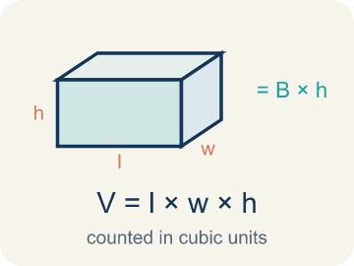 | Volume of Rectangular Prisms Volumen de prismas rectangulares  The space inside a rectangular prism. Formula: V = Bh = l × w × h.  Example: V = Bh = l × w × h
 | Volume Volumen  How much space is inside a solid shape.  Example: A box 2 × 1.5 × 1 = 3 ft³ — it holds 3 cubic feet of stuff
 | Rectangular prism Prisma rectangular  A solid box shape with six flat rectangle sides.  Example: A tissue box, a fish tank, a brick — all rectangular prisms
 | Cubic units Unidades cúbicas  The units used to measure space inside, like cubic inches.  Example: 1 ft³ = a cube that is 1 foot on every edge
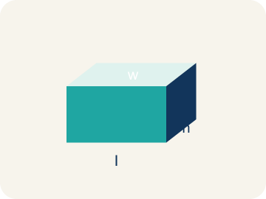 | Dimensions Dimensiones  How long, how wide, and how tall a shape is.  Example: A box with dimensions 4 × 3 × 2 means l = 4, w = 3, h = 2
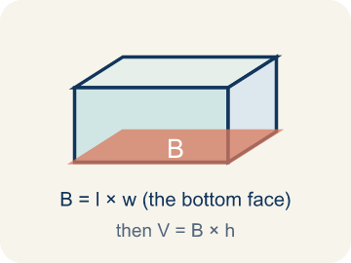 | Base area Área de la base  The area of the bottom of a solid. Volume = base area × height.  Example: If the base is 6 × 4 = 24 cm² and h = 3, then V = 24 × 3 = 72 cm³

Guided Notes
Fill in each blank as we go. Use the Word Bank to help you.
WORD BANK
Volume of Rectangular Prisms • Volume • Rectangular prism • Cubic units • Dimensions • Base area

1. The space inside a rectangular prism, found with V = l × w × h, is the ________________.
2. The amount of space inside a three-dimensional solid is its ________________.
3. A solid with six rectangular faces is a ________________.
4. The unit used to measure volume is ________________.
5. The measurements of length, width, and height of a solid are its ________________.
6. The area of the bottom face of a prism, multiplied by height to find volume, is the ________________.

Write About the Math
How many gallons of water does the small tank hold?
¿Cuántos galones de agua tiene la pecera pequeña?
Say your answer to a partner first. Then write it, using at least two of these words:
☐ Volume · Volumen
☐ Rectangular prism · Prisma rectangular
☐ Cubic units · Unidades cúbicas
☐ Dimensions · Dimensiones
☐ Base area · Área de la base
Model: You still multiply length × width × height even when an edge is a fraction or decimal. — Students explain the formula stays the same (V = l × w × h = 2 × 1.5 × 1 = 3 ft³) and that a fractional edge just means multiplying with a fraction or decimal.

Start Most language support
Complete the frames. Use the word bank.
Completa las oraciones. Usa el banco de palabras.
The tank's volume is ___ in³ because V = ___ × ___ × ___. It holds about ___ gallons because ___ ÷ 231 ≈ ___.
My answer is ___ because ___.
Mi respuesta es ___ porque ___.

Build Some language support
Write two connected sentences. Use because, so, or but.
Escribe dos oraciones conectadas. Usa porque, entonces o pero.
My claim is ___.
Mi afirmación es ___.
My evidence is ___, so ___.
Mi evidencia es ___, entonces ___.

Explain Light language support
Write a claim, give math evidence, and explain your reasoning.
Escribe una afirmación, da evidencia matemática y explica tu razonamiento.

Check Your Explanation three quick checks
☐ I answered the question.
☐ I used math evidence: numbers, an equation, or a model.
☐ I used at least two math words.

Worked Example

Watch & Read I Do — follow along with your teacher
Time Capsule Project
Your class is building a time capsule to bury on school grounds. The capsule is a rectangular prism that is 2 feet long, 1.5 feet wide, and 1 foot tall. You need to figure out how much stuff can fit inside — that means calculating the volume!

Think about:
• What are the three measurements of the time capsule?
• What does volume measure — length, area, or space inside?
• How is volume different from area?
• What if we made the capsule taller but narrower — would the volume change?
• What units do we use for volume versus area?

Solved Example I Do — watch each step
Problem: What is the volume of a rectangular prism with l = 4 in, w = 3 in, h = 5 in?
A) 12 in³
B) 24 in³
C) 60 in³
D) 60 in²
Step 1: V = l × w × h = 4 × 3 × 5 = 60 cubic inches.
Answer: C. 60 in³

Independent Practice

On Your Own You Do — show your work
Solve each problem. Show your thinking in the work box.

Level 2 Enrichment stretch your thinking
1. A fish tank measures 2 1/2 ft by 2 ft by 3 ft. What is its volume?
A) 7.5 ft³
B) 12 ft³
C) 15 ft³
D) 30 ft³

2. A prism with a 3/4 ft by 2 ft base has a volume of 9 ft³. What is its height?
A) 4 ft
B) 6 ft
C) 9 ft
D) 12 ft

Exit Ticket
Answer on your own. This shows what you learned today.
★ A rectangular prism has l = 7 ft, w = 2 ft, h = 3 ft. What is the volume?
A) 12 ft³
B) 24 ft³
C) 42 ft³
D) 42 ft²

Answer Key & Teacher Guide
Teacher reference — remove or fold back before distributing to students.

Guided Notes (Fill-in)
Notes 1: Volume of Rectangular Prisms
Notes 2: Volume
Notes 3: Rectangular prism
Notes 4: Cubic units
Notes 5: Dimensions
Notes 6: Base area

Worked Notes (I Do / We Do)
I Do: C. 60 in³
We Do: A. 2 cm

Independent Practice
Watch for this mistake: A common mistake in Volume of Rectangular Prisms is rounding a fractional edge length to the nearest whole number before multiplying, instead of using the exact fraction or decimal. For a box that is 2 ft × 1.5 ft × 1 ft, a student might round 1.5 down to 1 and compute 2 × 1 × 1 = 2 ft³, but the correct volume uses the exact edge length: 2 × 1.5 × 1 = 3 ft³ — a full cubic foot larger. Before you submit, ask: 'Did I multiply using the exact fractional or decimal edge length, or did I round it off first?'

Level 1 Support
1. A) Volume measures 3D space (cubic units); area measures 2D surface (square units) — Volume measures the space inside a 3D shape (cubic units like in³). Area measures a flat 2D surface (square units like in²).

On Level
2. A) Box B by 40 in³ — Box A: 10 × 5 × 4 = 200 in³. Box B: 8 × 6 × 5 = 240 in³. Box B is bigger by 40 in³.
3. B) 6 m³ — V = 1/2 × 3 × 4 = 6 m³.
4. D) 125 cm³ — A cube's volume is edge³ = 5 × 5 × 5 = 125 cm³.

Level 2 Enrichment
5. C) 15 ft³ — V = 2.5 × 2 × 3 = 15 ft³.
6. B) 6 ft — Height = V ÷ (base area) = 9 ÷ (3/4 × 2) = 9 ÷ 1.5 = 6 ft.

Exit Ticket
C) 42 ft³ — V = 7 × 2 × 3 = 42 cubic feet. Remember: volume uses cubic units (ft³).

Math Writing Criteria
The support level changes the amount of language scaffolding, not the mathematical expectation.
☐ The answer to the math question is correct.
☐ The evidence is real lesson mathematics (numbers, equation, or model), not restated claim.
☐ The support level changed the language scaffolding, never the mathematical expectation.

