Name |  | Date |  | Period
Lesson 5-2 · Session 2 · Version 2
Guided Practice · Version 2
Missing Measures in Triangles
VOCABULARY read and say each word before you begin
area  Spanish: área | How much flat space is inside a shape. | A in A = ½bh
base  Spanish: base | Any one side of the triangle you measure from. | b in A = ½bh
height | The perpendicular distance from the opposite vertex to the base line. | h in A = ½bh
formula  Spanish: fórmula | A math rule written with symbols. | A = ½bh
substitute  Spanish: sustituir | Put the numbers you know into a formula. | A = ½bh 30 = ½b(5)
EXPLORE TOGETHER Class Launch · 8–10 min
1. Triangular Park Lot  Ms. Chen is planning a triangular park lot that covers 126 square yards. The perpendicular height from the front road to the far corner is 18 yd. The base is not labeled.  a. Sketch. Draw the park lot. Write 126 yd² inside and label the perpendicular height of 18 yd with a square corner.  b. Substitute. Complete the equation for the park lot: 126 = ½ × ______ × 18  c. Solve. First double the area: 2 × 126 = ______ Then divide by the height: ______ ÷ 18 = ______ yd  d. Meaning. Which measurement of the park lot did you find? __________ | e. Sketch. Draw and label the park lot on the grid below. Let one square stand for a convenient number of units, and mark the perpendicular height with a square corner.​  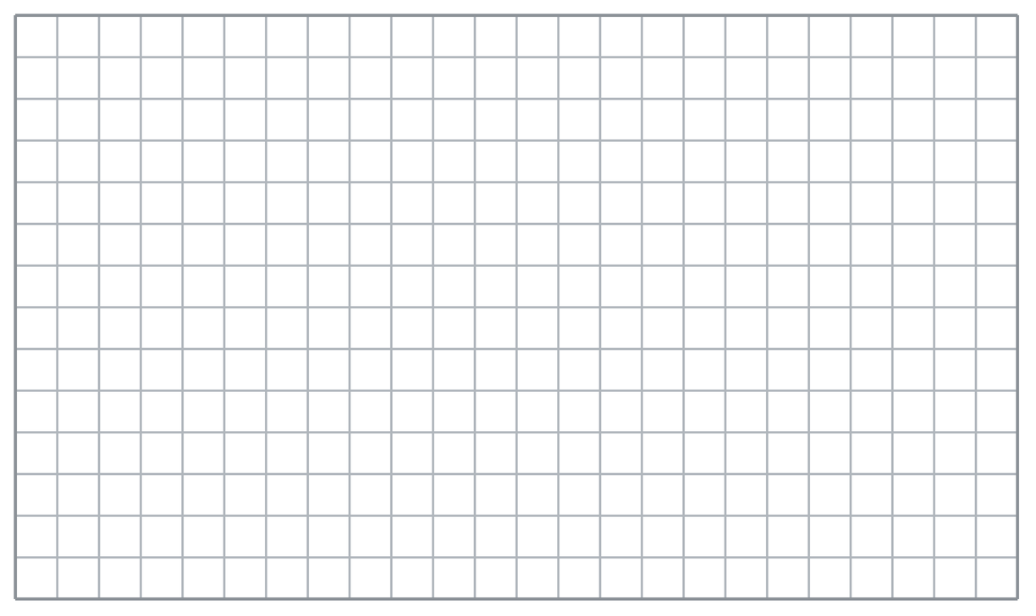
  TURN AND TALK
  How is finding a missing base different from finding an area? What changes?
PRACTICE WITH A PARTNER You Do Together · 10–12 min
2. Quilt Piece. A triangular quilt piece has an area of 54 in² and a base of 12 in. The perpendicular height is missing.  a. Substitute: 70 = ½ × 14 × __________  b. Height of the pennant __________ | 3. Roof Gable. The triangular gable on the front of a house covers 108 ft² of siding. Its perpendicular height is 9 ft.  a. Substitute: 140 = ½ × __________  b. Base of the backdrop __________
  PARTNER TALK
  Why must you deal with the half before you divide? Explain your reasoning.
  PARTNER TALK
  How could you check that your base is right without starting the problem over?

4. Awning Panel. A triangular awning panel covers 60 ft² of canvas. Its base measures 15 ft, and the perpendicular height is missing.
a. Double the area: 2 × 88 = __________
b. Height of the shade sail __________
PARTNER TALK
What would change in your steps if the height were given instead of the base?

PRACTICE ON YOUR OWN You Do · 8 problems · 18–20 min
5. Flower Bed. A triangular flower bed has an area of 72 m² and a base of 24 m.
Find the perpendicular height of the lawn
Hint Multiply the area by 2, then divide by the given base.
Answer height in meters

6. Kite Panel. A triangular kite panel covers 63 in² of fabric. Its perpendicular height is 14 in.  Sketch Malik’s kite panel and find its base  Hint Undo the factor of ½ by doubling the area, then divide by the perpendicular height.  Answer base in inches | Sketch. Draw and label the kite panel on the grid below. Let one square stand for a convenient number of units, and mark the perpendicular height with a square corner.​
  Show your work.

7. Sign Claim. A triangular sign has an area of 84 cm² and a perpendicular height of 7 cm. Rosa says the base must be 28 cm.  Justify or correct Elena’s claim using the formula.  Hint Substitute Elena’s proposed base and the given height into the triangle formula. Compare the resulting area with 90 cm².  Answer true base (Is Elena right?) | 8. Sandbox Wedge. A triangular wedge of a sandbox covers 45 m². The perpendicular height drawn to the base is 6 m.  Find the base of the patio section  Hint Multiply the area by 2, then divide by the given perpendicular height.  Answer base in meters

9. Window Wedge. A triangular wedge of glass has an area of 110 in² and a base of 20 in.  Sketch Priya’s wedge of glass and find its perpendicular height  Hint Double the area first, then divide by the base to find the perpendicular height.  Answer height in inches | Sketch. Draw and label the kite panel on the grid below. Let one square stand for a convenient number of units, and mark the perpendicular height with a square corner.​
  Show your work.

10. Missing Base. A triangle has an area of 150 cm² and a perpendicular height of 20 cm. Find its base.  Hint Double 91 to get 182, then divide by 13.  Answer cm | 11. Missing Height. A triangle has an area of 84 in² and a base of 12 in. Find its height.  Hint Double 96 to get 192, then divide by 16.  Answer in.

12. Two Unknowns. A triangular sign has an area of 96 m².
a. If its base is 15 m, find the perpendicular height. __________
b. If instead its perpendicular height is 10 m, find the base. __________
Hint Find twice the area, then divide that result by the known measure in each part.
Answer a and b
ANALYZE THE ERROR 5 min
13. Read the work below. Explain the mistake, then show the correct reasoning.
JONAH’S WORK
A triangular flag has an area of 72 in² and a base of 18 in.
72 = 18 × h
h = 72 ÷ 18
h = 4 in.

A triangle has an area of 66 ft² and a base of 11 ft. Bennett wrote: ‘I divided 66 by 11 and got 6, so the height is 6 ft.’
a. Explain the mistake. Jonah skipped one part of the triangle formula. Which part? Complete: “Jonah forgot __________, so his height is __________.” | b. Show correct work to find the flag’s perpendicular height.  Correct answer
  Show the correct work.
STRETCH YOUR THINKING multi-step reasoning · 8 min
14. Two Signs. Sign A is a triangle with area 120 ft² and base 16 ft. Sign B is a triangle with area 120 ft² and height 12 ft.
a. Find the perpendicular height of Sail A.
b. Find the base of Sail B.
c. Both sails have the same area. Explain how their shapes can still be different.
Answer both measures and your explanation
TEST PRACTICE multiple choice · fill one box · 6 min
15. A triangle has area 60 cm² and base 10 cm. Its height is — | 16. To find a missing measure you first —
  □ A. 12 cm | □ B. 6 cm | □ C. 600 cm | □ D. 30 cm
  □ A. halve the area | □ B. double the area | □ C. square the area | □ D. add the base

17. A triangle has area 45 in² and height 9 in. Its base is — | 18. Forgetting to double the area gives an answer that is —
  □ A. 405 in. | □ B. 5 in. | □ C. 10 in. | □ D. 20 in.
  □ A. zero | □ B. twice the true value | □ C. correct | □ D. half the true value
SPIRAL REVIEW earlier skills · keep them sharp · 6 min
19. From Lesson 5-2 Session 1. A triangle has base 18 cm and height 10 cm. Find its area.  Answer | 20. From Lesson 5-1 Session 2. A rhombus has diagonals of 8 m and 7 m. Find its area.  Answer

21. From Lesson 4-5 Session 1. If 18 is 30% of a number, find the number.  Answer | 22. From Lesson 3-3 Session 2. For 6 : 9, how much goes with 10?  Answer
CHECK YOUR UNDERSTANDING 5 min
23. Play Area. A triangular play area has an area of 132 yd² and a perpendicular height of 12 yd. A second triangle has the same 132 yd² area but a base of 33 yd.
a. Base of the first tent floor __________
b. Perpendicular height of the second tent floor __________
Hint Double the area in each part, then divide by that triangle’s known measure.
Answer

□ 4 — Can teach it | □ 3 — Got it | □ 2 — Need hint | □ 1 — Need help
Circle your confidence. Star one problem that shows your learning.

