UNIT 5 · LESSON 3 STANDARD 6.GR.1

Determine the Area of Trapezoids
Student Notes Packet
Name: ______________________ Date: ____________ Period: ________
Level 3 · Enrichment

Today's Goals
Content: I can find the area of a trapezoid using the formula A = ½(b1 + b2) × h.
Language: I can explain my steps using the words trapezoid, base, height, and area.

Key Vocabulary
Look at the picture, read the word, then read what it means.
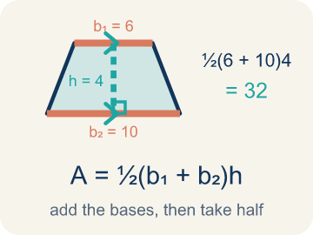 | Area of Trapezoids Área de trapecios  The space inside a trapezoid. Formula: A = 1/2(b₁ + b₂)h.  Example: A = 1/2(b₁ + b₂)h
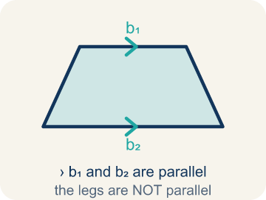 | Trapezoid Trapecio  A four-sided shape with just one pair of parallel sides.  Example: A table top wider than the bottom shelf — the top and bottom edges are parallel, the two sides slant inward
 | Parallel Paralelas  Two lines or sides that stay the same distance apart and never meet.  Example: The top and bottom of a parallelogram never get closer together — matching arrowheads (›) mark one parallel pair, double arrowheads (››) mark the other.
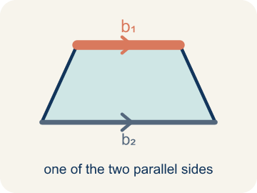 | Base 1 (b1) Base 1 (b1)  One of the two parallel sides of a trapezoid.  Example: If the bottom of the trapezoid is 10 ft, then b₁ = 10 ft in the formula A = ½(b₁ + b₂) × h
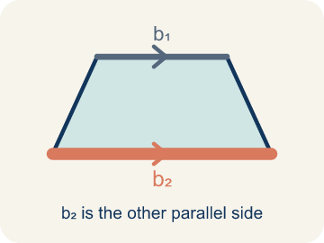 | Base 2 (b2) Base 2 (b2)  The other parallel side of a trapezoid.  Example: If the top of the trapezoid is 6 ft, then b₂ = 6 ft; both bases are parallel to each other
 | Height Altura  The straight-up distance between the two parallel sides.  Example: A dashed vertical line from the top base straight down to the bottom base at a 90° angle — NOT the slanted side
 | Perpendicular Perpendicular  Two lines that meet to make a square corner (90 degrees).  Example: The dashed height meets the base at a square corner — the small 90° box is what makes it perpendicular, not slanted.
 | Area Área  How much space is inside a flat shape.  Example: A trapezoid with b₁ = 10, b₂ = 6, h = 4 has area = ½(10 + 6) × 4 = 32 sq units
 | Decompose Descomponer  Break a figure into simpler shapes.  Example: A trapezoid = a rectangle + 2 triangles.
Right trapezoid Trapecio rectángulo
A trapezoid with two square corners.
Example: One side stands straight up from the base.

Guided Notes
Fill in each blank as we go. Use the Word Bank to help you.
WORD BANK
Area of Trapezoids • Trapezoid • Parallel • Base 1 (b1) • Base 2 (b2) • Height • Perpendicular • Area • Decompose • Right trapezoid

1. The space inside a trapezoid, found with A = ½(b₁ + b₂)h, is the ________________.
2. A quadrilateral with exactly one pair of parallel sides is a ________________.
3. Two sides that stay the same distance apart and never meet are ________________.
4. One of the two parallel sides of a trapezoid is ________________.
5. The other parallel side of a trapezoid is ________________.
6. The perpendicular distance between the two parallel bases is the ________________.
7. Two lines that meet at a 90° square corner are ________________.
8. The amount of flat space inside the trapezoid is its ________________.
9. Breaking a figure into simpler shapes is called ________________.
10. A trapezoid with two square corners is a ________________.

Write About the Math
How many bags of concrete does the builder need?
¿Cuántas bolsas de concreto necesita el constructor?
Say your answer to a partner first. Then write it, using at least two of these words:
☐ Trapezoid · Trapecio
☐ Parallel · Paralelas
☐ Base 1 (b1) · Base 1 (b1)
☐ Base 2 (b2) · Base 2 (b2)
☐ Height · Altura
Model: We use both bases because the top and bottom are different lengths. — Students explain a trapezoid has two parallel sides of different lengths, so using only one would over- or under-count the area; strong answers mention averaging the bases.

Start Most language support
Complete the frames. Use the word bank.
Completa las oraciones. Usa el banco de palabras.
The driveway's area is ___ sq ft because A = 1/2 x (___ + ___) x ___. He needs ___ bags because ___ / 6 = ___.
My answer is ___ because ___.
Mi respuesta es ___ porque ___.

Build Some language support
Write two connected sentences. Use because, so, or but.
Escribe dos oraciones conectadas. Usa porque, entonces o pero.
My claim is ___.
Mi afirmación es ___.
My evidence is ___, so ___.
Mi evidencia es ___, entonces ___.

Explain Light language support
Write a claim, give math evidence, and explain your reasoning.
Escribe una afirmación, da evidencia matemática y explica tu razonamiento.

Check Your Explanation three quick checks
☐ I answered the question.
☐ I used math evidence: numbers, an equation, or a model.
☐ I used at least two math words.

Worked Example

Watch & Read I Do — follow along with your teacher
Blueprint Review
Your architecture firm is designing a trapezoidal window for a modern building. The glass supplier charges by the square foot, so the team must calculate the exact area. The window has a top edge of 4 feet, a bottom edge of 8 feet, and a height of 5 feet.

Think about:
• What shape is the window?
• How many parallel sides does it have?
• What measurements are given?
• Why does the formula use two bases instead of one?
• What would happen if both bases were the same length?

Solved Example I Do — watch each step
Problem: What is the area of a trapezoid with bases 6 cm and 10 cm, and height 4 cm?
A) 24 sq cm
B) 32 sq cm
C) 40 sq cm
D) 64 sq cm
Step 1: A = ½ × (b₁ + b₂) × h = ½ × (6 + 10) × 4 = ½ × 16 × 4 = 32 sq cm.
Answer: B. 32 sq cm

Exit Ticket
Answer on your own. This shows what you learned today.
★ A trapezoid has bases of 9 inches and 5 inches, and a height of 6 inches. What is its area?
A) 27 sq in
B) 42 sq in
C) 42 in
D) 84 sq in

