Name |  | Date |  | Period

Lesson 5-3 · Session 1
Homework
Trapezoids by Decomposing
Maryland Standard 6.G.A.1 · Learning target — I can find the area of a trapezoid by decomposing it into a rectangle and triangles.
Show a model, calculation, or explanation for each exercise. Label units and answer every part.
Exercises 1–12 earn 1 point for a correct response and 1 for supporting work. Spiral Review and Test Practice earn 1 point each.
REMEMBER review this before you start
• A trapezoid can be split (decomposed) into a rectangle and one or two triangles to find its area.
• Find the area of each piece, then add them together.
• Watch out — the two triangle bases together equal the difference of the two trapezoid bases.
• Check it — sketch the pieces and label every measure before you compute.
WORKED EXAMPLE the same steps you practiced in class
Finding a Trapezoid’s Area by Decomposing An isosceles trapezoid has a top base of 8 m, a bottom base of 14 m, and a height of 6 m. Find the area.
Step 1 Decompose it: a rectangle in the middle and two matching triangles on the ends.
Step 2 Rectangle: top base by height. 8 × 6 = 48
Step 3 Leftover bottom: 14 − 8 = 6, split evenly into two triangle bases of 3 m.
Step 4 Each triangle ½ × 3 × 6 = 9, so two give 18. 48 + 18 = 66
Answer The area of the trapezoid is 66 square meters (66 m²).
EXERCISES 12 exercises · 24 points
1. A trapezoid is decomposed into a rectangle with area 20 sq in and two triangles with areas 3 sq in each. Find the total area.

Show your work.
Answer
2. Sketch a trapezoid and show one way to decompose it into a rectangle and triangle(s).

Sketch. Draw the trapezoid on the grid, then cut it into a rectangle and triangles.​
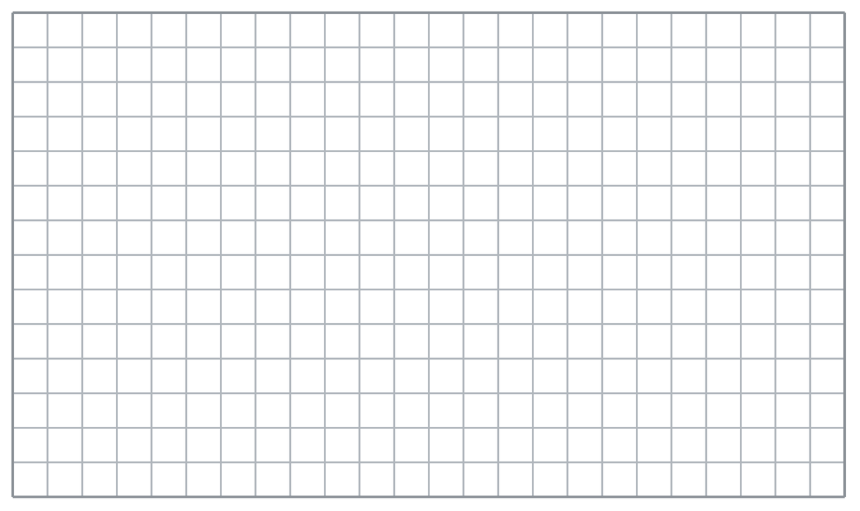
Show your work.
Answer
3. Why is decomposing a helpful strategy for finding the area of an odd shape?

Show your work.
Answer
4. A trapezoid was cut into a rectangle and two matching triangles. Fill in each piece.
a. rectangle 9 cm by 5 cm ______ cm²
b. one triangle, base 4 cm, height 5 cm ______ cm²
c. total of the rectangle and both triangles ______ cm²
d. longer base 9 + 4 + 4 = ______ cm; shorter base = ______ cm

Answer
5. Planter Face. The front of a planter is an isosceles trapezoid with bases of 10 ft and 18 ft and a height of 7 ft. Cut it into a rectangle and two matching triangles, then find the total area.

Show your work.

Answer
6. Mural Border. A mural border is a trapezoid with one square corner. Its parallel sides measure 12 in. and 20 in., and the height between them is 9 in. Find its area by decomposing.

Show your work.

Answer
7. Ramp Side. The side of a loading ramp is an isosceles trapezoid with bases of 6 m and 14 m and a height of 5 m. Find the total area.

Show your work.

Answer
8. A trapezoid has bases of 8 in. and 16 in. and a height of 6 in. Amina cut it into a rectangle and two triangles and wrote ‘Area = 48 in².’ Explain her mistake, then show the correct total.

Show your work.

Answer
9. A trapezoid has bases of 7 cm and 13 cm and a height of 4 cm. Decompose it and find the area.

Show your work.
Answer cm²
10. A trapezoid has bases of 9 m and 15 m and a height of 6 m. Find the area by decomposing.

Show your work.
Answer m²
11. Name the Pieces. For a trapezoid with bases 11 in. and 19 in. and height 5 in., find the rectangle piece and the triangle pieces separately.

Show your work.
Answer rectangle and triangles
12. Find the Mistake. Dana decomposed a trapezoid but used a height of 6 for the rectangle and 4 for the triangles. Explain the mistake.

Show your work.
Answer the mistake
SPIRAL REVIEW earlier skills · 1 point each
13. From Lesson 5-2 Session 1. A triangle has base 24 in. and height 5 in. Find its area.
Answer
14. From Lesson 5-1 Session 1. A parallelogram has base 9 cm and height 7 cm. Find its area.
Answer
15. From Lesson 4-4 Session 1. Find 25% of 160.
Answer
TEST PRACTICE multiple choice · fill one box · 1 point each
16. A trapezoid decomposes into a rectangle and —
□ A. two circles | □ B. two triangles | □ C. a cube | □ D. a pyramid
17. A rectangle of 40 m² plus triangles of 14 m² gives —
□ A. 560 m² | □ B. 26 m² | □ C. 54 m² | □ D. 40 m²
18. If the bases are 8 and 14, the triangle bases total —
□ A. 14 | □ B. 22 | □ C. 8 | □ D. 6
CHECK YOURSELF Score: ______ / 30
□ Solved on my own | □ Needed a hint | □ Need help on Question # ______
Check each labeled measure and required face or region. Use square units for area and cubic units for volume.

