Name |  | Date |  | Period
Lesson 5-3 · Session 2
Guided Practice
The Trapezoid Area Formula
VOCABULARY read and say each word before you begin
trapezoid  Spanish: trapecio | A four-sided shape with one pair of parallel sides. | A = ½(b1 + b2)h
base  Spanish: base | One of the two parallel sides of a trapezoid. | b1 and b2
height | The perpendicular distance between the two parallel base lines. | h, at a square corner
right trapezoid | A trapezoid with two square corners. | one side stands straight up
formula  Spanish: fórmula | A math rule written with symbols. | A = ½(b1 + b2)h
EXPLORE TOGETHER Class Launch · 8–10 min
1. County Land Shape
A county is shaped like a right trapezoid. Its parallel sides measure 14 mi and 26 mi, and the perpendicular distance between them is 10 mi.
a. Identify. Parallel sides: ______ mi and ______ mi Height: ______ mi
b. Add. Sum of the bases: ______ + ______ = ______ mi
c. Formula. A = ½ × ______ × ______ = ______ mi²
d. Reasoning. Two copies of this county form a rectangle. How long is that rectangle? ______ mi
TURN AND TALK
Why does the formula add the two bases before anything else happens?

PRACTICE WITH A PARTNER You Do Together · 10–12 min
2. Ramp Side. The flat side of a skate ramp is a right trapezoid. Its parallel sides measure 12 ft and 20 ft, and the height between them is 7 ft.
a. Add the bases __________
b. Area of the ramp side: ½ × __________
PARTNER TALK
How is this formula like finding the average of the two bases? Explain your thinking.

3. Table Runner. A trapezoid table runner has parallel bases of 18 in. and 30 in. The perpendicular height between the bases is 11 in.  a. Sketch and label the runner. b1 + b2 = __________  b. Area of the runner __________ | c. Sketch. Draw and label the figure on the grid below. Let one square stand for a convenient number of units, and mark the perpendicular height with a square corner.​  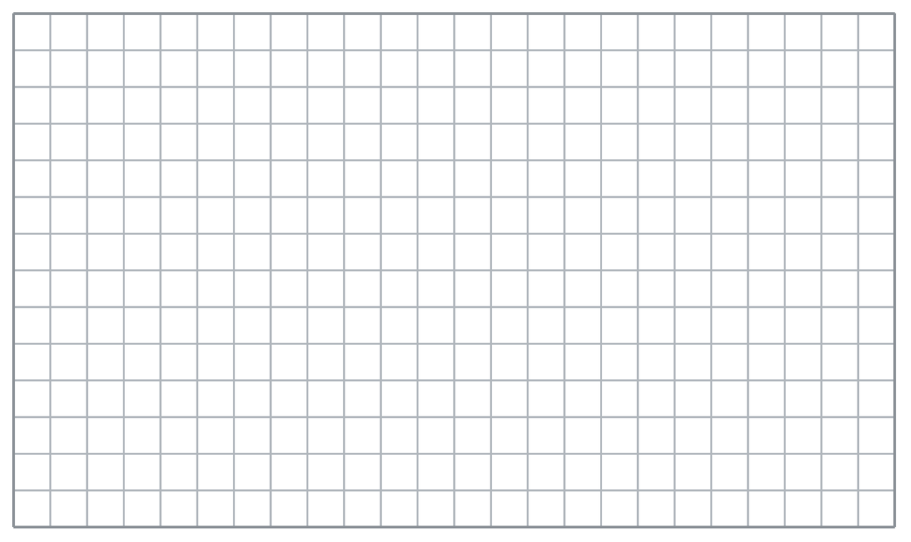
  PARTNER TALK
  How do you decide which measures are bases and which one is the height?

4. Garage Door Panel. A panel on a garage door is a trapezoid. Its parallel bases measure 15 ft and 23 ft, and the height between them is 6 ft.
a. Add the bases __________
b. Area of the panel: ½ × __________
PARTNER TALK
What does the sum of the two bases tell you before you multiply by the height?

PRACTICE ON YOUR OWN You Do · 8 problems · 18–20 min
5. Field Section. A section of a practice field is a trapezoid with parallel sides of 25 m and 35 m and a height of 12 m.  Find the area of the section  Hint Add the two parallel bases first, then multiply by the height, then take half of that product.  Answer area in m² | 6. Pool Cover. A pool cover is a trapezoid with bases of 16 ft and 22 ft and a height of 10 ft. Cover fabric costs $2 for each square foot.  Find the area of the cover, then find the total cost of the fabric.  Hint Get the area from the trapezoid formula first. The price per square foot tells you what to do with that area.  Answer area in ft² and total cost

7. Talia’s Answer. A trapezoid has bases of 11 cm and 17 cm and a height of 20 cm. Talia says its area is 560 cm².  Justify or correct Talia’s answer using the formula.  Hint Walk through the formula one step at a time and watch for a step Talia may have skipped.  Answer true area (Is Talia right?) | 8. Sidewalk Panel. A sidewalk panel is a trapezoid with parallel sides of 8 m and 20 m and a height of 7 m.  Find the area of the panel  Hint Add the two parallel bases first, multiply by the height, then take half of that product.  Answer area in m²

9. Two Signs. Sign M is a trapezoid with bases of 10 cm and 26 cm and a height of 8 cm. Sign N is a trapezoid with bases of 14 cm and 22 cm and the same height of 8 cm.  Find each area, then explain what you notice  Hint Add each sign’s bases before you multiply, then set the two sums side by side.  Answer area of each sign and what you notice | 10. Use the Formula. A trapezoid has parallel bases of 9 cm and 15 cm and a height of 8 cm. Find its area.  Hint Add 9 and 15, halve the sum, then multiply by 8.  Answer cm²

11. Window Pane. A window is a trapezoid with bases of 20 in. and 28 in. and a height of 15 in. Find its area.  Hint Half of (20 + 28) is 24.  Answer in² | 12. Missing Base. A trapezoid has an area of 84 m², a height of 7 m, and one base of 10 m.  a. What is the sum of the two bases? __________  b. Find the other base. __________  Hint Area ÷ height × 2 gives the sum of the bases.  Answer a and b
ANALYZE THE ERROR 5 min
13. Read the work below. Explain the mistake, then show the correct reasoning.
SOFIA’S WORK

A trapezoid has bases of 7 m and 21 m and a height of 5 m. Sofia wrote: ‘A = ½ × 7 × 5 = 17.5 m².’
a. Explain the mistake. Sofia used only one of the parallel sides. What does the formula ask for? | b. Show correct work  Correct answer
  Show the correct work.
STRETCH YOUR THINKING multi-step reasoning · 8 min
14. Two Methods. A trapezoid has bases of 8 ft and 16 ft and a height of 6 ft.
a. Find the area using the formula.
b. Find the area again by decomposing into a rectangle and triangles.
c. Explain why both methods must give the same answer.
Answer both areas and your explanation
TEST PRACTICE multiple choice · fill one box · 6 min
15. A trapezoid with bases 6 and 10 and height 5 has area — | 16. The trapezoid formula averages the —
  □ A. 30 | □ B. 80 | □ C. 21 | □ D. 40
  □ A. two bases | □ B. two heights | □ C. base and height | □ D. area and height

17. A trapezoid with bases 12 and 18 and height 4 has area — | 18. In A = ½(b1 + b2)h you must first —
  □ A. 120 | □ B. 60 | □ C. 34 | □ D. 72
  □ A. halve h | □ B. multiply by h | □ C. add the bases | □ D. square b1
SPIRAL REVIEW earlier skills · keep them sharp · 6 min
19. From Lesson 5-3 Session 1. A trapezoid with bases 6 m and 12 m and height 4 m: find the rectangle piece.  Answer | 20. From Lesson 5-2 Session 2. A triangle has area 96 in² and height 12 in. Find its base.  Answer

21. From Lesson 4-5 Session 1. If 36 is 45% of a number, find the number.  Answer | 22. From Lesson 3-6 Session 1. Convert 3 yards to feet.  Answer
CHECK YOUR UNDERSTANDING 5 min
23. Kitchen Counters. One counter is a trapezoid with parallel sides of 28 in. and 44 in. and a height of 12 in. A second counter has the same height but bases of 30 in. and 42 in.
a. Sum of the first counter’s bases __________
b. Area of the second counter __________
Hint Add the bases before multiplying. In part b, look at the two sums side by side before you decide.
Answer

□ 4 — Can teach it | □ 3 — Got it | □ 2 — Need hint | □ 1 — Need help
Circle your confidence. Star one problem that shows your learning.

